Software Engineering
Unit 1

Q1. What is Software Crisis?
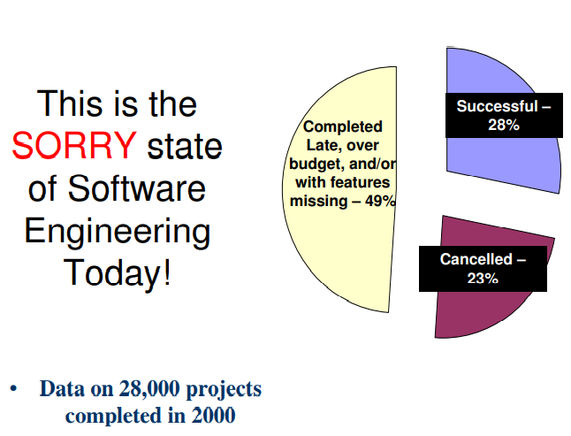
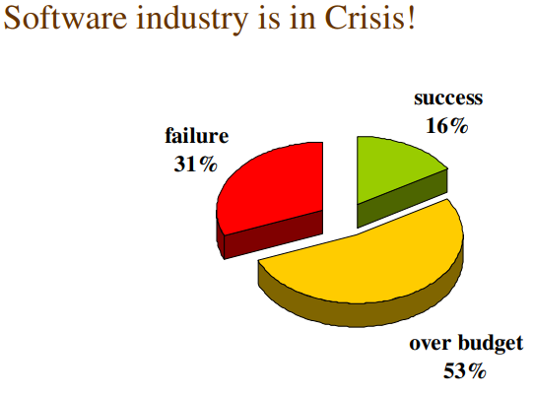

As per the IBM report, “31% of the project get cancelled before they are completed, 53% overrun their cost estimates by an average of 189% and for every 100 projects, there are 94 restarts”.

Q2. Relative Cost of Hardware and Software.

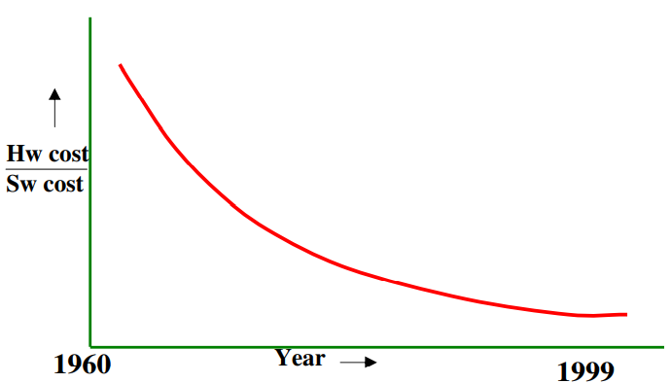

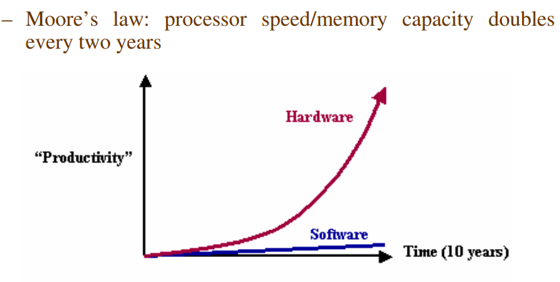

Q3. What are factors contributing to software crisis?

• Larger problems,
• Lack of adequate training in software engineering,
• Increasing skill shortage,
• Low productivity improvements.

Q4. Some Software Failures.
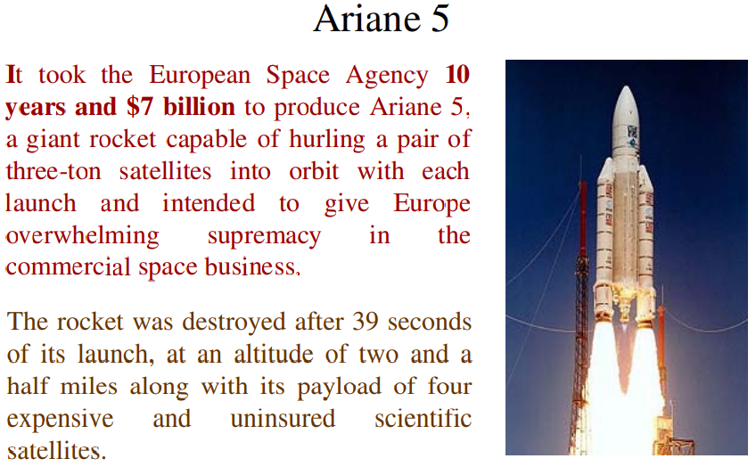

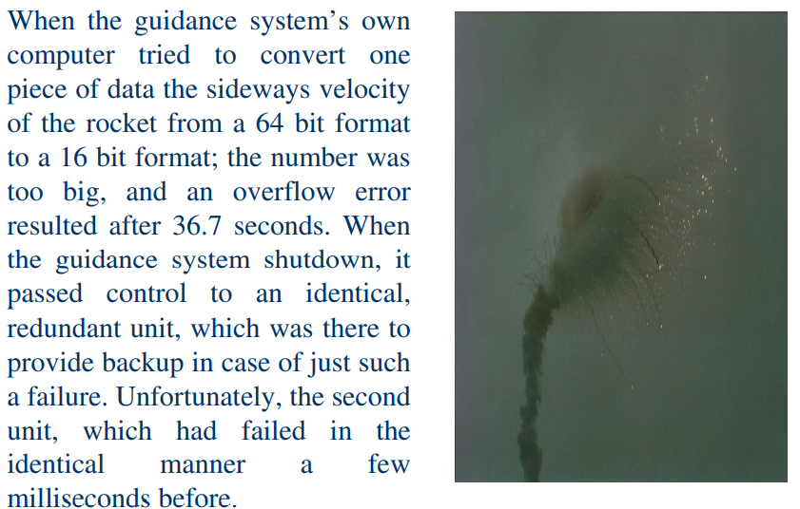

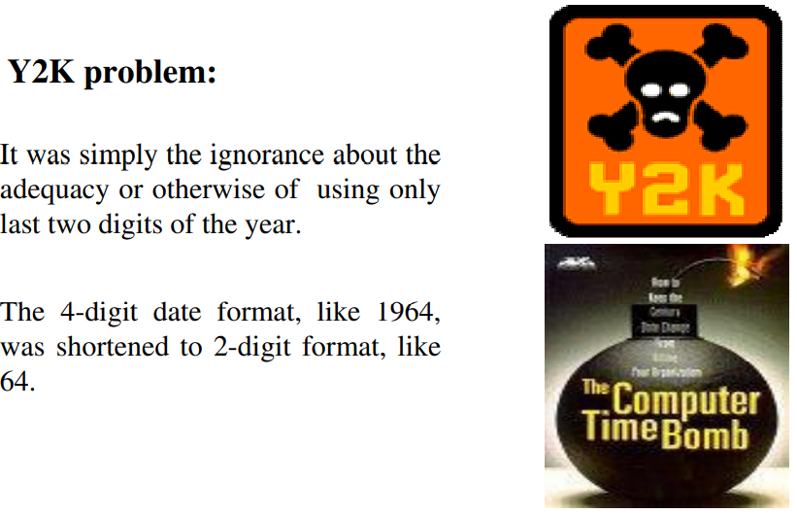

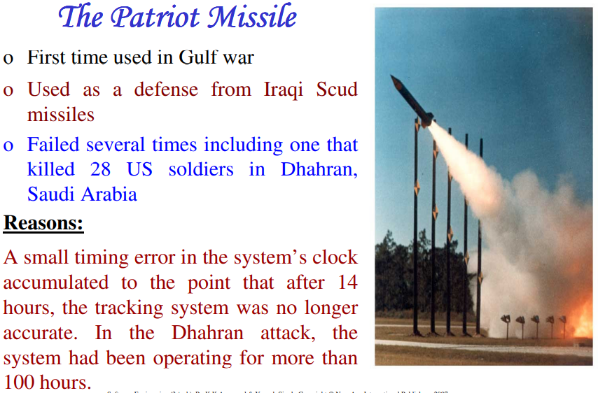

Q5. “No Silver Bullet”
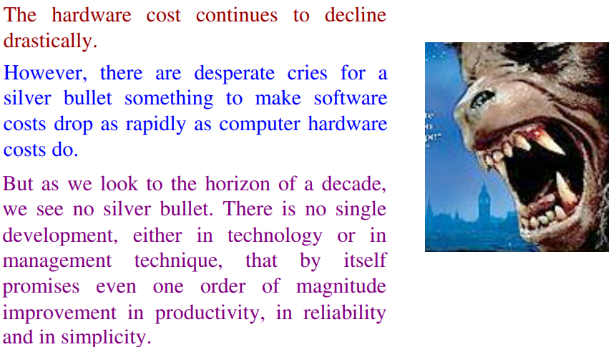
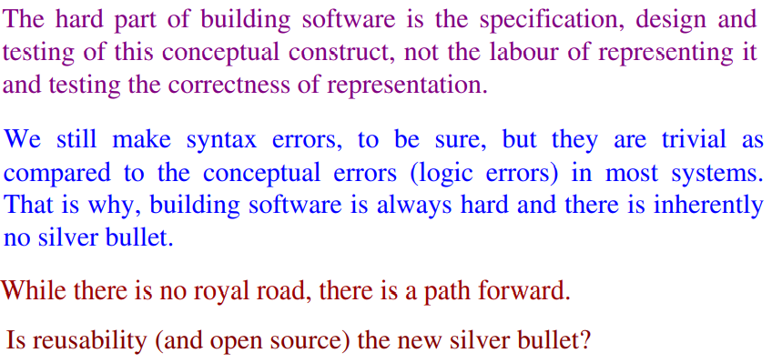
The blame for software bugs belongs to: • Software companies • Software developers • Legal system • Universities

Q6. What is software?

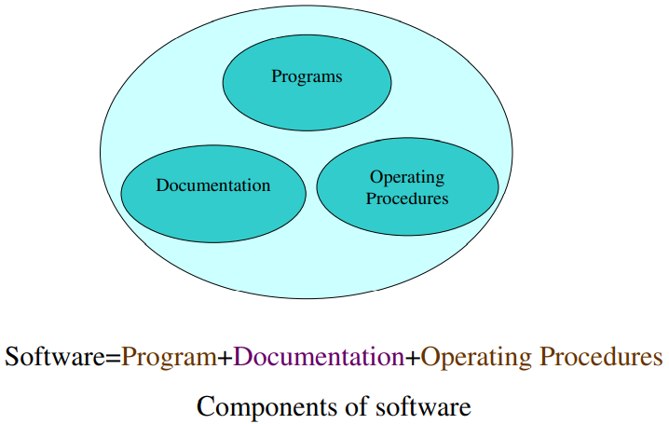

Q6. Documentation of software.
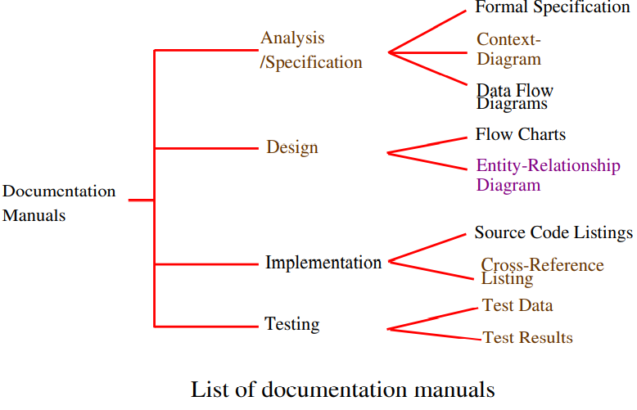

Q7. Operating Procedures.

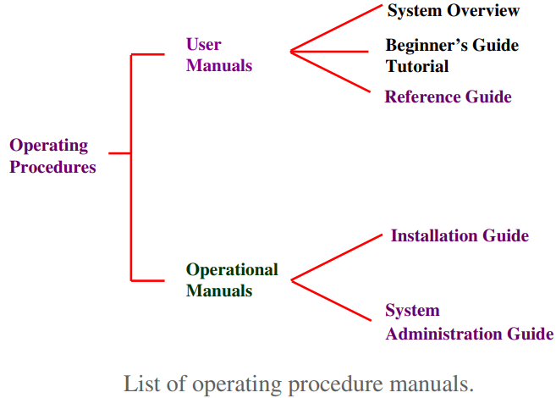

Q8. Why Software Product developed.

• Software products may be developed for a particular customer or may be developed for a general market Software Product
• Software products may be
–Generic – developed to be sold to a range of different customers
–Bespoke (custom) - developed for a single customer according to their specification

Q9. What is software Engineering?

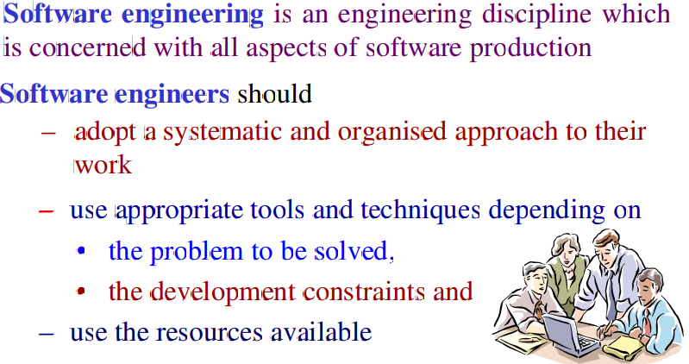
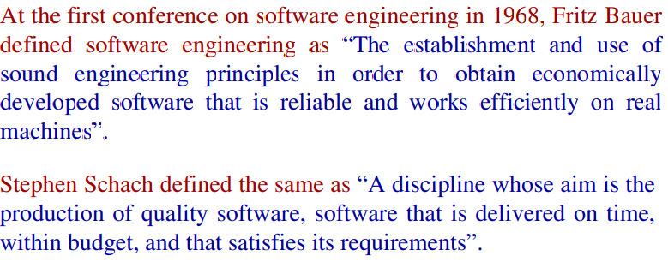
Q10. What is Software Process?

The software process is the way in which we produce software.

A Software Process refers to a structured set of activities, methods, and practices used to develop and maintain software systems. It encompasses all phases of software development, from initial conception through to delivery and ongoing maintenance.

Q11. Why is it difficult to improve software process?

• Not enough time • Lack of knowledge • Wrong motivations • Insufficient commitment
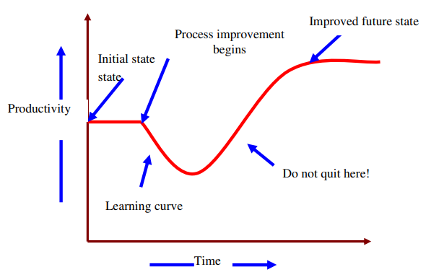

Q12. What are characteristics of a Software?

- Software does not wear out
- Software is not manufactured
- Reusability of component
- Software is flexible

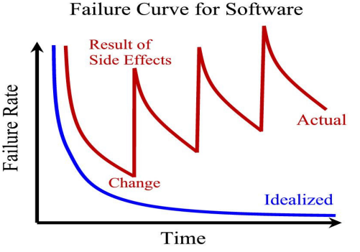

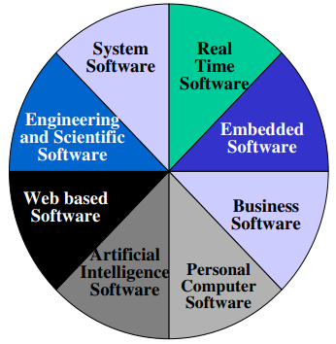
Q13. Changing nature of Software.

Trend has emerged to provide source code to the customer and organizations.

Software where source codes are available are known as open source software.

Examples Open source software: LINUX, MySQL, PHP, Open office, Apache webserver etc.

Q14. Deliverables and Milestones.

Different deliverables are generated during software development. The examples are source code, user manuals, operating procedure manuals etc.

The milestones are the events that are used to ascertain the status of the project. Finalization of specification is a milestone. Completion of design documentation is another milestone. The milestones are essential for project planning and management.

Q15. Product and Process

Product: What is delivered to the customer, is called a product. It may include source code, specification document, manuals, documentation etc. Basically, it is nothing but a set of deliverables only.

Process: Process is the way in which we produce software. It is the collection of activities that leads to (a part of) a product. An efficient process is required to produce good quality products. If the process is weak, the end product will undoubtedly suffer, but an obsessive over reliance on process is also dangerous.

Q16. Productivity and Effort.

Productivity is defined as the rate of output, or production per unit of effort, i.e. the output achieved with regard to the time taken but irrespective of the cost incurred.

Hence most appropriate unit of effort is Person Months (PMs), meaning thereby number of persons involved for specified months. So, productivity may be measured as LOC/PM (lines of code produced/person month)

Q17. Software Components.

“An independently deliverable piece of functionality providing access to its services through interfaces”.

“A component represents a modular, deployable, and replaceable part of a system that encapsulates implementation and exposes a set of interfaces”.

Q18. Role of Management in Software Development.
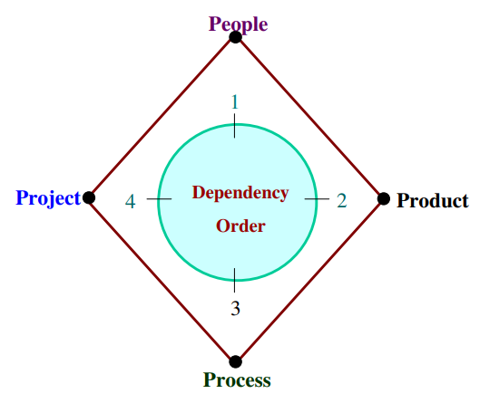
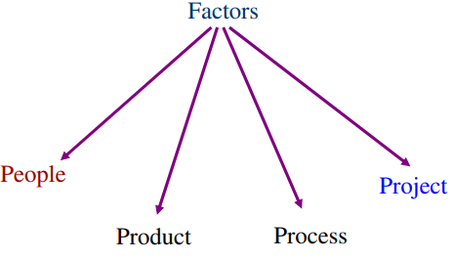

Q18. Software Life Cycle Models

The goal of Software Engineering is to provide models and processes that lead to the production of well-documented maintainable software in a manner that is predictable.

“The period of time that starts when a software product is conceived and ends when the product is no longer available for use. The software life cycle typically includes a requirement phase, design phase, implementation phase, test phase, installation and check out phase, operation and maintenance phase, and sometimes retirement phase”.

Q19. Waterfall Model

This model is easy to understand and reinforces the notion of “define before design” and “design before code”. The model expects complete & accurate requirements early in the process, which is unrealistic.

Problems of waterfall model
i. It is difficult to define all requirements at the beginning of a project
ii. This model is not suitable for accommodating any change
iii. A working version of the system is not seen until late in the project’s life
iv. It does no t scale up well to large projects.
v. Real projects are rarely sequential
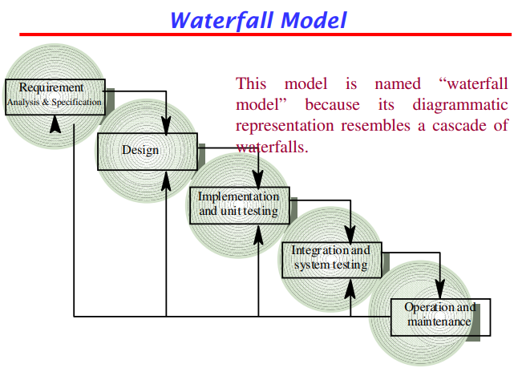
Q20. Iterative Enhancement Model

This model has the same phases as the waterfall model, but with fewer restrictions. Generally the phases occur in the same order as in the waterfall model, but they may be conducted in several cycles. Useable product is released at the end of the each cycle, with each release providing additional functionality

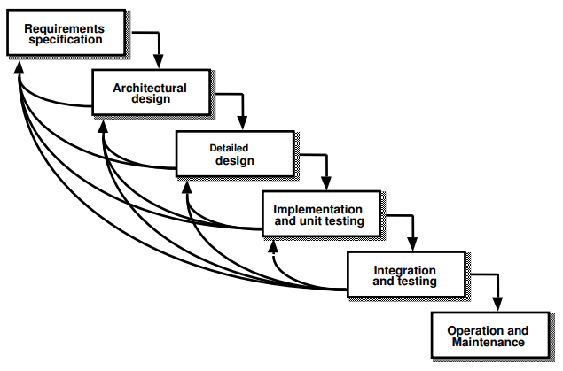

Q 21. Evolutionary Process Model

Evolutionary process model resembles iterative enhancement model. The same phases as defined for the waterfall model occur here in a cyclical fashion. This model differs from iterative enhancement model in the sense that this does not require an useable product at the end of each cycle. In evolutionary development, requirements are implemented by category rather than by priority.

This model is useful for projects using new technology that is not well understood. This is also used for complex projects where all functionality must be delivered at one time, but the requirements are unstable or not well understood at the beginning

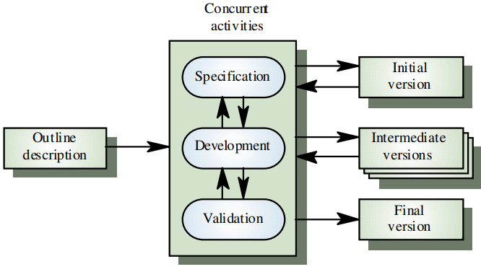
Q22. Prototyping Model

The prototype may be a usable program but is not suitable as the final software product.

The code for the prototype is thrown away. However experience gathered helps in developing the actual system.

The development of a prototype might involve extra cost, but overall cost might turnout to be lower than that of an equivalent system developed using the waterfall model.

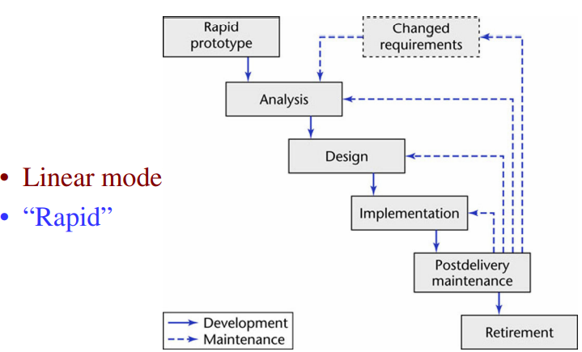

Q23. Spiral Model

Models do not deal with uncertainly which is inherent to software projects.

Important software projects have failed because project risks were neglected & nobody was prepared when something unforeseen happened.

Barry Boehm recognized this and tired to incorporate the “project risk” factor into a life cycle model.
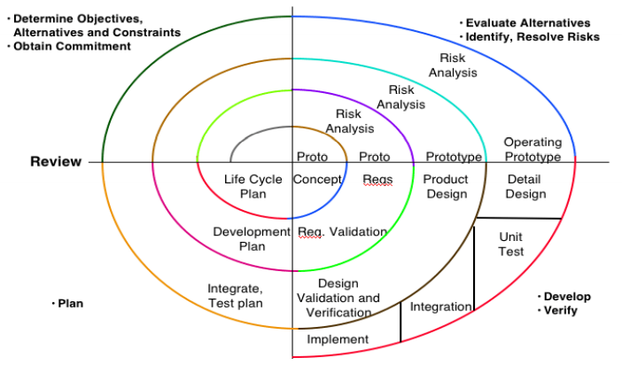
The result is the spiral model, which was presented in 1986

The radial dimension of the model represents the cumulative costs. Each path around the spiral is indicative of increased costs. The angular dimension represents the progress made in completing each cycle. Each loop of the spiral from X-axis clockwise through 360 represents one phase. One phase is split roughly into four sectors of major activities.

- Planning: Determination of objectives, alternatives & constraints.
- Risk Analysis: Analyze alternatives and attempts to identify and resolve the risks involved.
- Development: Product development and testing product.
- Assessment: Customer evaluation

An important feature of the spiral model is that each phase is completed with a review by the people concerned with the project (designers and programmers)

The advantage of this model is the wide range of options to accommodate the good features of other life cycle models.

It becomes equivalent to another life cycle model in appropriate situations.

The spiral model has some difficulties that need to be resolved before it can be a universally applied life cycle model. These difficulties include lack of explicit process guidance in determining objectives, constraints, alternatives; relying on risk assessment expertise; and provides more flexibility than required for many applications.

Q24. Software Requirements Specification (SRS)

The Software Requirements Specification (SRS) is a comprehensive document that outlines the complete software requirements for a project. It serves as a formal agreement between stakeholders and the development team, detailing what the software should do and the constraints under which it must operate.
For example, it will describe the software’s ability to handle user input, process data, and deliver appropriate results. It will also address user needs such as speed, security, and user-friendliness, but won't specify how these will be technically achieved. The document ensures clarity between stakeholders and developers, keeping the focus on "what" the system does, not "how."

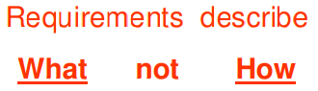

Q25. Requirement Engineering
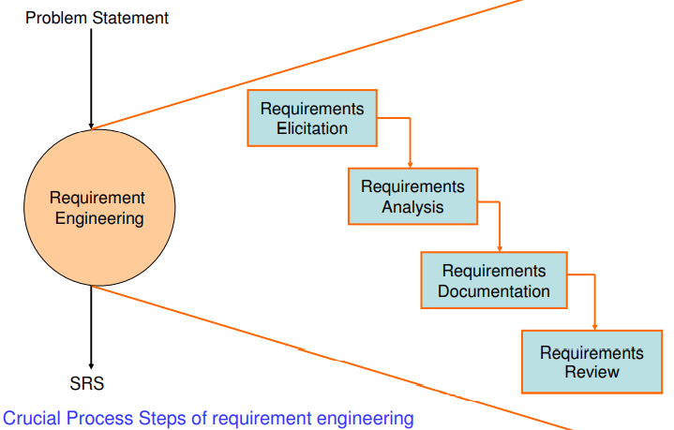
Requirement Engineering is the disciplined application of proven principles, methods, tools, and notations to describe a proposed system’s intended behaviour and its associated constraints.

SRS may act as a contract between developer and customer.

State of practice Requirements are difficult to uncover
• Requirements change
• Over reliance on CASE Tools
• Tight project Schedule
• Communication barriers
• Market driven software development
• Lack of resources

A University wish to develop a software system for the student result management of its M.Tech. Programme. A problem statement is to be prepared for the software development company. The problem statement may give an overview of the existing system and broad expectations from the new software system.

Q27. Types of Requirements

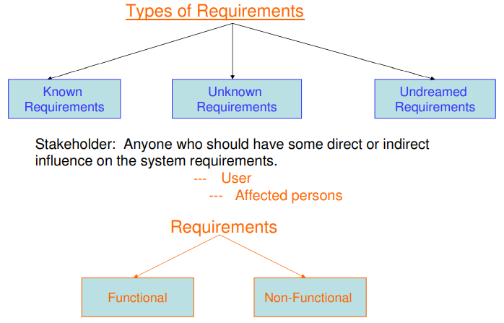
Functional requirements describe what the software has to do. They are often called product features.

Non Functional requirements are mostly quality requirements. That stipulate how well the software does, what it has to do.

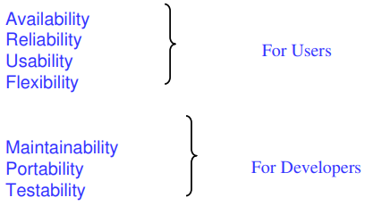

User and system requirements
• User requirement are written for the users and include functional and non functional requirement. • System requirement are derived from user requirement.
• The user system requirements are the parts of software requirement and specification (SRS) document.
Interface Specification
• Important for the customers.
TYPES OF INTERFACES
• Procedural interfaces (also called Application Programming Interfaces (APIs)). • Data structures • Representation of data
Q28. Feasibility Study

A feasibility study checks if a project is practical and worth pursuing. It looks at key areas to decide if the project can be done successfully within time, budget, and resources.
Key parts include:
- Technical Feasibility – Can the needed technology and tools be developed or used?
- Economic Feasibility – Is the project cost-effective, with benefits greater than costs?
- Operational Feasibility – Will the system work well with current processes, and will users accept it?
- Legal Feasibility – Does the project follow laws and regulations?
- Schedule Feasibility – Can the project be completed on time?
This helps in deciding whether to move forward with a project.
Q29. Requirements Elicitation

Requirements elicitation is the process of gathering, discovering, and understanding the needs and expectations of stakeholders for a system or product. Techniques for requirements elicitation:

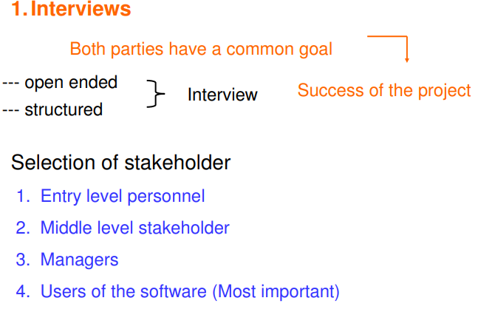

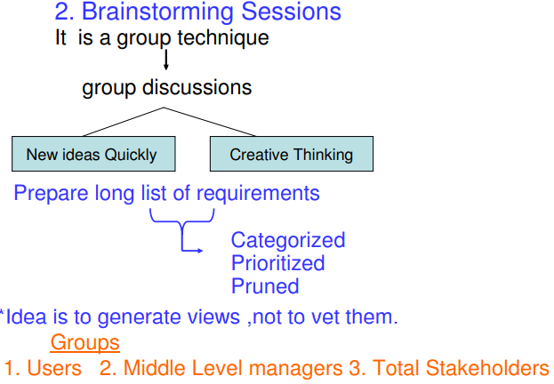

3. Facilitated Application specification Techniques (FAST)

-- Similar to brainstorming sessions. -- Team oriented approach -- Creation of joint team of customers and developers.

Guidelines
1. Arrange a meeting at a neutral site.
2. Establish rules for participation.
3. Informal agenda to encourage free flow of ideas.
4. Appoint a facilitator.
5. Prepare definition mechanism board, worksheets, wall stickier.
6. Participants should not criticize or debate.

FAST session Preparations Each attendee is asked to make a list of objects that are:

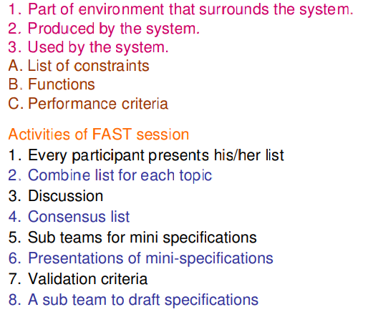

4. Quality Function Deployment
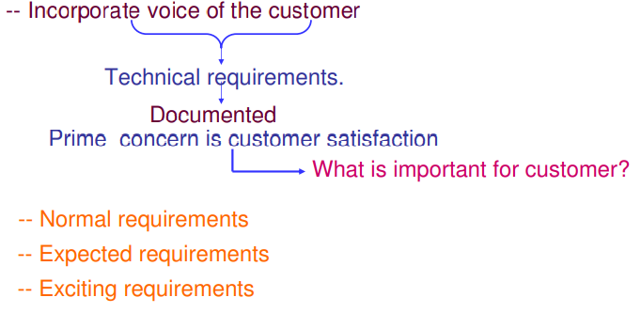

Steps
1. Identify stakeholders
2. List out requirements
3. Degree of importance to each requirement.

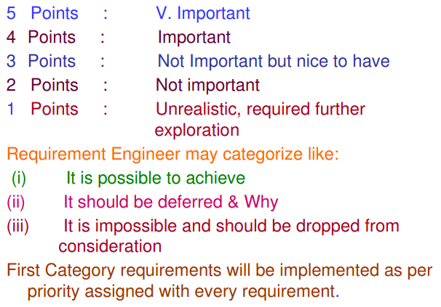

5. The Use Case Approach

The Use Case Approach, introduced by Ivar Jacobson, is a method for capturing and modeling functional requirements in software development. It focuses on describing how users (or "actors") interact with a system to achieve specific goals. A use case represents a specific scenario or sequence of steps that the system performs in response to an actor's request. This method is useful in understanding system behavior from the user's perspective.
Use Case captures who (actor) does what (interaction) with the system, for what purpose (goal), without dealing with system internals.
*defines all behavior required of the system, bounding the scope of the system.
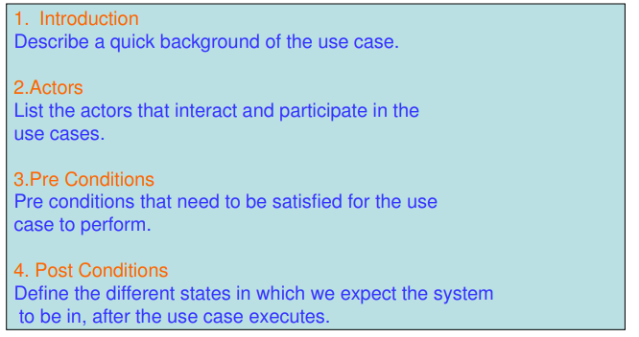
Jacobson & others proposed a template for writing Use cases as shown below

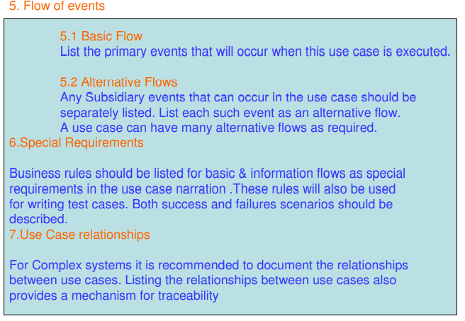

Use Case Guidelines
1. Identify all users
2. Create a user profile for each category of users including all roles of the users play that are relevant to the system.
3. Create a use case for each goal, following the use case template maintain the same level of abstraction throughout the use case. Steps in higher level use cases may be treated as goals for lower level (i.e. more detailed), sub-use cases.
4. Structure the use case
5. Review and validate with users.
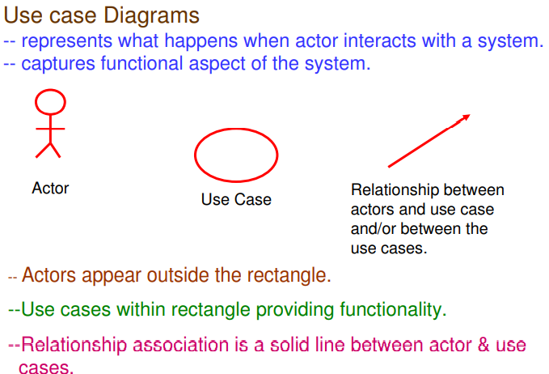

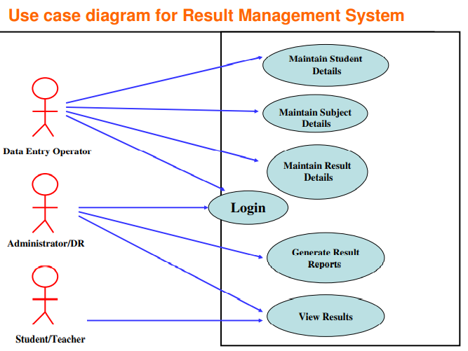
Q30. Requirements Analysis.

We analyze, refine and scrutinize requirements to make consistent & unambiguous requirements.

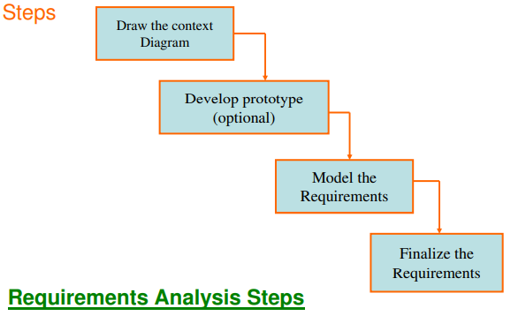

Ex:
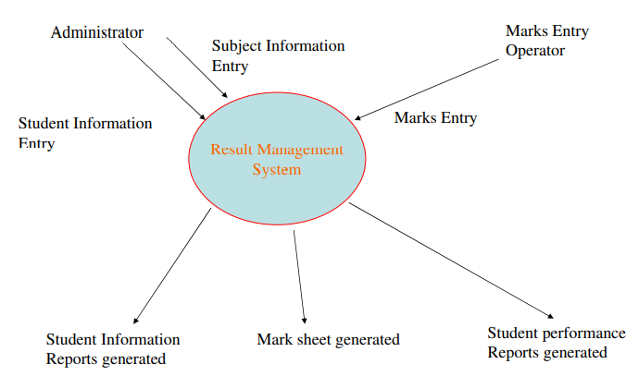

Q31. Data Flow Diagrams
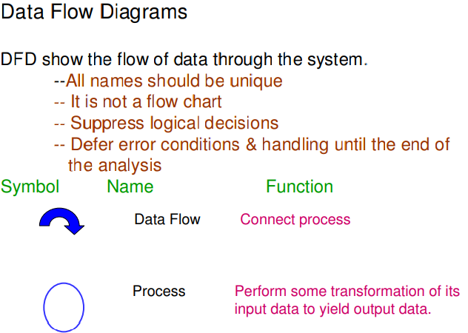
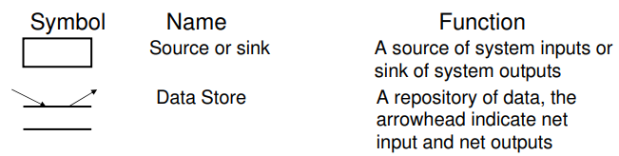

Q32. Leveling In DFD

Leveling DFD represent a system or software at any level of abstraction.

A level 0 DFD is called fundamental system model or context model represents entire software element as a single bubble with input and output data indicating by incoming & outgoing arrows.
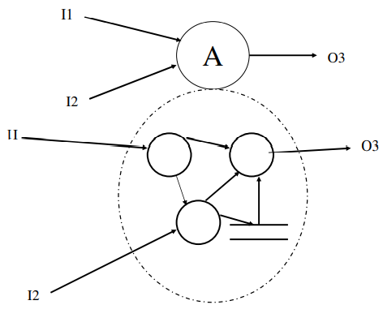

Q33. Data Dictionaries

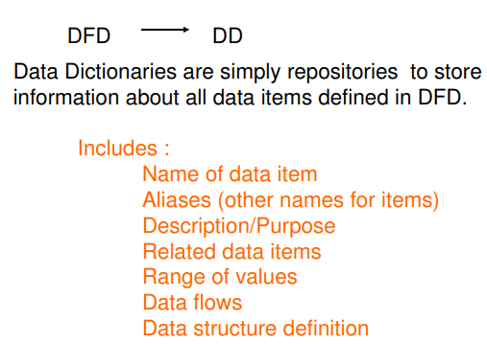
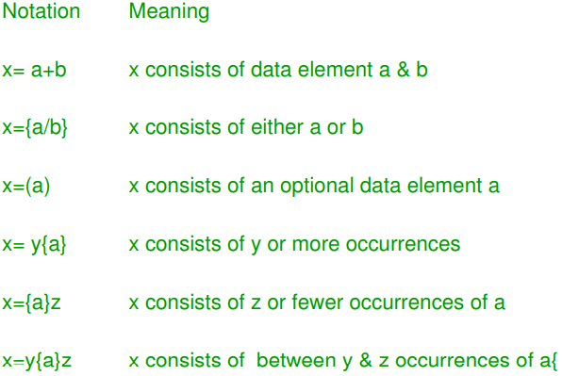

Q34. ER Diagram.

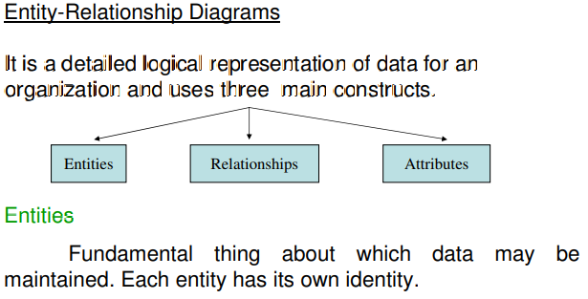

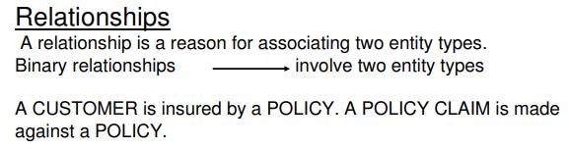

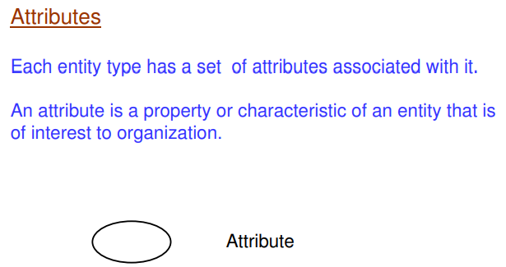

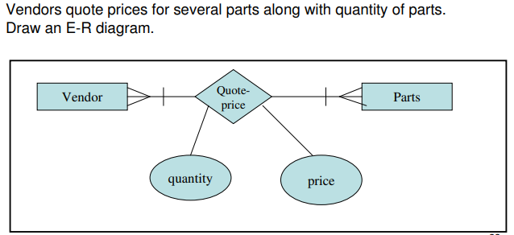
Q35. Structured requirements definition (SRD)

Structured Requirements Definition (SRD) outlines steps to document system requirements clearly.
- User-Level DFD: Create individual DFDs for each user, showing inputs (e.g., data provided by users) and outputs (e.g., system responses).
- Combined User-Level DFD: Combine individual DFDs to show how all users interact with the system and each other.
- Application-Level DFD: Focus on internal system processes, data stores, and data flows, showing how the system processes inputs and outputs.
- Application-Level Functions: Define specific system functions based on the processes identified in the application-level DFD (e.g., validate login, process transactions).

Q35. Requirements Documentation

This is the way of representing requirements in a consistent format.

Requirements Documentation is the process of recording and organizing all the system requirements gathered during the development process. It serves as a reference for stakeholders and the development team to ensure everyone has a clear understanding of what the system should do.

- Functional Requirements: Specify what the system must do (e.g., user login, data processing).
- Non-Functional Requirements: Define system qualities such as performance, security, and usability.
- Business Requirements: High-level needs and objectives from the business perspective.
- Technical Requirements: Specific technical details, such as platform and technology constraints.
- Assumptions and Constraints: Any assumptions made and limitations on the project.

Q36. Nature of SRS
- Correct
An SRS is correct if and only if every requirement stated therein is one that the software shall meet.
- Unambiguous
An SRS is unambiguous if and only if, every requirement stated therein has only one interpretation.
- Complete
An SRS is complete if and only if, it includes the following elements
(i) All significant requirements, whether related to functionality, performance, design constraints, attributes or external interfaces.
(ii) Responses to both valid & invalid inputs.
(iii) Full Label and references to all figures, tables and diagrams in the SRS and definition of all terms and units of measure.

- Consistent
An SRS is consistent if and only if, no subset of individual requirements described in it conflict.

- Ranked for importance and/or Stability

If an identifier is attached to every requirement to indicate either the importance or stability of that particular requirement

- Verifiable
An SRS is verifiable, if and only if, every requirement stated therein is verifiable.

- Modifiable
An SRS is modifiable, if and only if, its structure and style are such that any changes to the requirements can be made easily, completely, and consistently while retaining structure and style.

- Traceable
An SRS is traceable, if the origin of each of the requirements is clear and if it facilitates the referencing of each requirement in future development or enhancement documentation.

All of these are characteristics of a good SRS

Q37. Organization of the SRS
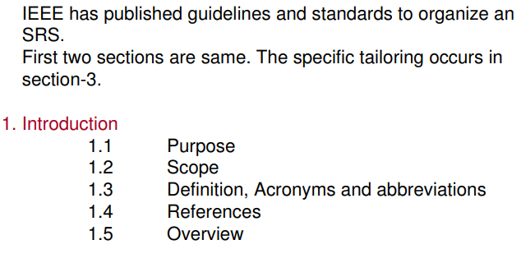

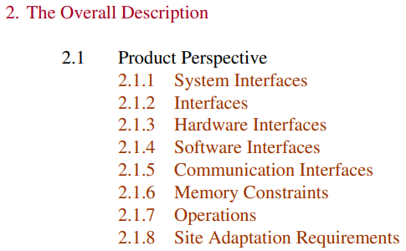

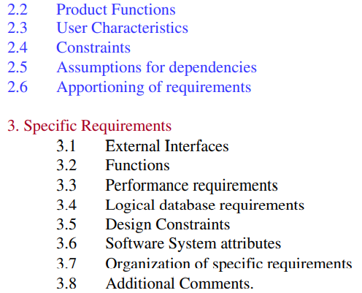

Q38. Requirements Validation

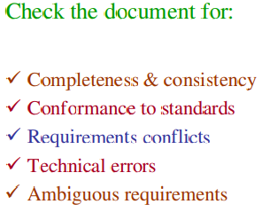

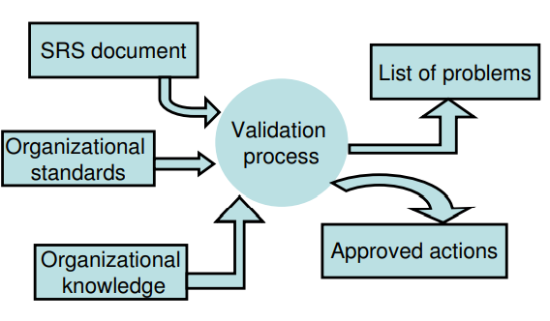

Q39. Requirements Review Process

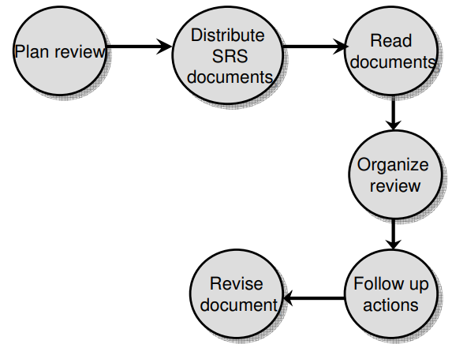

Q40. Review Checklists

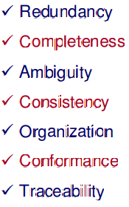

Q41. Requirements Management

Requirements Management is the process of handling and controlling requirements throughout the software development lifecycle. It ensures that all requirements are properly documented, tracked, and maintained, adapting to changes as needed. This process is crucial for project success and stakeholder satisfaction.

Key components of Requirements Management include:
- Requirements Identification: Clearly defining and documenting all requirements, including functional and non-functional aspects.
- Requirements Traceability: Maintaining a clear link between requirements and other project artifacts, such as design, implementation, and testing. This helps ensure that all requirements are addressed and facilitates impact analysis when changes occur.
- Change Control: Establishing a formal process for managing changes to requirements. This includes evaluating the impact of changes, obtaining necessary approvals, and updating documentation accordingly.
- Requirements Communication: Ensuring that all stakeholders, including developers, testers, and clients, understand the requirements and any changes made. Effective communication helps minimize misunderstandings and misalignments.
- Requirements Validation and Verification: Regularly reviewing requirements to ensure they are complete, accurate, and feasible. This involves validating requirements with stakeholders and verifying that the system meets these requirements during development and testing.
- Requirements Prioritization: Assessing and ranking requirements based on their importance and urgency, which helps in decision-making regarding resource allocation and scope management.
Software Engineering
Unit 2

Q1. Software Project Planning

After the finalization of SRS, we would like to estimate size, cost and development time of the project.

Software Project Planning is a crucial phase in the software development lifecycle that involves defining the scope, objectives, resources, schedule, and overall strategy for a software project.

In order to conduct a successful software project, we must understand:
- Scope of work to be done
- Software Project Planning
- The risk to be incurred
- The resources required
- The task to be accomplished
- The cost to be expended
- The schedule to be followed

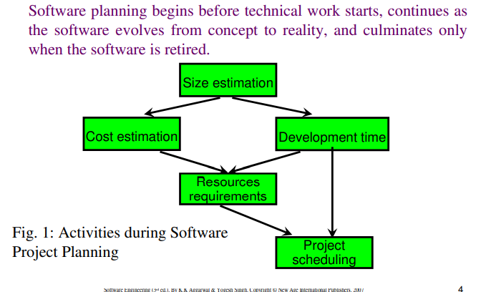
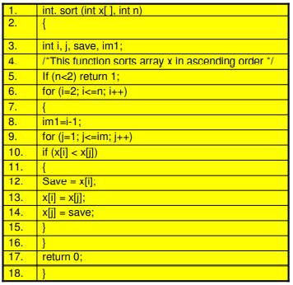
Q2. Size Estimate.

Size estimation in software engineering refers to the process of predicting the size of a software project, typically measured in terms of lines of code (LOC), function points (FP), or story points.

Q3. Lines of code.

if LOC is simply a count of the number of lines then figure shown below contains 17 LOC. Rn Comment

“A line of code is any line of program text that is not a comment or blank line, regardless of the number of statements or fragments of statements on the line. This specifically includes all lines containing program header, declaration, and executable and non-executable statements”.

Q4. Function Point Analysis

Alan Albrecht while working for IBM, recognized the problem in size measurement in the 1970s, and developed a technique (which he called Function Point Analysis), which appeared to be a solution to the size measurement problem.

The principle of Albrecht’s function point analysis (FPA) is that a system is decomposed into functional units.

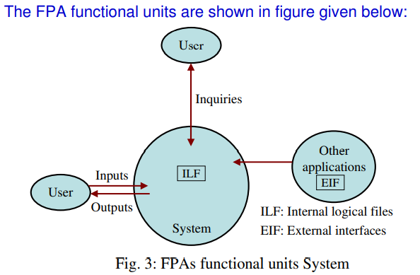

Function Point Analysis (FPA) measures software size using five functional units:

- External Inputs (EI): Data or control inputs that the system processes (e.g., login forms).
- External Outputs (EO): Processed data or reports provided to users (e.g., reports, invoices).
- External Inquiries (EQ): Data retrieval requests without altering data (e.g., search queries).
- Internal Logical Files (ILF): Internal data stored and maintained by the system (e.g., customer database).
- External Interface Files (EIF): External data files used but not maintained by the system (e.g., shared files).

Special features Software Project Planning

Function point approach is independent of the language, tools, or methodologies used for implementation; i.e. they do not take into consideration programming languages, data base management systems, processing hardware or any other data base technology.

Function points can be estimated from requirement specification or design specification, thus making it possible to estimate development efforts in early phases of development.

Function points are directly linked to the statement of requirements; any change of requirements can easily be followed by a re-estimate.

Software Project Planning Function points are based on the system user’s external view of the system, non-technical users of the software system have a better understanding of what function points are measuring.

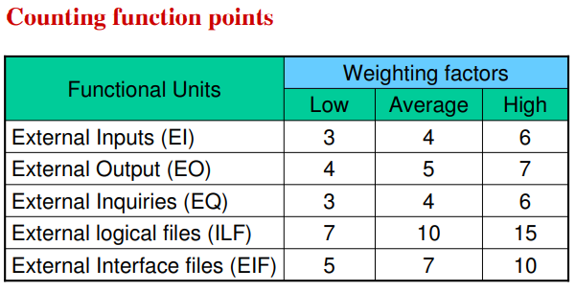

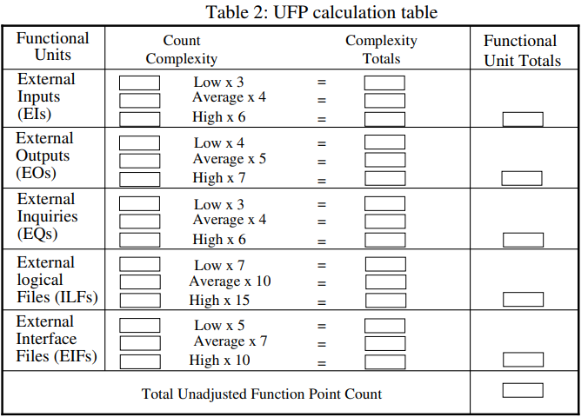
The weighting factors are identified for all functional units and multiplied with the functional units accordingly. The procedure for the calculation of Unadjusted Function Point (UFP) is given in table shown above.

Q5. Unadjusted Function Point
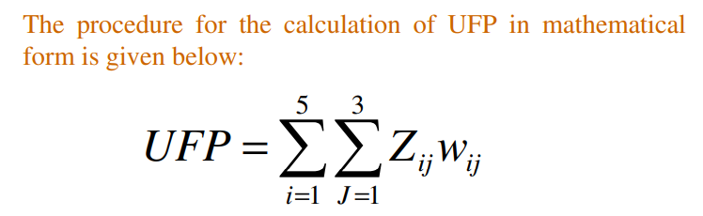

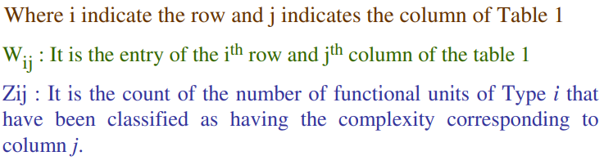
Q6 Complexity Adjustment Factor

CAF stands for Complexity Adjustment Factor, and it's used to adjust the Unadjusted Function Points (UFP) based on the complexity of the system. It's calculated as part of the Function Point Analysis (FPA) to reflect the overall influence of various system characteristics.

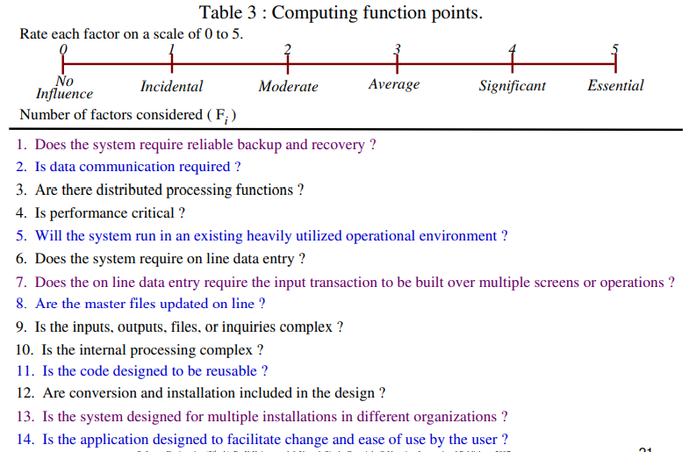
Q7. Consider a software project with the following parameters:
- External Inputs (EI):
  - 10 with low complexity
  - 15 with average complexity
  - 17 with high complexity
- External Outputs (EO):
  - 6 with low complexity
  - 13 with high complexity
- External Inquiries (EQ):
  - 3 with low complexity
  - 4 with average complexity
  - 2 with high complexity
- Internal Logical Files (ILF):
  - 2 with average complexity
  - 1 with high complexity
- External Interface Files (EIF):
  - 9 with low complexity
In addition, the system has the following complexity adjustment factors:
- Significant data communication is required.
- Performance is very critical.
- The code is designed to be moderately reusable.
- The system is not designed for multiple installations across different organizations.
All other complexity adjustment factors are treated as average.
Question: Compute the Function Points (FP) for this project.
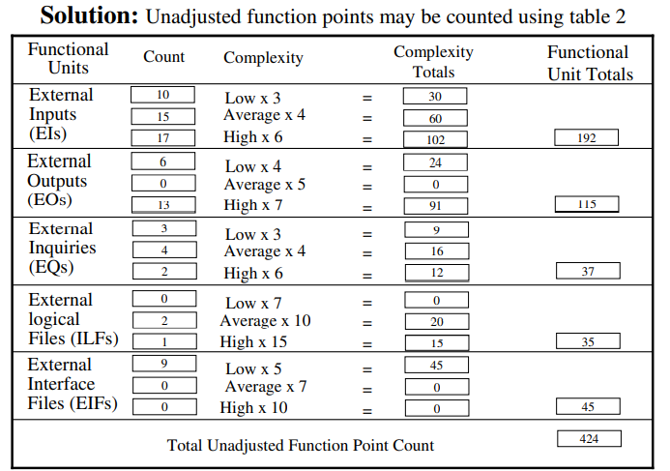

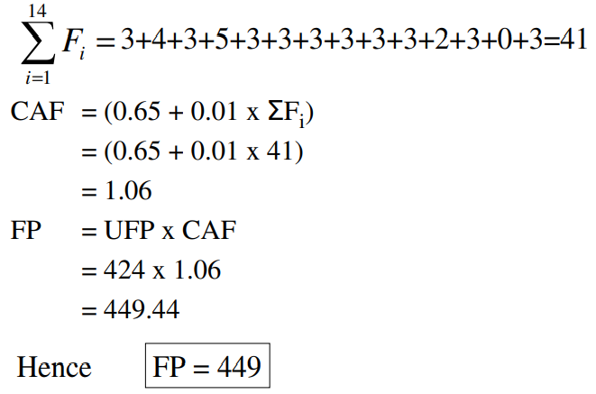

Q8. Cost Estimation
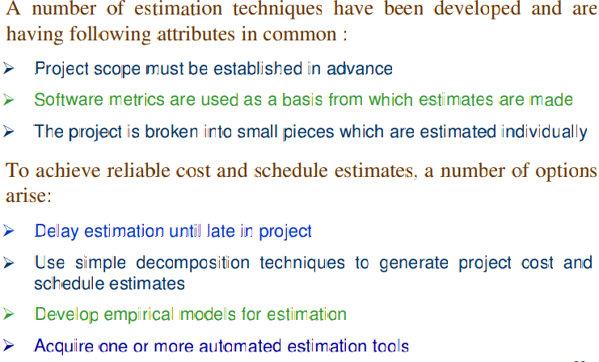
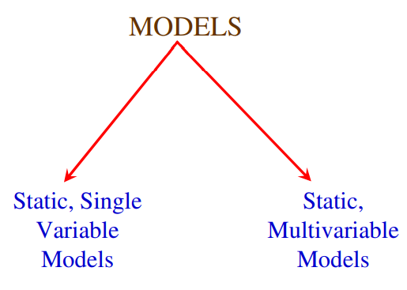

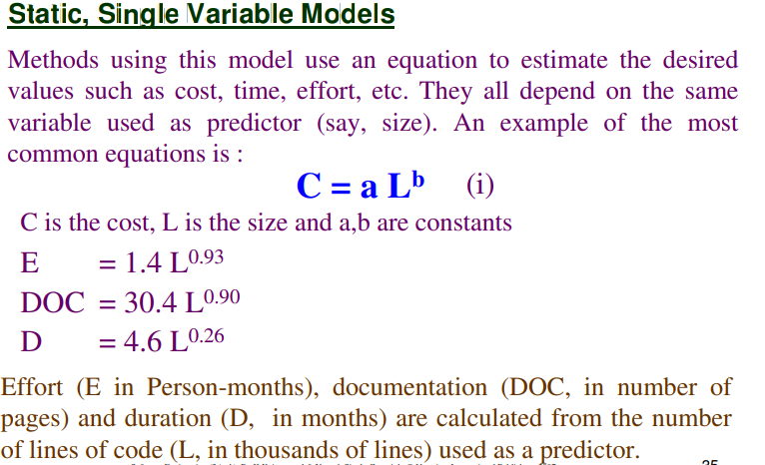
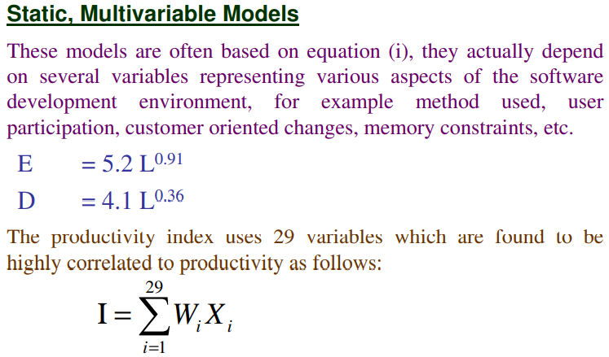

Q9. The Constructive Cost model (COCOMO)
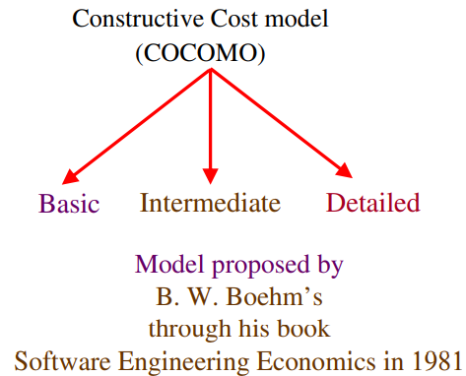

The Constructive Cost Model (COCOMO) is a popular cost estimation model used in software engineering to predict project costs based on the size of the software and various project characteristics. Developed by Barry Boehm in 1981, it uses mathematical formulas to estimate the effort, time, and cost required to complete a software project.

Types of COCOMO Models:
- Basic COCOMO: Provides a rough estimate of effort based on the size of the software in terms of Lines of Code (LOC). It is the simplest form of COCOMO and classifies projects into three categories:

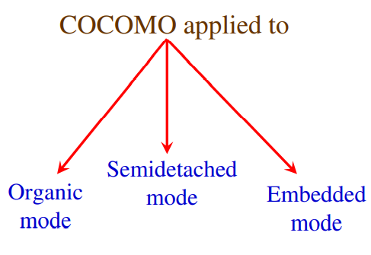

  - Organic: Small teams working on well-understood projects.
  - Semi-detached: Intermediate-sized projects with mixed teams and moderately complex requirements.
  - Embedded: Complex projects involving tight hardware or software constraints.

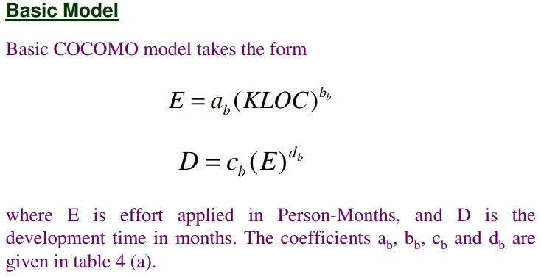

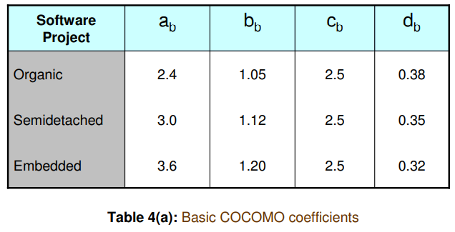

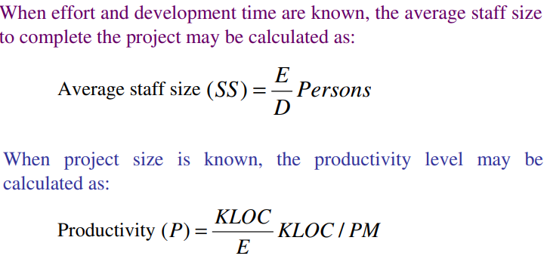

- Intermediate COCOMO: Includes additional factors called cost drivers, which adjust the basic estimate based on factors like product complexity, experience, and development tools. It provides a more accurate estimate than the Basic COCOMO.
Intermediate COCOMO cost drivers:

1. Product Attributes
- Required Software Reliability (RELY)
- Database Size (DATA)
- Product Complexity (CPLX)

2. Hardware Attributes
- Execution Time Constraint (TIME)
- Main Storage Constraint (STOR)
- Virtual Machine Volatility (VIRT)
- Computer Turnaround Time (TURN)

3. Personnel Attributes
- Analyst Capability (ACAP)
- Programmer Capability (PCAP)
- Personnel Continuity (PCON)
- Application Experience (AEXP)
- Programming Language Experience (LEXP)

4. Project Attributes
- Use of Modern Programming Practices (MODP)
- Use of Software Tools (TOOL)
- Required Development Schedule (SCED)

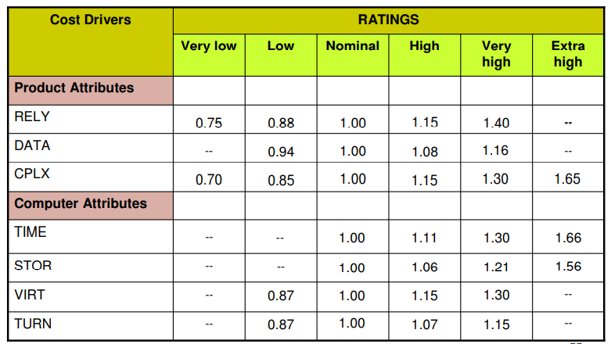
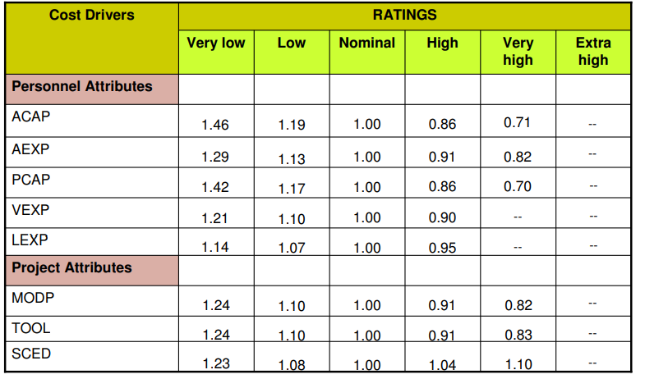
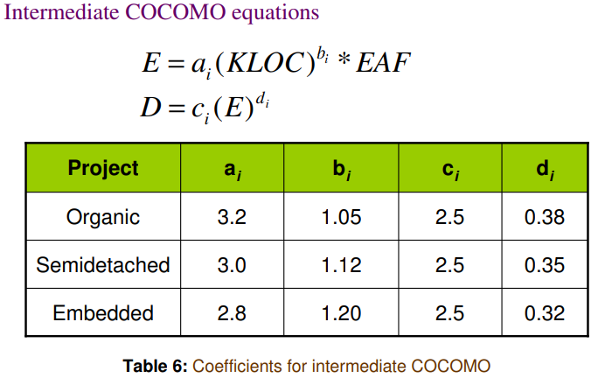

- Detailed COCOMO: Adds further refinement by breaking the project into smaller components and calculating costs for each component individually. It provides the most detailed and accurate estimates.
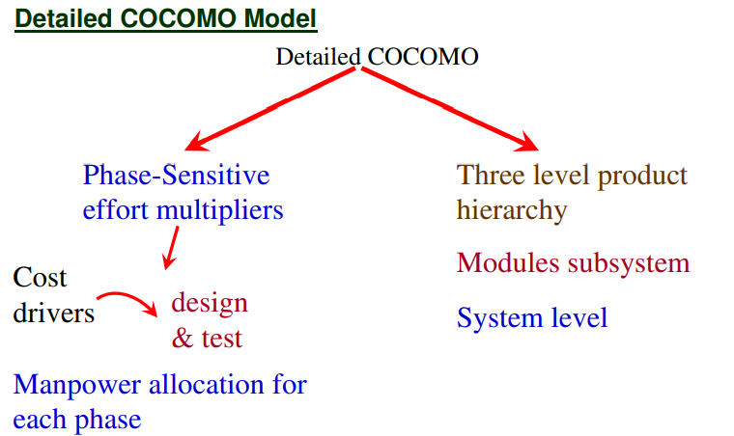

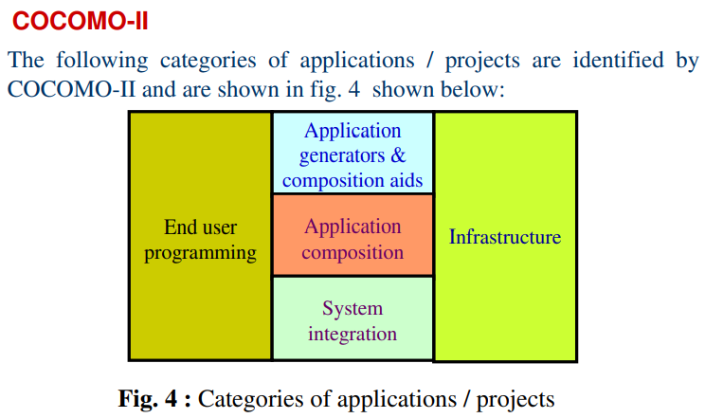

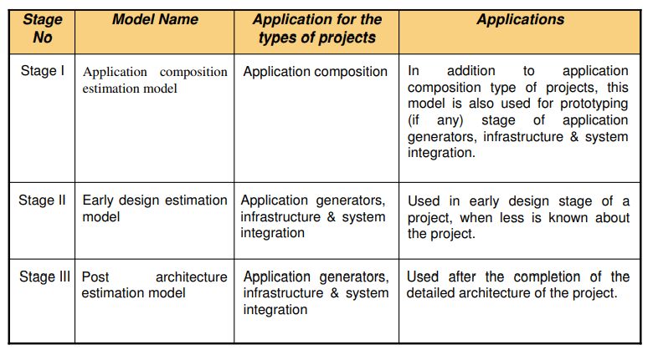
Q10. ACEM

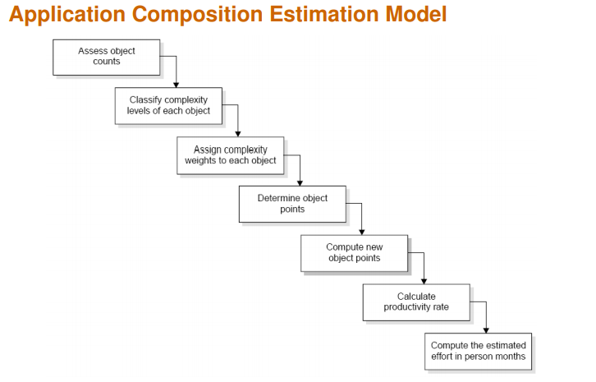

Q11. Putnam Resource Allocation Model

The Putnam Resource Allocation Model, also known as the Putnam Model or SLIM (Software Life Cycle Management), is a software cost estimation model developed by Lawrence H. Putnam in the 1970s. It focuses on the relationship between the effort, time, and productivity of software development projects. The model is based on the idea that software development follows a predictable curve, where the allocation of resources over time significantly influences project success.

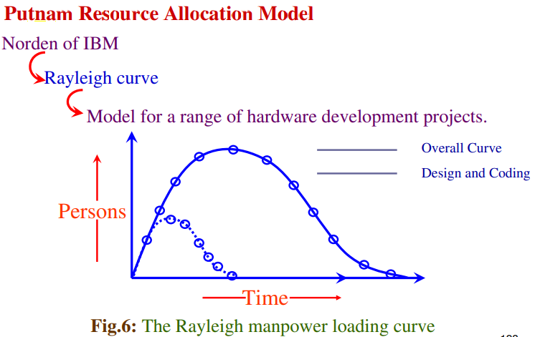

Resource Allocation: The model emphasizes the importance of efficiently allocating resources (i.e., personnel) over the project's lifecycle. It recognizes that the timing and amount of resources directly affect project duration and quality.
- Effort and Time: The model establishes a relationship between the total effort (in person-months) and the development time (in months). As development time increases, the effort required decreases and vice versa.
- Productivity: Productivity is defined as the amount of software produced per unit of effort. The Putnam Model uses the concept of "productivity curves," which illustrate how productivity changes over time based on resource allocation.
- Quality vs. Time: The model suggests that higher quality can be achieved by extending development time and adequately allocating resources, allowing for more thorough testing and refinement.
- Cumulative Distribution Function: The model uses a cumulative distribution function to estimate the probability of meeting specific project deadlines based on resource allocation and effort.

Advantages:
- Provides a systematic approach to resource allocation and effort estimation.
- Considers the impact of time and resources on productivity and quality.
- Useful for planning and managing large software projects.

Disadvantages:
- Requires accurate input data, which can be challenging to obtain.
- May not account for all real-world complexities of software development.
- Assumes a predictable development process, which may not always hold true.
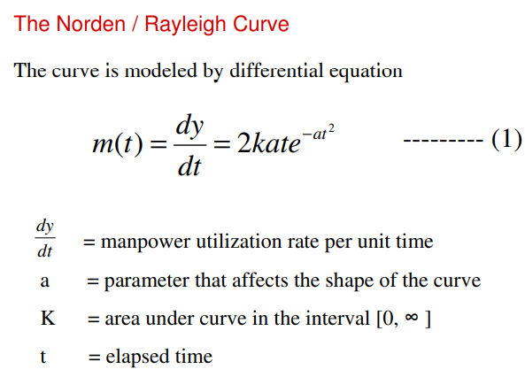

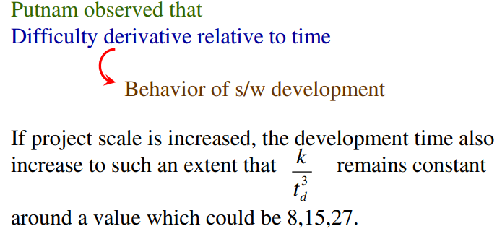

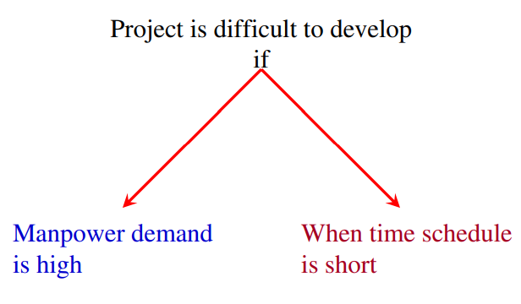

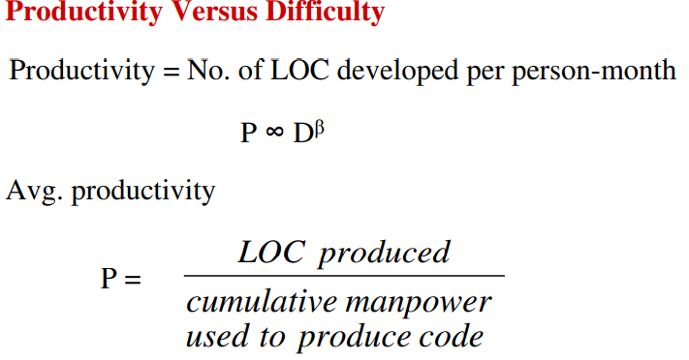

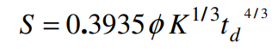

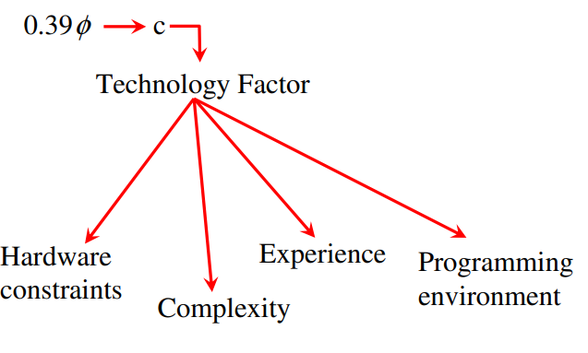

Q12. Development Cycle

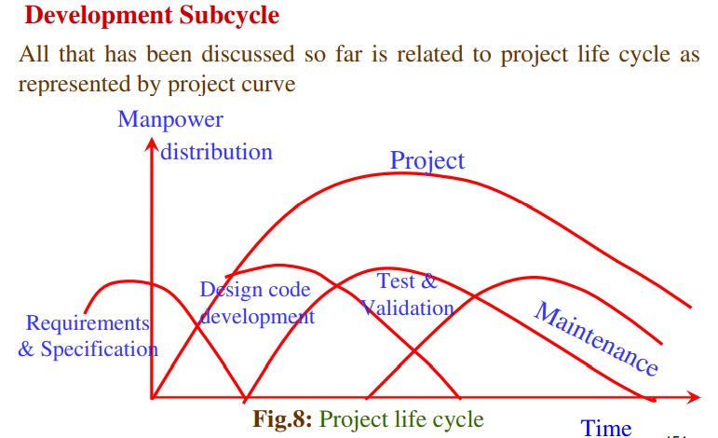

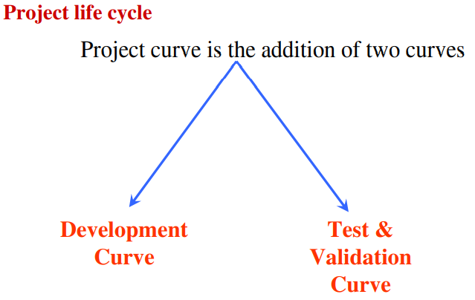

Q13. Risk Management

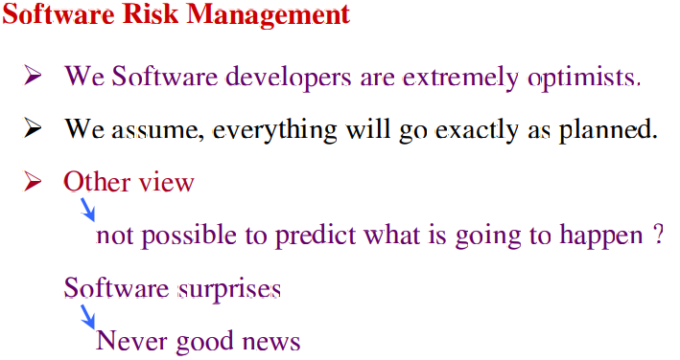

Risk management is required to reduce this surprise factor

Dealing with concern before it becomes a crisis.

Quantify probability of failure & consequences of failure.

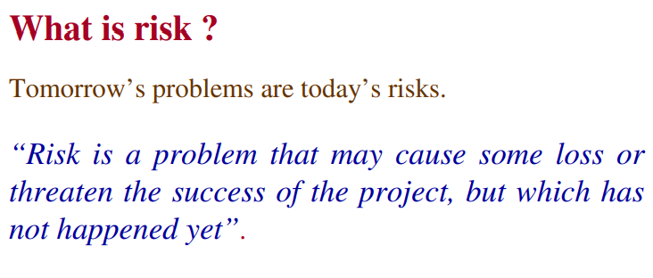

Risk management is the process of identifying addressing and eliminating these problems before they can damage the project

Q14. Typical Software Risk

Capers Jones has identified the top five risk factors that threaten projects in different applications.

1. Dependencies on outside agencies or factors.

• Availability of trained, experienced persons • Inter group dependencies • Customer-Furnished items or information • Internal & external subcontractor relationships

2. Requirement issues

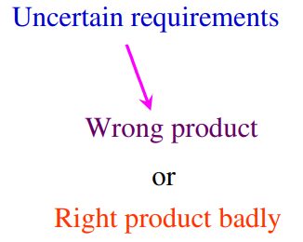

• Lack of clear product vision • Unprioritized requirements • Lack of agreement on product requirements • New market with uncertain needs • Rapidly changing requirements • Inadequate Impact analysis of requirements changes

3. Management Issues

Project managers usually write the risk management plans, and most people do not wish to air their weaknesses in public.

• Inadequate planning • Inadequate visibility into actual project status • Unclear project ownership and decision making • Staff personality conflicts • Unrealistic expectation • Poor communication

4. Lack of knowledge

• Inadequate training • Poor understanding of methods, tools, and techniques • Inadequate application domain experience • New Technologies • Ineffective, poorly documented or neglected processes

5. Other risk categories

• Unavailability of adequate testing facilities • Turnover of essential personnel • Unachievable performance requirements • Technical approaches that may not work

Q15. Risk Management Activities

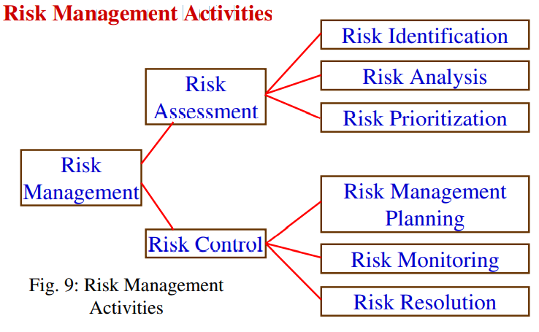

Risk Assessment
- Risk Identification: Systematically identifying potential risks that could impact the project.
- Risk Analysis: Examining how changes in risk input variables might affect project outcomes.
- Risk Prioritization: Focusing on identifying and addressing severe risks based on their impact and likelihood.

Risk Controlling
- Risk Management Planning: Developing a comprehensive plan to manage each significant risk identified.
- Risk Monitoring: Continuously tracking identified risks and assessing their status throughout the project lifecycle.
- Risk Resolution: Implementing the planned strategies to effectively manage and mitigate each identified risk.

Q16. Software Design Document (SDD)

A Software Design Document (SDD) is a comprehensive document that outlines the design of a software system. It serves as a blueprint for the development team and stakeholders, detailing how the system will be constructed to meet specified requirements
The SDD serves multiple purposes:
- Provides a clear understanding of how the system will be built and how it will function.
- Facilitates communication among stakeholders, including developers, project managers, and clients.
- Acts as a reference throughout the software development lifecycle, ensuring alignment with design goals and requirements.
Q17. Design Framework

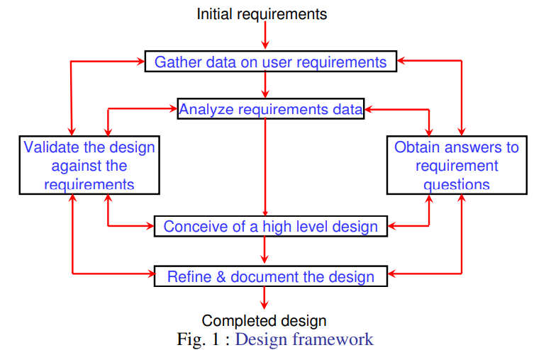
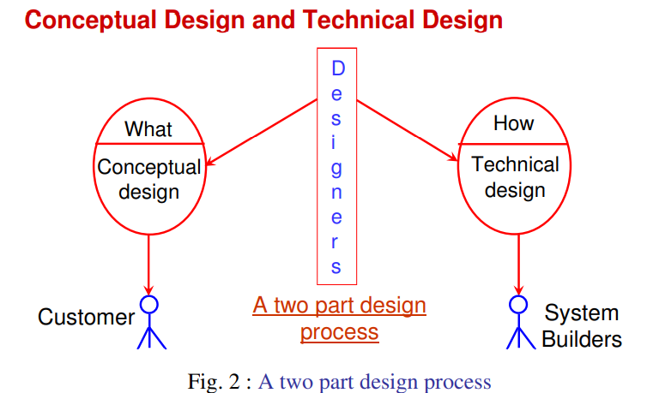

The design needs to be

Correct & complete
Understandable
At the right level
Maintainable

Q18. Modularity

A modular system consist of well defined manageable units with well defined interfaces among the units

Properties :
i. Well defined subsystem
ii. Well defined purpose
iii. Can be separately compiled and stored in a library.
iv. Module can use other modules
v. Module should be easier to use than to build
vi. Simpler from outside than from the inside.

Modularity is the single attribute of software that allows a program to be intellectually manageable. It enhances design clarity, which in turn eases implementation, debugging, testing, documenting, and maintenance of software product.

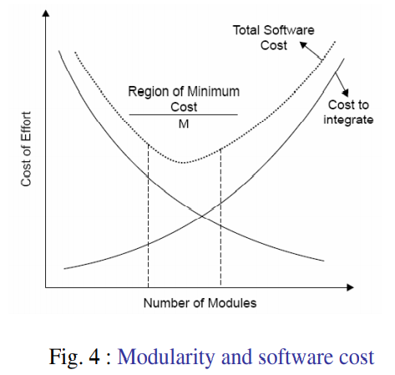

Q19 Module Coupling

Coupling is the measure of the degree of interdependence between modules.
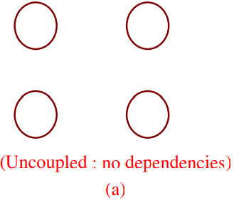
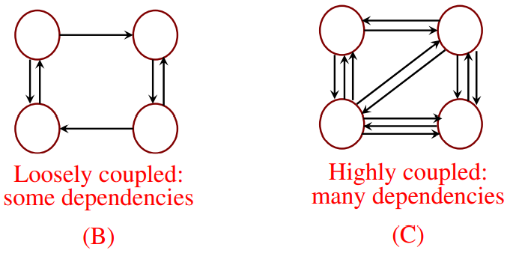

This can be achieved as: Controlling the number of parameters passed amongst modules. Avoid passing undesired data to calling module. Maintain parent / child relationship between calling & called modules. Pass data, not the control information.

Q20. Types of Coupling:

Consider the example of editing a student record in a ‘student information system’.

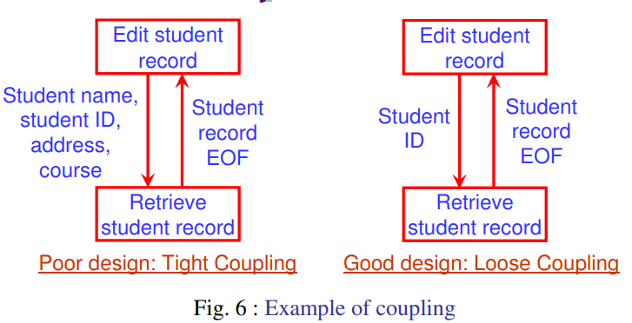

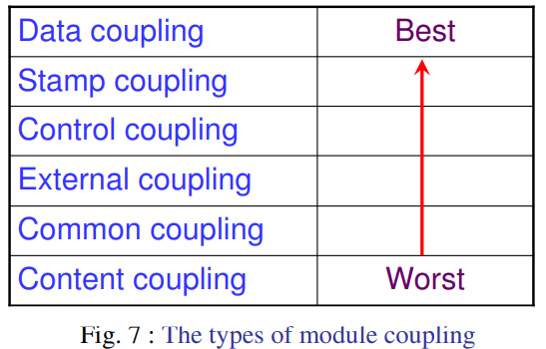

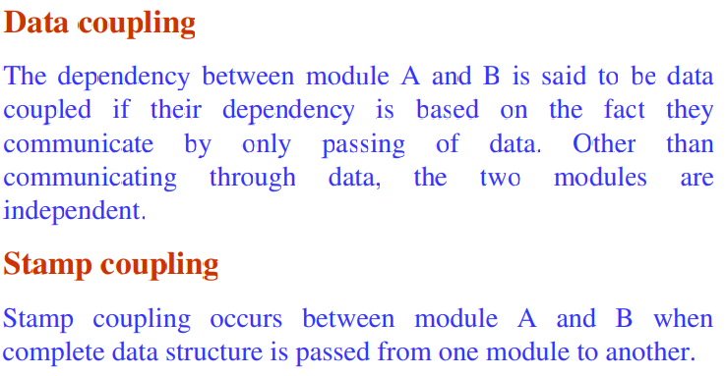

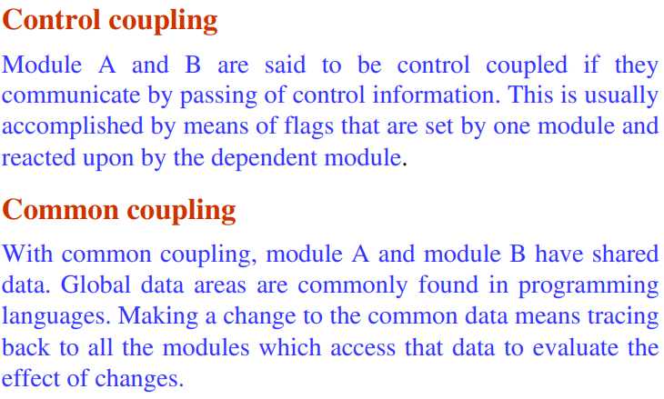
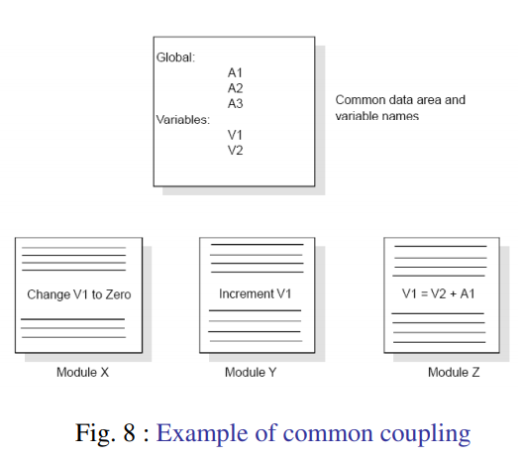

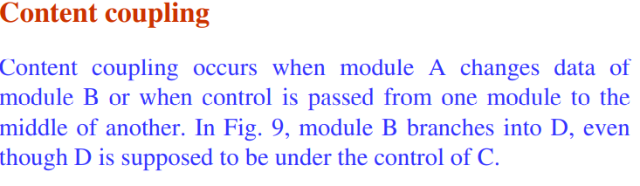

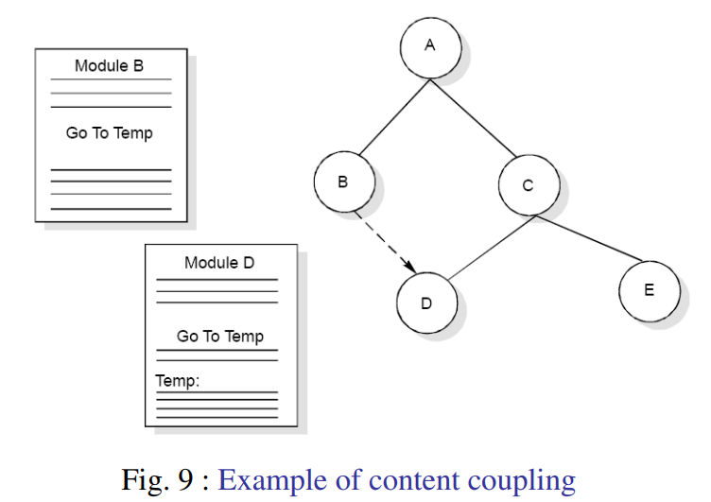

Q21 Module Cohesion

Cohesion is a measure of the degree to which the elements of a module are functionally related.

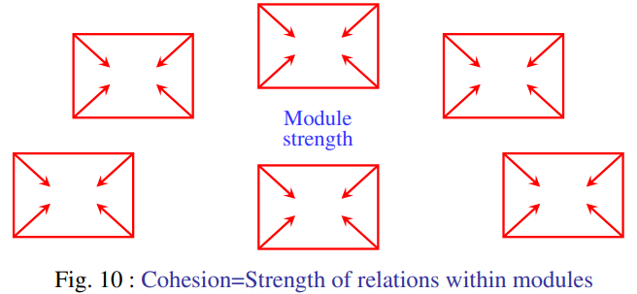

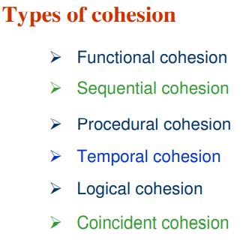

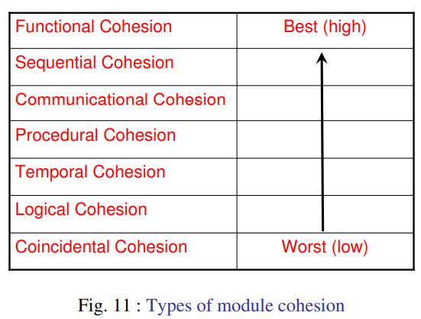

Functional Cohesion
A and B are part of a single functional task. This is very good reason for them to be contained in the same procedure.

Sequential Cohesion
Module A outputs some data which forms the input to B. This is the reason for them to be contained in the same procedure.

Procedural Cohesion
Procedural Cohesion occurs in modules whose instructions although accomplish different tasks yet have been combined because there is a specific order in which the tasks are to be completed.

Temporal Cohesion
Module exhibits temporal cohesion when it contains tasks that are related by the fact that all tasks must be executed in the same time-span.

Logical Cohesion
Logical cohesion occurs in modules that contain instructions that appear to be related because they fall into the same logical class of functions.

Coincidental Cohesion
Coincidental cohesion exists in modules that contain instructions that have little or no relationship to one another.

Q22. Relationship between Cohesion & Coupling

If the software is not properly modularized, a host of seemingly trivial enhancement or changes will result into death of the project. Therefore, a software engineer must design the modules with goal of high cohesion and low coupling
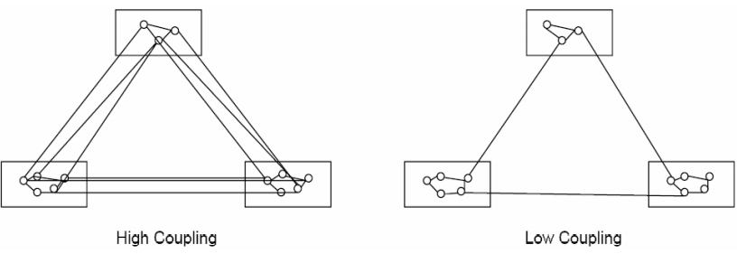
Q23. STRATEGY OF DESIGN

A good system design strategy is to organize the program modules in such a way that are easy to develop and latter to, change. Structured design techniques help developers to deal with the size and complexity of programs. Analysts create instructions for the developers about how code should be written and how pieces of code should fit together to form a program. It is important for two reasons:

First, even pre-existing code, if any, needs to be understood, organized and pieced together.

Second, it is still common for the project team to have to write some code and produce original programs that support the application logic of the system.

Q24. Bottom-Up Design:

Bottom-up tree structure These modules are collected together in the form of a “library”.

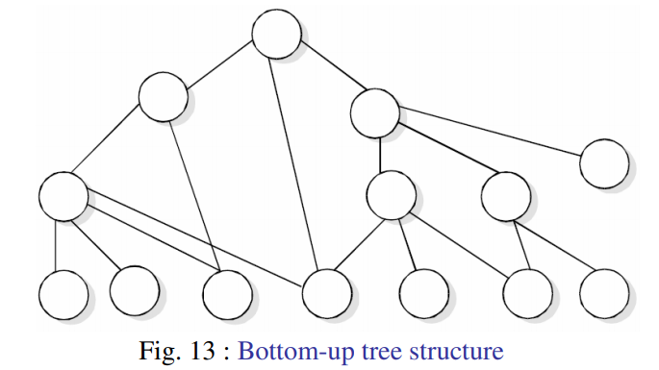
Bottom-up design is a software design approach where individual modules or components are developed first, starting from the lower-level functionalities. These small, independent modules are created, tested, and combined to form more complex systems, building up towards the higher-level system requirements.

Q25. Top-Down Design

A top down design approach starts by identifying the major modules of the system, decomposing them into their lower level modules and iterating until the desired level of detail is achieved. This is stepwise refinement; starting from an abstract design, in each step the design is refined to a more concrete level, until we reach a level where no more refinement is needed and the design can be implemented directly.

Q26. Hybrid Design

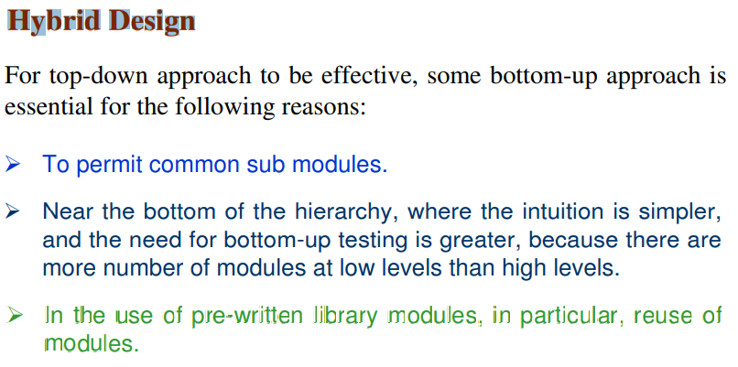

Q27. FUNCTION ORIENTED DESIGN

Function Oriented design is an approach to software design where the design is decomposed into a set of interacting units where each unit has a clearly defined function. Thus, system is designed from a functional viewpoint.

Function-oriented design is a software design approach that focuses on decomposing the system into a set of functions or procedures. These functions represent specific tasks or operations that the system performs, often derived from the system's requirements. Key characteristics include:

Q28. Design Notations

Design notations are largely meant to be used during the process of design and are used to represent design or design decisions. For a function oriented design, the design can be represented graphically or mathematically by the following:

- Data flow diagrams
- Data Dictionaries
- Structure Charts
- Pseudocode
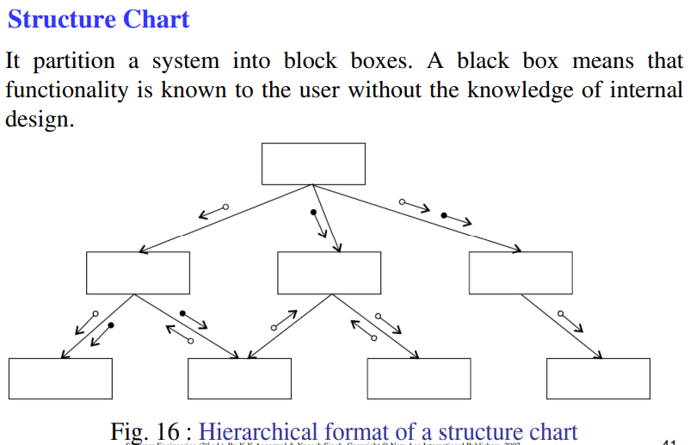

Pseudocode

Pseudocode notation can be used in both the preliminary and detailed design phases. Using pseudocode, the designer describes system characteristics using short, concise, English language phrases that are structured by key words such as It-Then-Else, While-Do, and End.

Q29. Functional Procedure Layers

Function are built in layers, Additional notation is used to specify details.

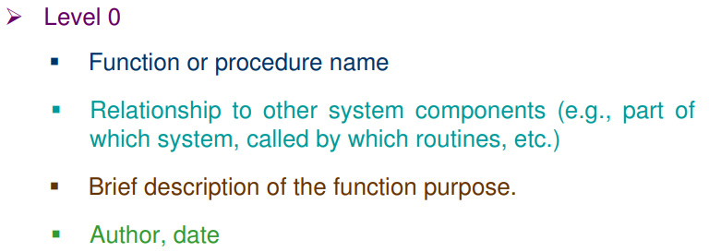
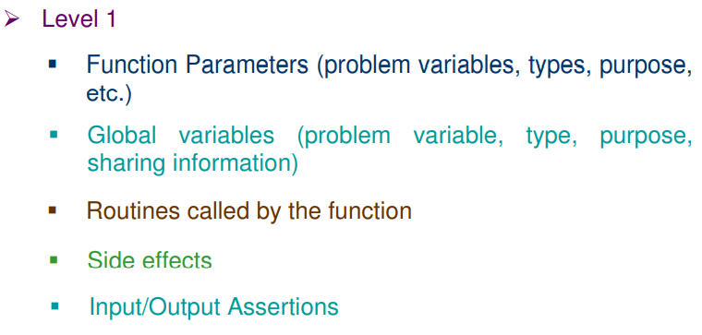
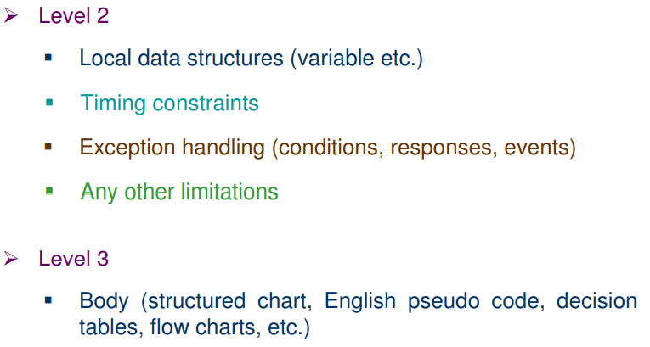

Q30. IEEE Recommended practice for software design descriptions (IEEE STD 1016-1998)

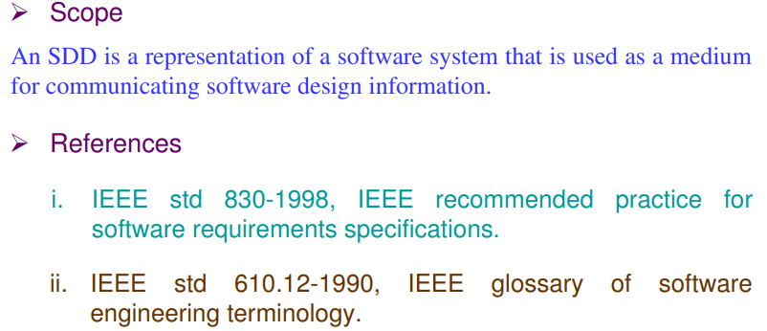
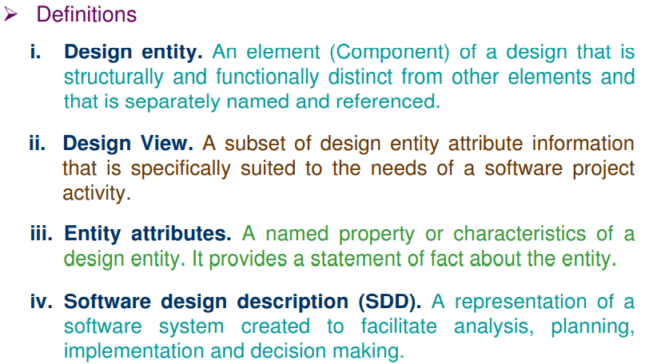
Q31. Design Description Organization

Each design description writer may have a different view of what are considered the essential aspects of a software design. The organization of SDD is given in table 1. This is one of the possible ways to organize and format the SDD. Software Design Design Description Organization
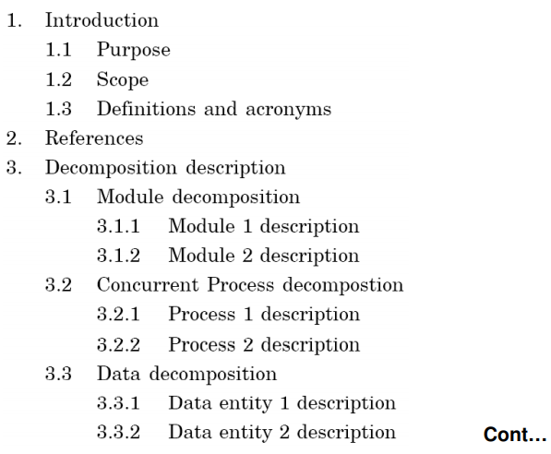
A recommended organization of the SDD into separate design views to facilitate information access and assimilation is given in table

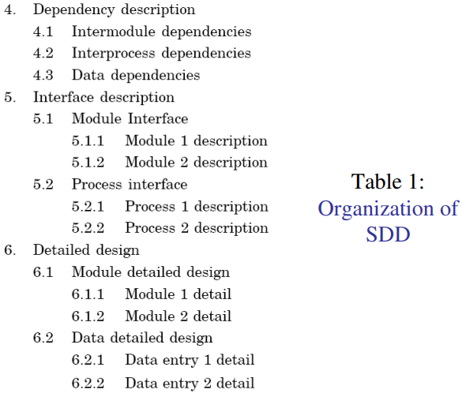

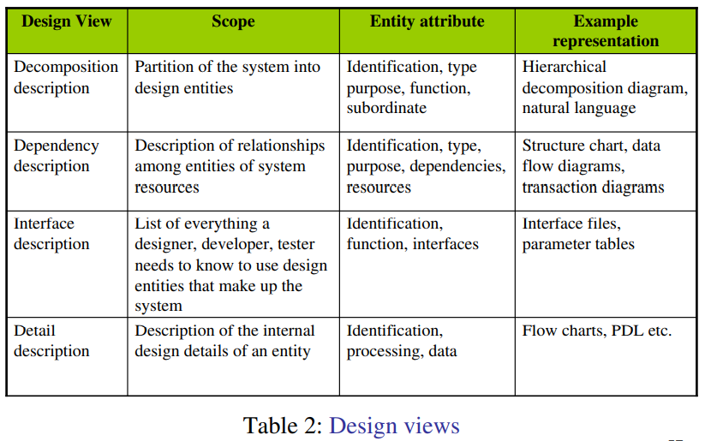
Q31. Object Oriented Design

Object oriented design is the result of focusing attention not on the function performed by the program, but instead on the data that are to do manipulated by the program. Thus, it is orthogonal to function oriented design.

Object Oriented Design begins with an examination of the real world “things” that are part of the problem to be solved. These things (which we will call objects) are characterized individually in terms of their attributes and behavior.

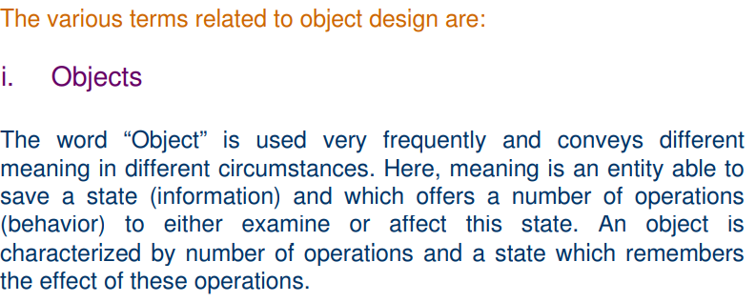
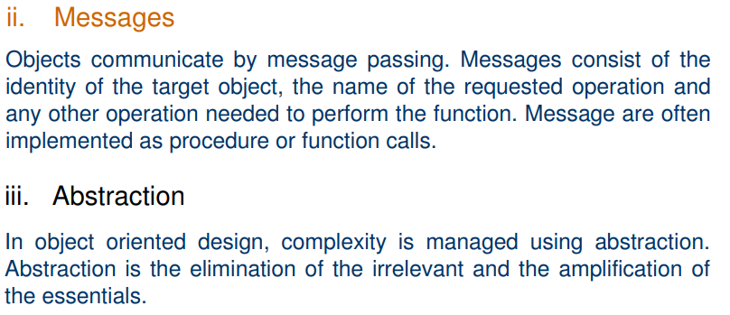
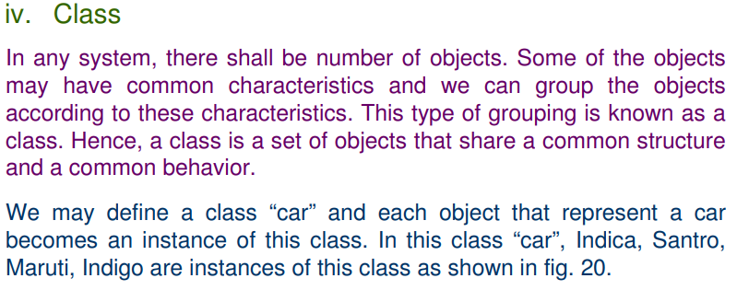
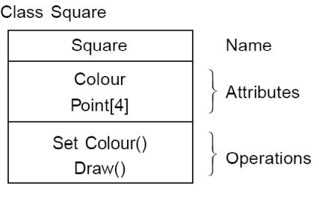

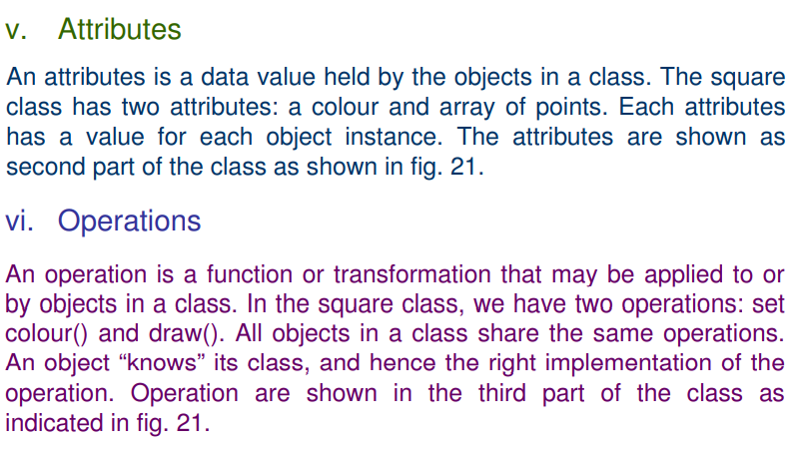
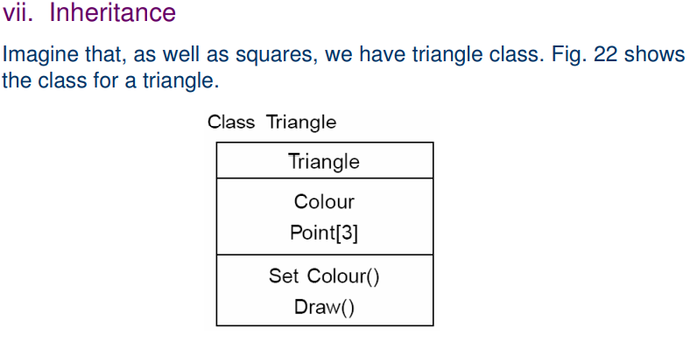
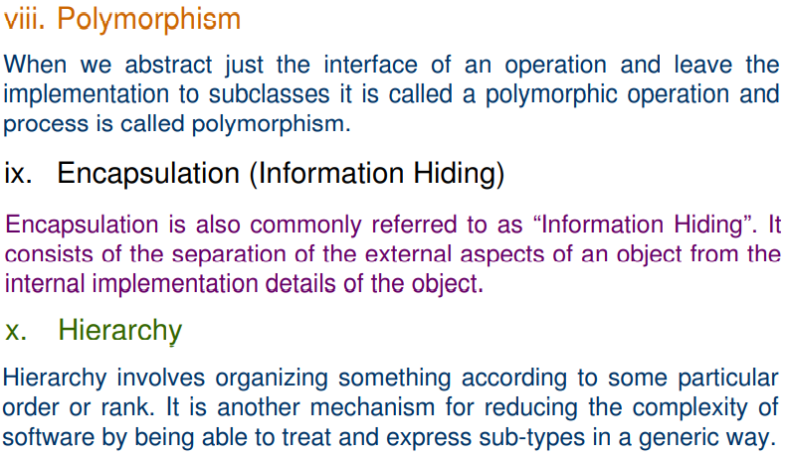

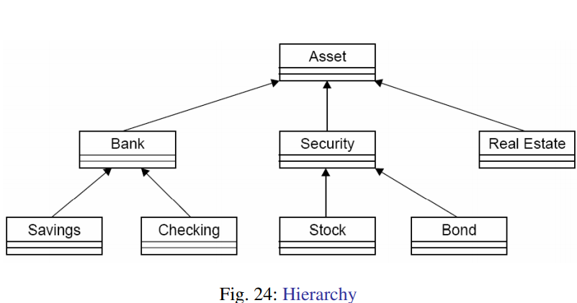

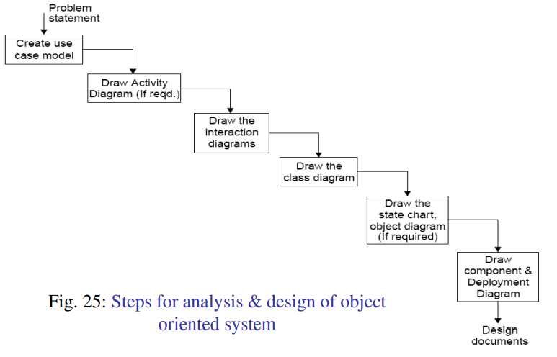

Q32. User Interface Design

The user interface is the front-end application view to which the user interacts to use the software. The software becomes more popular if its user interface is:
- Attractive
- Simple to use
- Responsive in a short time
- Clear to understand
- Consistent on all interface screens

Types of User Interface
- Command Line Interface: The Command Line Interface provides a command prompt, where the user types the command and feeds it to the system. The user needs to remember the syntax of the command and its use.
- Graphical User Interface: Graphical User Interface provides a simple interactive interface to interact with the system. GUI can be a combination of both hardware and software. Using GUI, the user interprets the software.

PYQ:

Q1. Discuss the need and importance of SRS.

The Software Requirements Specification (SRS) is essential because it clearly defines the software’s functionality, constraints, and interfaces, ensuring alignment between stakeholders and developers. It helps prevent misunderstandings, serves as a reference throughout development, aids in testing, and improves project management and quality control.

Q4 Compare Facilitated application specification technique with brainstorming sessions. (Tabular)

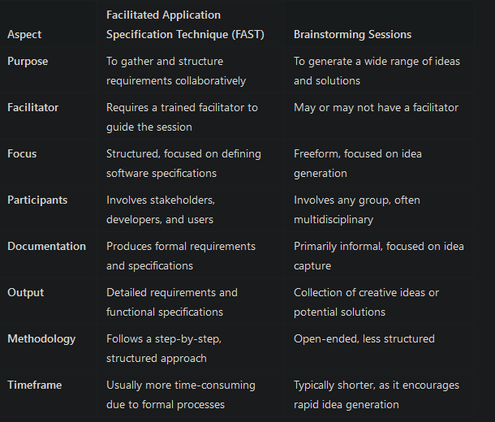

Q5. What are size metrics? How FP mertic is advantageous over LOC metric?

Size Metrics: These are measures used to estimate or assess the size of a software system. Common size metrics include Lines of Code (LOC) and Function Points (FP). They help in project estimation, cost analysis, and productivity assessment.
FP vs. LOC:
- FP Metric: Measures software size based on functionality, considering inputs, outputs, user interactions, and files.
- Advantages over LOC:
  - Language-independent, making it suitable for comparing systems in different languages.
  - Focuses on user requirements, not just code length.
  - More accurate for effort estimation in early stages of developmen

Q6. Data Structure Matrices:
Data structure matrices are used to represent relationships between data entities in a structured format, typically in a tabular form. They help visualize connections and dependencies between data components, aiding in understanding data flow and organization within a system.
Q7. Software Prototyping:
Software prototyping is the process of creating a preliminary version (prototype) of a software application to visualize and validate requirements. Prototypes can be low-fidelity (paper sketches) or high-fidelity (interactive models). This approach helps gather user feedback, refine requirements, and reduce risks before full-scale development.
Q8. Time vs. Cost Trade-off in Putnam Resource Allocation Model:
The Putnam model suggests that there is a trade-off between time and cost in software development. If a project is expedited (shortened time), it typically requires more resources (higher costs) to maintain quality and meet deadlines. Conversely, extending the timeline can reduce costs but may increase project risks and complexity. The optimal allocation seeks to balance resource usage and project deadlines for efficiency.

Q9. Write the name phase of software cycle for which IEEE recommended standard IEEE 830-1993 is used.

The IEEE recommended standard IEEE 830-1993 is used in the Requirements Specification phase of the software development lifecycle. It provides guidelines for writing software requirements specifications (SRS), ensuring clarity, consistency, and completeness in documenting requirements.

Q10. Write the full form of FAST and QFD techniques.

- FAST: Facilitated Application Specification Technique
- QFD: Quality Function Deployment

Q11. Explain the Walston-Felix model.

The Walston-Felix model is a software metrics model designed to predict software development effort based on the size of the software and its complexity. It provides a mathematical approach to estimate the resources required for software projects. The model is particularly focused on the relationship between lines of code (LOC) and effort in software development.

Key Aspects of the Walston-Felix Model:
- Effort Estimation: The model estimates the effort required (usually in person-hours) to develop a software project based on its size measured in LOC.
- Mathematical Formula: The basic formula used in the Walston-Felix model is:
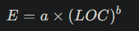

  - E: Estimated effort (in person-hours)
  - a: A constant that represents the productivity of the development team
  - LOC: The size of the software in lines of code
  - b: An exponent that represents the non-linear relationship between size and effort (typically greater than 1).

Q12. What is Risk Exposure? What technique is used to control each risk?

Risk Exposure refers to the potential impact or consequences of a risk on a project, typically quantified as the product of the probability of the risk occurring and the potential loss or damage it could cause. It helps prioritize risks based on their significance to the project's success, enabling project managers to allocate resources effectively for risk management.
The formula for Risk Exposure is:

Techniques to Control Risks:
- Avoidance: Altering the project plan to eliminate the risk or protect the project objectives from its impact. For example, choosing a different technology that poses fewer risks.
- Mitigation: Implementing actions to reduce the likelihood or impact of the risk. This could include additional testing, improved training, or enhancing system security.
- Transfer: Shifting the risk to a third party, such as through insurance or outsourcing. This technique is often used to manage financial risks.
- Acceptance: Acknowledging the risk and deciding to proceed without specific action, typically when the risk is minor or the cost of mitigation exceeds the potential impact. This may involve creating contingency plans to manage the consequences if the risk occurs.
- Contingency Planning: Developing backup plans to address risks that are accepted or unavoidable. This ensures that if the risk occurs, there are predefined steps to minimize its impact.

Software Engineering | Unit – 3

Q1. Define Software Metrics?

Software metrics can be defined as “The continuous application of measurement based techniques to the software development process and its products to supply meaningful and timely management information, together with the use of those techniques to improve that process and its product”.

Q2. Why do we need software metrics?
Software metrics help answer critical questions like measuring software size, estimating development costs, predicting bugs, determining testing timelines, assessing module complexity, strength, coupling, reliability, test technique effectiveness, and evaluating the strength of programs and test suites.

Q3. Area of application of software metrics?

The most established area of software metrics is cost and size estimation techniques.
The prediction of quality levels for software, often in terms of reliability, is another area where software metrics have an important role to play.
The use of software metrics to provide quantitative checks on software design is also a well established area.

Q4. What are the categories of metrics?
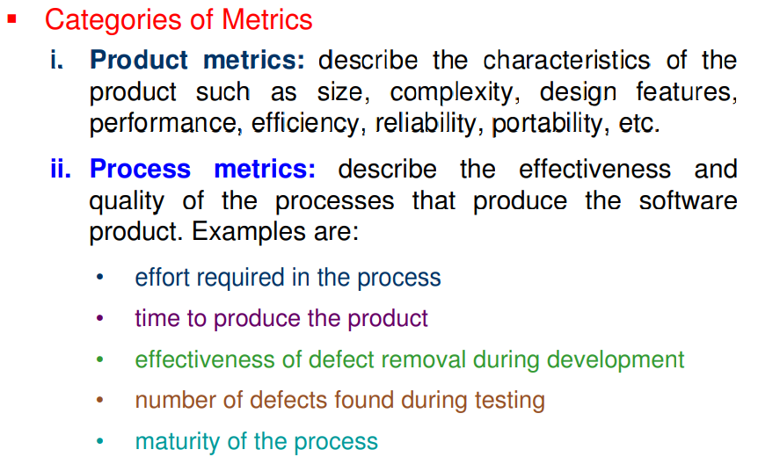

Q5. What are token count?

The size of the vocabulary of a program, which consists of the number of unique tokens used to build a program is defined as:
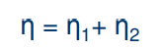

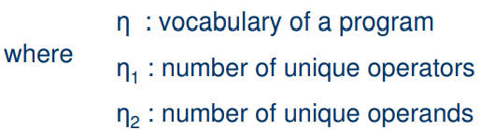

The length of the program in the terms of the total number of tokens used is:
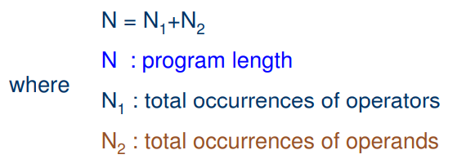

Q6. What is Halstead Software Metric Science?

Halstead Software Metric Science, introduced by Maurice Halstead in 1977, measures software code complexity, effort, and maintainability. It treats software as a collection of tokens (operators and operands) and applies mathematical formulas to quantify various program attributes.

Key Concepts:
- Operators: Symbols or keywords that perform actions (e.g., +, if, return).
- Operands: Variables, constants, or data being manipulated.

Core Metrics:
- Program vocabulary (n): Total unique operators (n1) and operands (n2):
n = n1 + n2
- Program length (N): Total occurrences of operators (N1) and operands (N2):
N = N1 + N2
- Volume (V): Size of the implementation in terms of information:
V = N * log2(n)
- Difficulty (D): Complexity of the program:
D = (n1 / 2) * (N2 / n2)
- Effort (E): Effort required to develop or understand the code:
E = D * V
- Time to implement (T): Approximation of development time:
T = E / 18
- Bugs (B): Estimated number of defects in the program:
B = V / 3000

Significance:
Halstead metrics provide a quantitative way to evaluate code readability, maintainability, and complexity. They are useful for predicting effort, identifying complex modules, and improving software quality.

Q7. What is the volume metric of the program?

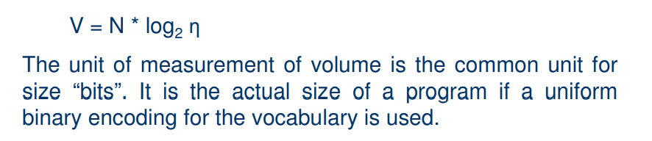
Q8. What is Program Level, Program Difficulty, Effort?
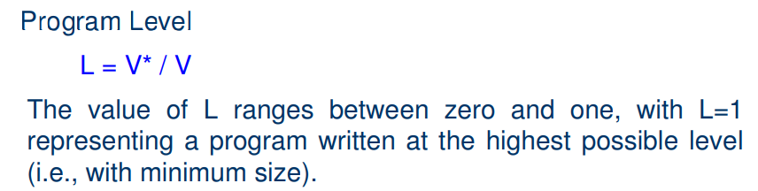
V∗=(n1​+n2​)⋅log2​(n) (ideal volume)
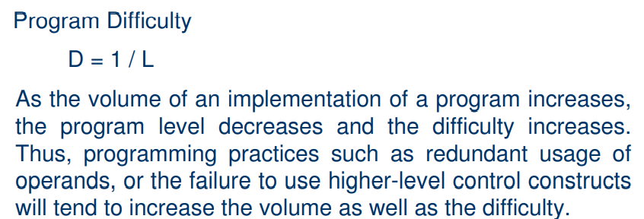
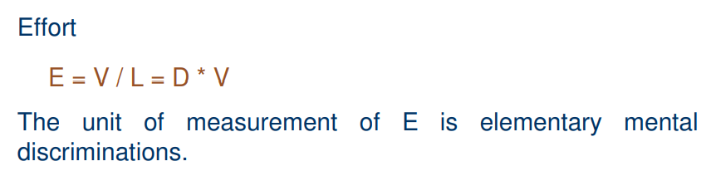

Q9. What are the rules for counting in C language?

The rules for counting tokens in the C language, based on Halstead's software metrics, can be summarized as follows:
- Comments: Comments are not counted as they do not contribute to the program's operational complexity.
- Identifiers and function declarations: These are not counted as operands in the metric. Only variables and constants are considered operands.
- Variables and constants: Both are considered operands.
- Global variables: When used across multiple modules of the same program, global variables are counted as multiple occurrences of the same operand.
- Local variables: Local variables with the same name in different functions are considered unique operands.
- Function calls: Function calls are considered operators, as they represent actions or operations.
- Control and looping statements:
  - All control statements like if, else, switch, case, etc., and looping statements like for, while, and do-while are counted as operators.
- Switch statement: The switch and all case statements are considered operators.
- Brackets, commas, and terminators: These symbols (e.g., (), {}, [], ,, and ;) are considered operators.
- GOTO statement: The GOTO is counted as an operator, and the label is counted as an operand.
- Unary and binary operators:
  - The unary and binary occurrences of operators like +, -, and * are treated separately.
- Array variables:
  - In expressions like array-name[index], array-name and index are considered operands, while the [] is counted as an operator.
- Structure variables:
  - In expressions like struct-name.member-name or struct-name->member-name, the struct-name and member-name are operands, while . and -> are considered operators.
- Preprocessor directives: All preprocessor directives (e.g., #define, #include) are ignored in the token count.
Q10. What is the Estimate Program Length?
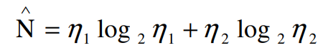

Q11. Write all the variated Metrics of Halstead?
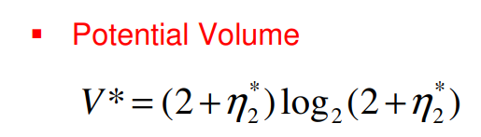

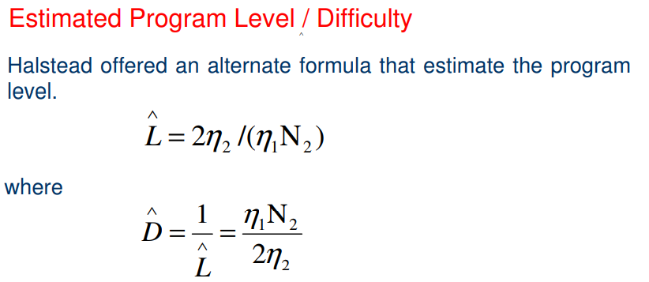

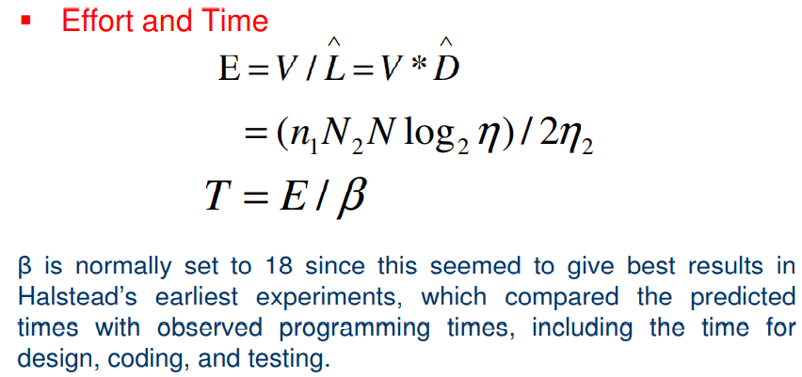

Q12. What is Language Level?

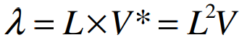

Components:
- L is the language level (as previously defined).
- V is the actual program volume (total number of operators and operands).
- V* is the ideal program volume (based on unique operators and operands).
- The formula essentially multiplies the program level (L) by the ideal volume (V*) or squares the program level and multiplies by the actual volume.

Meaning of Language Level (λ):
- λ (Language level) is a measure of the complexity of the programming language and the efficiency of the code.
- A higher value of λ suggests that the language and code structure are more complex and closer to the ideal in terms of its volume and level, making it potentially harder to maintain or understand.
- A lower value of λ means the language and code are more efficient, with simpler constructs and fewer variations, closer to an idealized minimal form.
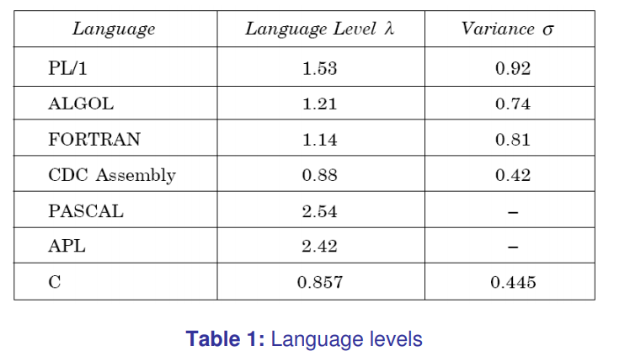

Q13.
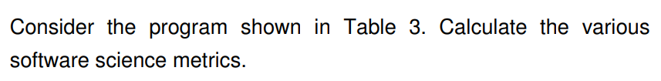

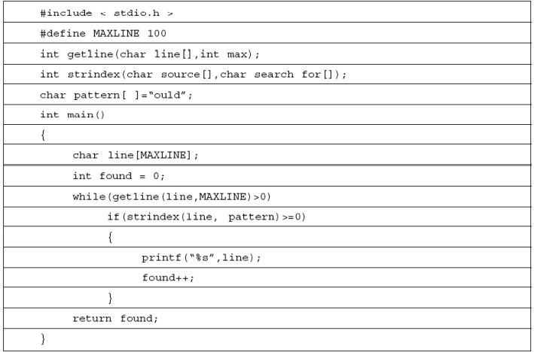

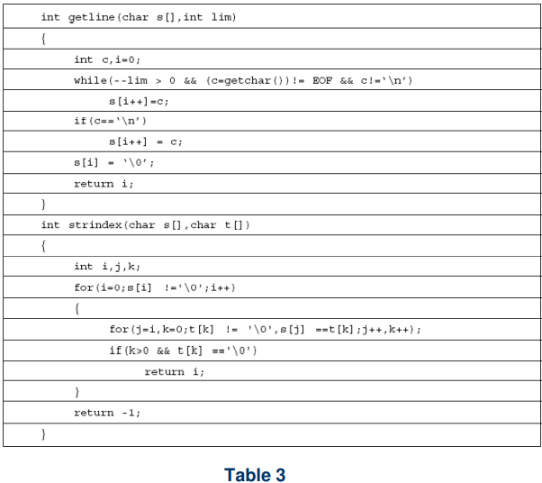

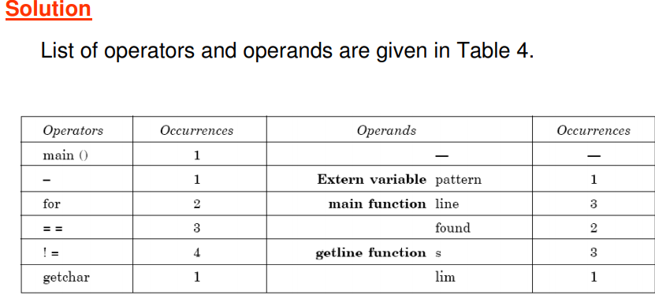

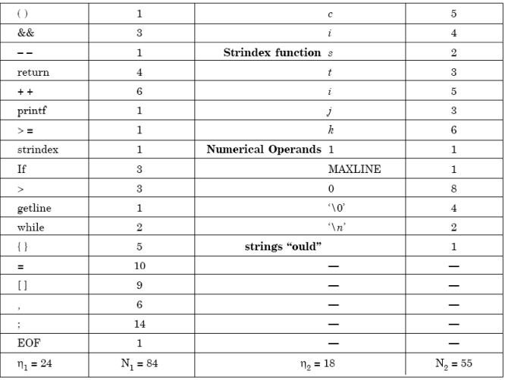
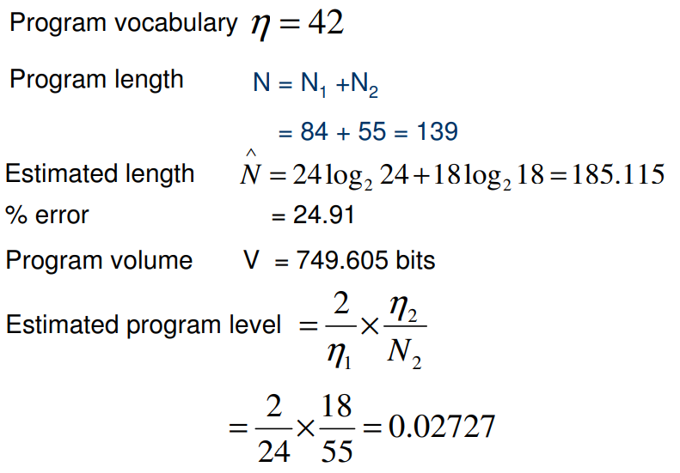

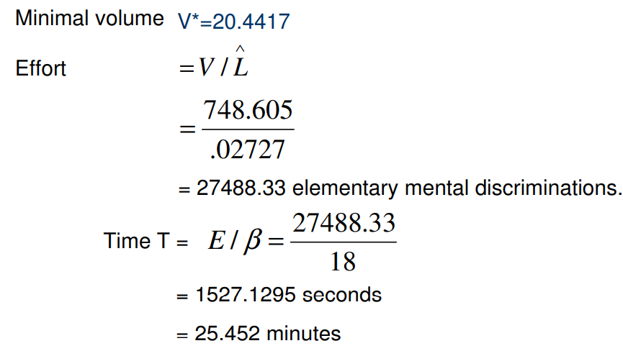
Q14. What is Data Structure Metrics? How can we calculate amount of data in a program ?

Essentially the need for software development and other activities are to process data. Some data is input to a system, program or module; some data may be used internally, and some data is the output from a system, program, or module.

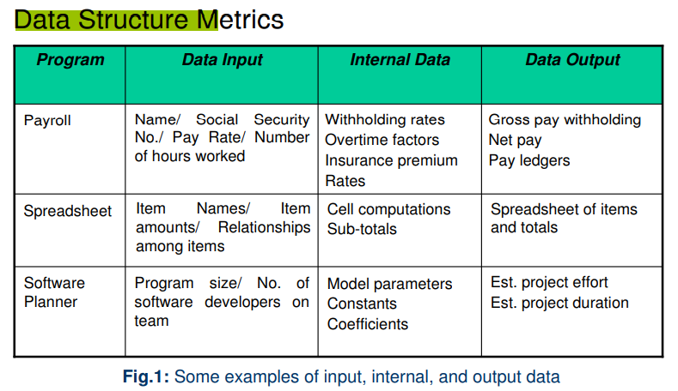

That's why an important set of metrics which capture in the amount of data input, processed in an output form software. A count of this data structure is called Data Structured Metrics. In these concentrations is on variables (and given constant) within each module & ignores the input-output dependencies.
There are some Data Structure metrics to compute the effort and time required to complete the project. These considerations are:
- The Amount of Data.
- The Usage of data within a Module.
- Program weakness.
- The sharing of Data among Modules.

Q15. Define the following Terms:-
- Live Variable.
- Variable Span.
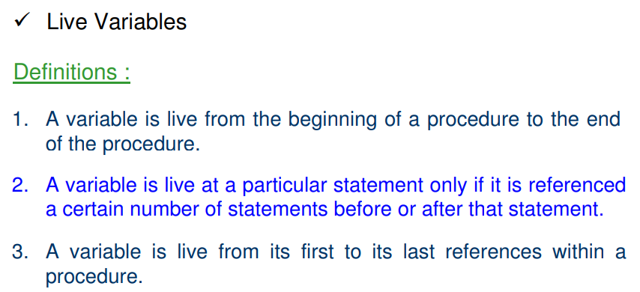
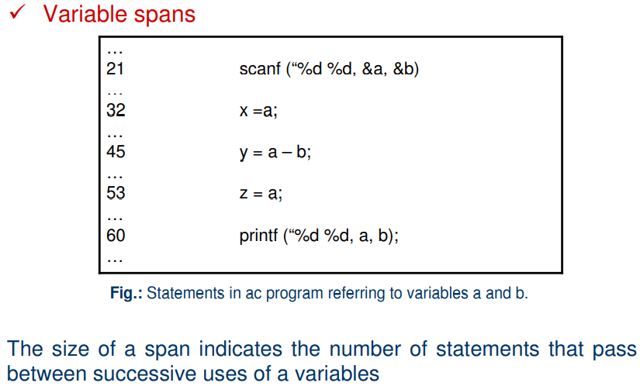

Q16. Explain all the metric or considerations in data structure metrics.

1. The Amount of Data: One method for determining the amount of data is to count the number of entries in the cross-reference list. The Amount of Data A variable is a string of alphanumeric characters that is defined by a developer and that is used to represent some value during either compilation or execution
To measure the amount of Data, there are further many different metrics, and these are:
- Number of variable (VARS): In this metric, the Number of variables used in the program is counted.
- Number of Operands (η2): In this metric, the Number of operands used in the program is counted.
- Total number of occurrence of the variable (N2): In this metric, the total number of occurrence of the variables are computed
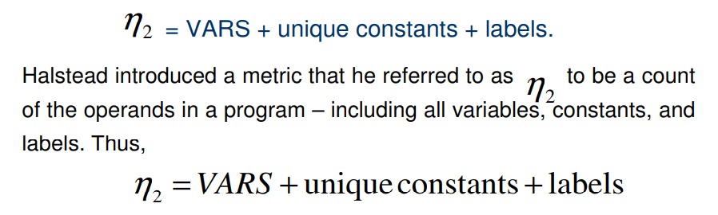
Consider,
int a = 5; // Variable 'a' initialized with constant 5
int b = 10; // Variable 'b' initialized with constant 10
int c = a + b; // Operand 'a' and 'b' used
int d = c * 2; // Operand 'c' and constant 2 used
int e = b + d; // Operand 'b' and 'd' used
if (a > b) { // 'a' and 'b' used in condition
goto label1; // Label used
}
label1:

Step 1: Count the VARS (Variables)
The variables in the program are:
- a
- b
- c
- d
- e
So, VARS = 5.

Step 2: Count the Unique Constants
The constants used are:
- 5 (assigned to a)
- 10 (assigned to b)
- 2 (used in c * 2)
So, there are 3 unique constants: 5, 10, and 2.

Step 3: Count the Labels
The program has the label:
- label1 (used in the goto statement)
So, there is 1 label.

Step 4: Compute n2
Using the formula:
n2 = VARS + unique constants + labels
n2 = 5 (variables) + 3 (unique constants) + 1 (label)
n2 = 9

2. The Usage of data within a Module: The measure this metric, the average numbers of live variables are computed. A variable is live from its first to its last references within the procedure.
Consider,
int a = 5;
int b = 10;
int c = a + b;
a = c;
b = a;

Live Variable Analysis:
At each program point, we track which variables are live (used later in the code).
- Point 1: int a = 5;
Live variables: None, because a is just assigned a value and not used yet.
- Point 2: int b = 10;
Live variables: None, because b is also just assigned a value and not used yet.
- Point 3: int c = a + b;
Live variables: {a, b} because a and b are used to compute c.
- Point 4: a = c;
Live variables: {c} because c is used to assign to a, but b is no longer used.
- Point 5: b = a;
Live variables: {a} because a is used to assign to b, but c is no longer needed.

Average of Live Variables:
Now, to compute the average number of live variables, we track the number of live variables at each point and calculate the average:
- Point 1: 0 live variables
- Point 2: 0 live variables
- Point 3: 2 live variables (a, b)
- Point 4: 1 live variable (c)
- Point 5: 1 live variable (a)
Average number of live variables = (0 + 0 + 2 + 1 + 1) / 5 = 0.8
Thus, the average number of live variables in the given program is 0.8.

3. Program weakness: Program weakness depends on its Modules weakness. If Modules are weak(less Cohesive), then it increases the effort and time metrics required to complete the project.
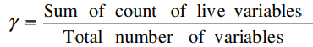

Module Weakness (WM) = LV* γ
A program is normally a combination of various modules; hence, program weakness can be a useful measure and is defined as:
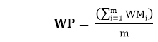
Where
WMi: Weakness of the ith module
WP: Weakness of the program
m: No of modules in the program
4. There Sharing of Data among Module: As the data sharing between the Modules increases (higher Coupling), no parameter passing between Modules also increased, As a result, more effort and time are required to complete the project. So Sharing Data among Module is an important metrics to calculate effort and time.

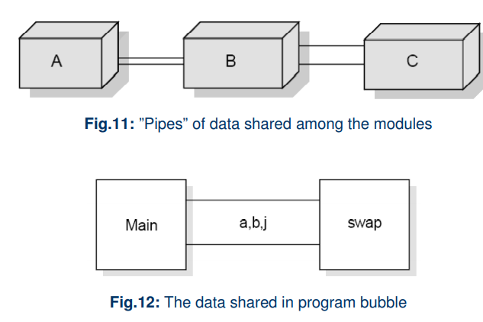

Q17. What is Information Flow Metrics?

Information Flow Metrics are software metrics used to assess the flow of information within a software system, particularly the movement and control of data between modules, functions, or components. These metrics help to evaluate the dependencies, data sharing, and communication between different parts of a program, which can be crucial for understanding its complexity, maintainability, and security.
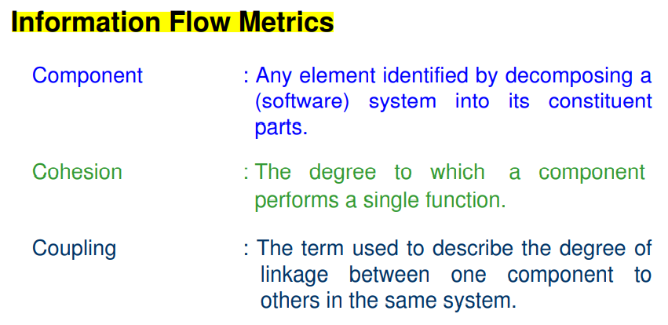

Q18. Explain the basic information flow model.

The basic information flow model helps in assessing the flow of control and data between components within a system. It is commonly used to evaluate how tightly or loosely components are coupled in terms of control and data passing. The model defines three primary metrics: FAN IN, FAN OUT, and the Information Flow (IF) index for a component. These metrics provide insight into how components interact with each other, which can help evaluate system complexity, modularity, and maintainability.

Explanation of Metrics:
- FAN IN:
  - FAN IN refers to the number of other components that can call or pass control to a given component.
  - This is a measure of how many components are dependent on the component in question.
  - Example: If Component A is called by Component B, C, and D, then FAN IN of A is 3.
- FAN OUT:
  - FAN OUT refers to the number of components that are called by the given component.
  - This is a measure of how many components are dependent on the component in question.
  - Example: If Component A calls Component E and F, then FAN OUT of A is 2.
- Information Flow Index (IF):
  - The Information Flow (IF) index of a component measures the interaction between components in terms of both control and data flow. It is derived from FAN IN and FAN OUT using the formula:

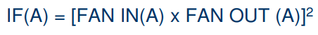

  - This formula gives a numerical value representing the complexity of the interactions involving the component, with higher values indicating a higher level of information flow.
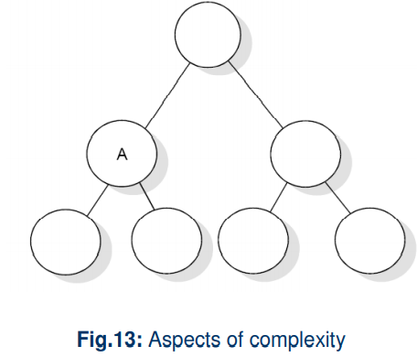

Steps for Deriving Information Flow Metrics:
- Note the Level of Each Component:
  - Determine the hierarchy or level of each component in the system design. The system is usually organized in levels or layers based on the system architecture.
- Calculate FAN IN for Each Component:
  - For each component, count the number of components that can call or pass control to it. If the component is at the highest level, assign a FAN IN of 1 (or 0 in some cases, depending on the system's conventions). This ensures that components at the top level are appropriately modeled.
- Calculate FAN OUT for Each Component:
  - For each component, count the number of components that it can call or pass control to. If a component does not call any other components, its FAN OUT is assigned a value of 1.
- Calculate IF (Information Flow) for Each Component:
  - Use the formula to calculate the IF value for each component:

  - This provides a numeric measure of how information flows into and out of the component.
- Calculate LEVEL SUM:
  - For each level in the system design, sum the IF values for all components within that level. This gives a total measure of information flow within that particular level.
- Calculate SYSTEM SUM:
  - Sum the IF values for all components across the entire system to get the SYSTEM SUM, representing the overall information flow for the entire system.
- Rank Components:
  - For each level in the system design, rank the components based on their FAN IN, FAN OUT, and IF values. This helps in identifying which components have the highest levels of interactivity and complexity.
- Visual Representation:
  - Plot histograms or line plots for FAN IN, FAN OUT, and IF values for each level, as well as the LEVEL SUM values for each level. This visual representation helps to understand the distribution of information flow across components and levels in the system.

Example:
Consider a simple system with three components:
- Component A: FAN IN = 1, FAN OUT = 2
- Component B: FAN IN = 2, FAN OUT = 1
- Component C: FAN IN = 1, FAN OUT = 1
Using the formula for IF:
- IF(A) = (1 × 2)^2 = 4
- IF(B) = (2 × 1)^2 = 4
- IF(C) = (1 × 1)^2 = 1
- LEVEL SUM: The sum of IF values at the level, e.g., IF(A) + IF(B) + IF(C) = 4 + 4 + 1 = 9.
- SYSTEM SUM: The total IF value for the entire system is 9 (for this example, it is the same as the LEVEL SUM since there's only one level).

Q19. Write another Method of Information Flow Model?
The more sophisticated method of the Information Flow Model builds on the basic model by considering additional factors such as data elements read and written, as well as parameters passed to and from components. This method provides a more detailed understanding of the flow of information and control within a system, accounting for interactions at a more granular level.

Metrics:
- FAN IN(A):
  - This represents the total incoming flow to a component A. It includes:
    - a: The number of components that call A (i.e., the number of components that invoke or depend on A).
    - b: The number of parameters passed to A from components higher in the hierarchy (components that depend on A).
    - c: The number of parameters passed to A from components lower in the hierarchy (components that A depends on).
    - d: The number of data elements read by component A.
The formula for FAN IN is:
FAN_IN(A)=a+b+c+d
This metric provides a measure of how much external information flows into component A, including control flow (i.e., how many components call A) and data flow (i.e., how many parameters and data elements are passed to it).
- FAN OUT(A):
  - This represents the total outgoing flow from component A. It includes:
    - e: The number of components called by A (i.e., the components that A calls).
    - f: The number of parameters passed from A to components higher in the hierarchy (components that A calls and sends information to).
    - g: The number of parameters passed from A to components lower in the hierarchy (components that A calls and receives information from).
    - h: The number of data elements written to by A.
The formula for FAN OUT is:
FAN_OUT(A)=e+f+g+h
This metric provides a measure of how much information flows out of component A, including both control flow (i.e., the number of components A calls) and data flow (i.e., the number of parameters and data elements passed from it).

Detailed Information Flow Index (IF):
Given the enhanced FAN IN and FAN OUT metrics, we can calculate the Information Flow Index (IF) of component A in a more sophisticated manner:

This equation remains the same as in the basic model, but now it incorporates the additional data factors (read and written elements, parameters passed to and from components) for a more comprehensive view of the information flow in the system.

Example:
Consider a system with component A and the following values:
- a (number of components calling A) = 3
- b (number of parameters passed to A from higher components) = 2
- c (number of parameters passed to A from lower components) = 1
- d (number of data elements read by A) = 4
For FAN IN(A):
FAN_IN(A)=3+2+1+4=10
Now, for FAN OUT(A):
- e (number of components called by A) = 2
- f (number of parameters passed from A to higher components) = 3
- g (number of parameters passed from A to lower components) = 2
- h (number of data elements written to by A) = 5
For FAN OUT(A):
FAN_OUT(A)=2+3+2+5=12
Now, using the formula for the Information Flow Index (IF):
IF(A)= {12*10}^2 = 14400
This is the more sophisticated measure of information flow for component A, incorporating both control flow and data flow considerations.

Q20. What are object-oriented metrics? State all object oriented metrics? What are the importance of these metrics?
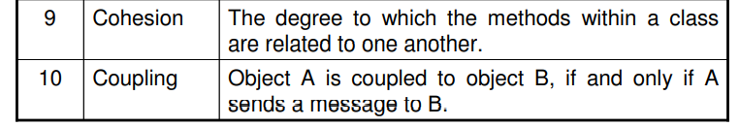
Object-oriented (OO) metrics are used to measure various aspects of an object-oriented software system. These metrics help assess the design, quality, and maintainability of an object-oriented program. Object-oriented metrics are based on the concepts of objects, classes, inheritance, polymorphism, encapsulation, and other features that define object-oriented programming.

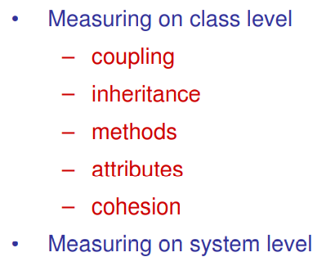
Size Metrics:
- Number of Methods per Class (NOM): Counts the total methods in a class.
- Number of Attributes per Class (NOA): Counts the total attributes in a class.
- Weighted Number of Methods per Class (WMC): Measures the complexity by summing the complexities of all methods in a class.

Coupling Metrics:
- Response for a Class (RFC): Measures the number of methods (internal and external) that can be executed in response to a message to an object.
- Data Abstraction Coupling (DAC): Counts the number of abstract data types in a class.
- Message Passing Coupling (MPC): Counts the number of send statements (messages) in a class.
- Coupling Factor (CF): Ratio of actual coupling to the maximum possible coupling in the system.
- Coupling Between Objects (CBO): Measures the number of classes to which a particular class is coupled.

Cohesion Metrics:
- Lack of Cohesion in Methods (LCOM): Measures how closely the methods in a class are related to each other.
- Tight Class Cohesion (TCC): Percentage of pairs of public methods that share common attributes.
- Loose Class Cohesion (LCC): Similar to TCC but also considers indirectly connected methods.
- Information-based Cohesion (ICH): Measures the number of invocations between methods of the same class, weighted by the number of parameters of the invoked methods.

Inheritance Metrics:
- Depth of Inheritance Tree (DIT): The level of a class in the inheritance hierarchy.
- Number of Children (NOC): The number of immediate subclasses of a class.
- Attribute Inheritance Factor (AIF): The ratio of inherited attributes to total attributes in a class.
- Method Inheritance Factor (MIF): The ratio of inherited methods to the total number of methods in a class system.
Importance of metrics in object-oriented software development:
- Quality Assurance: Evaluate code and design quality.
- Project Management: Assist in estimating timelines and resource allocation.
- Performance Evaluation: Gauge component performance for optimization.
- Maintainability: Identify complex or tightly coupled classes for refactoring.
- Cost Estimation: Provide data for better development cost estimates.
- Risk Management: Identify high-risk areas for proactive mitigation.
Q21. Explain Use-Case Oriented Metrics?

Use-Case Oriented Metrics focus on measuring the complexity of a software system based on its use cases and actors.
- Actors are entities interacting with the system (users, other systems). They are classified as:
  - Simple: System with a defined interface (weight = 1).
  - Average: System interacting via text-based protocols (weight = 2).
  - Complex: Person interacting through a GUI (weight = 3).
- Use Cases define system functionality and are categorized by the number of transactions:
  - Simple: 3 or fewer transactions (weight = 5).
  - Average: 4 to 7 transactions (weight = 10).
  - Complex: More than 7 transactions (weight = 15).
The total weight is calculated by multiplying the number of actors or use cases by their respective weights and summing the results. This helps estimate the complexity and effort required for development and testing.

Q22. What are the Web Engineering Project Metrics?
Web Engineering Project Metrics help assess the scale and complexity of a web project. Key metrics include:
- Number of Static Web Pages: Count of pages with fixed content.
- Number of Dynamic Web Pages: Pages with content that changes based on user input.
- Number of Internal Page Links: Links between pages for navigation.
- Word Count: Total number of words across all pages.
- Web Page Similarity: Measures content uniqueness.
- Web Page Search and Retrieval: Efficiency of the site's search functionality.
- Number of Static Content Objects: Non-interactive elements like images or CSS.
- Number of Dynamic Content Objects: Interactive elements like scripts or live data.
These metrics help estimate development time, optimize performance, and improve site design.

Q23. Explain Metric Analysis.
Metric Analysis uses statistical techniques to interpret software metrics. Key methods include:
- Summary Statistics: Mean, median, max, and min values to summarize data.
- Graphical Representations: Visuals like histograms, pie charts, and box plots to display data distribution.
- Principal Component Analysis (PCA): Simplifies complex data by identifying key factors.
- Regression and Correlation: Predicts values (regression) and measures relationships (correlation) between variables.
- Reliability Models: Predicts future software reliability based on past performance.

Q24. What are the problem with metric data?
Problems with metric data include:
- Normal Distribution: Metrics may not follow a normal distribution, making standard statistical techniques less effective.
- Outliers: Extreme values can skew results and distort analysis.
- Measurement Scale: Inconsistent or inappropriate scales can lead to inaccurate comparisons.
- Multicollinearity: High correlation between metrics can make it difficult to identify individual metric effects.

Q25. What are the Pattern of Successful Applications?

The patterns of successful application of metrics include:
- Any metric is better than none: Even basic metrics provide valuable insights.
- Automation is essential: Automating the collection and analysis of metrics saves time and improves accuracy.
- Empiricism is better than theory: Rely on actual data and observations rather than just theoretical assumptions.
- Use multifactor rather than single metrics: A combination of metrics offers a more comprehensive view of the software.
- Don’t confuse productivity metrics with complexity metrics: Understand the difference between measuring output and measuring the complexity of the code.
- Let them mature: Metrics improve over time as they evolve and adapt to the project.
- Maintain them: Continuously monitor and update metrics to keep them relevant.
- Let them die: Discard outdated or ineffective metrics that no longer provide value.

Q26. Explain Hardware Reliability Curve in Detail.
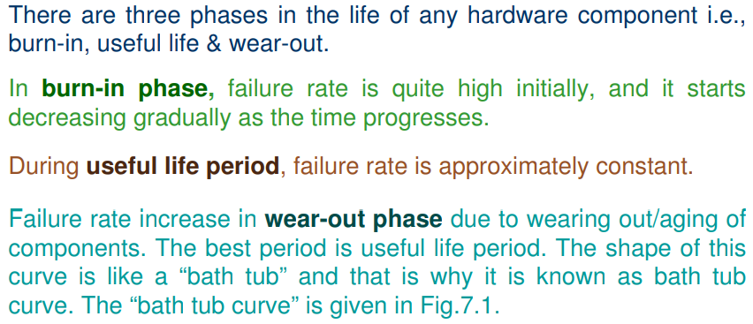
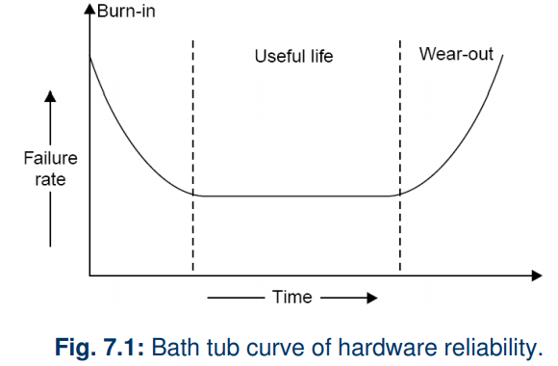

Q27. Explain Software Reliability Curve in Detail.
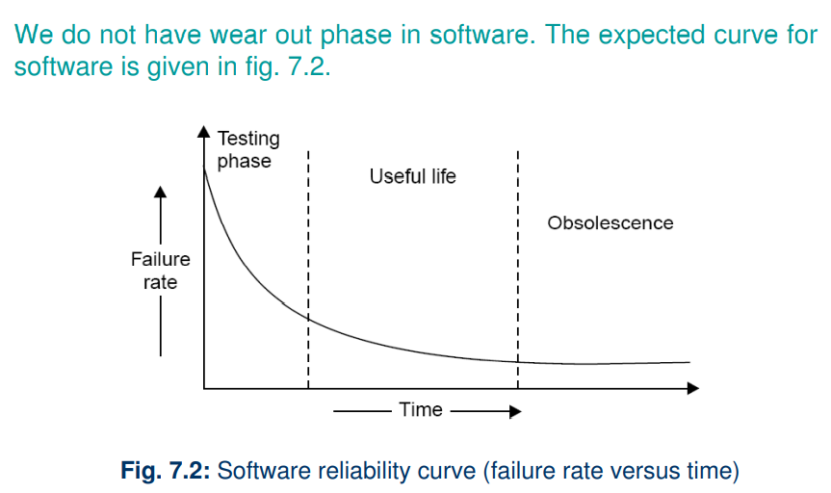
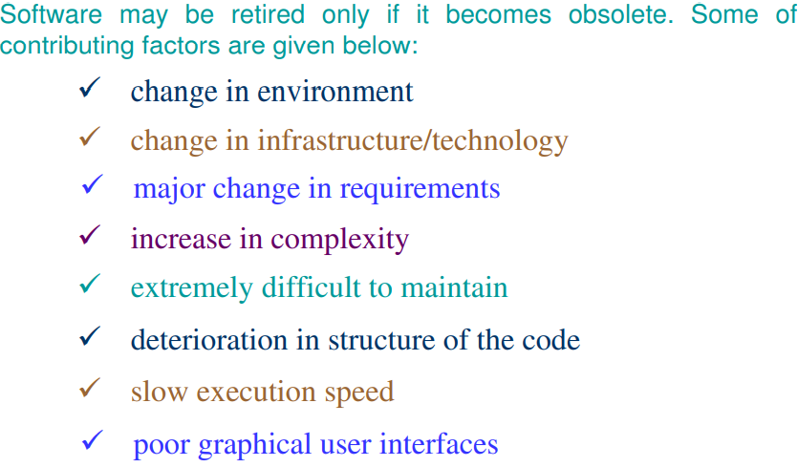
Q28. What is Software Reliability?

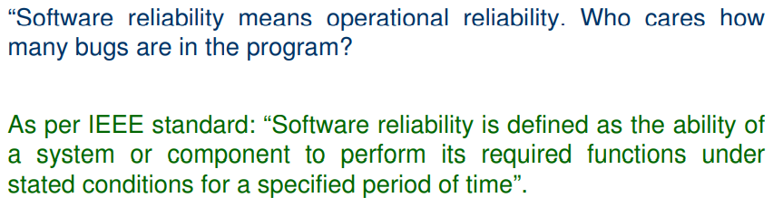
Software reliability is also defined as the probability that a software system fulfills its assigned task in a given environment for a predefined number of input cases, assuming that the hardware and the inputs are free of error.

“It is the probability of a failure free operation of a program for a specified time in a specified environment”.

Q29. What is Failures and Faults?
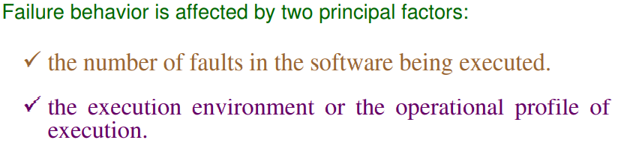
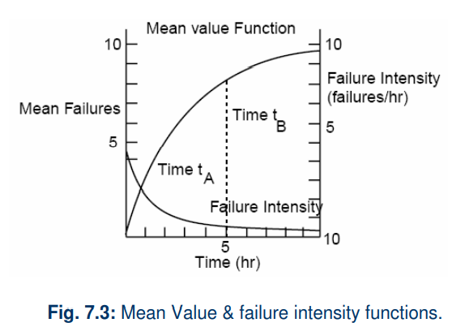

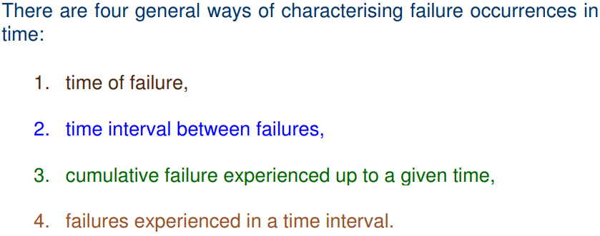

Q30. What is Environment and Operation Profile?

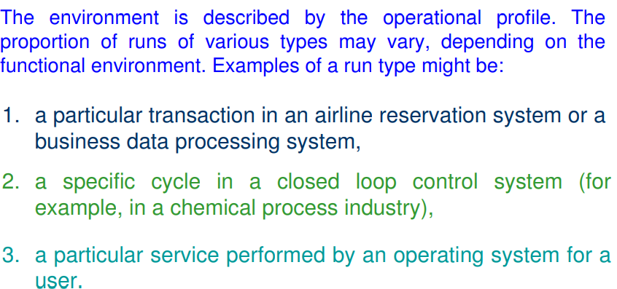

Q32. Show the relation between Reliability and failure intensity.

Fig.7.7 shows how failure intensity and reliability typically vary during a test period, as faults are removed.

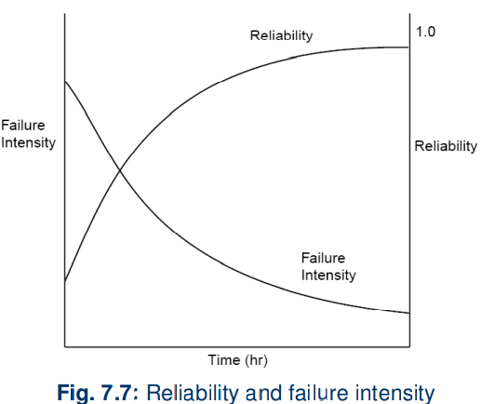

Q33. What are the uses of Reliability Studies?
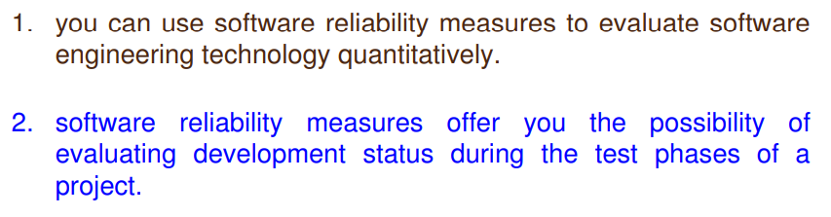
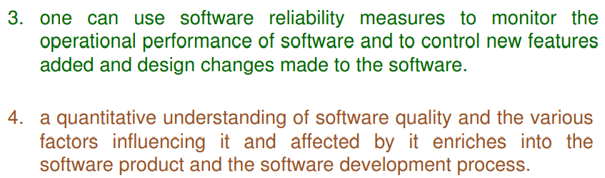
Q34. What do you mean by Software Quality? What are the attributes of software quality?

Software Quality is defined as the degree to which a software product meets the requirements specified by the customer and its intended functionality, and performs effectively, efficiently, and reliably under specified conditions.
In other words, it refers to the conformance to specifications, the ability to meet user expectations, and the software's overall performance, reliability, and maintainability.
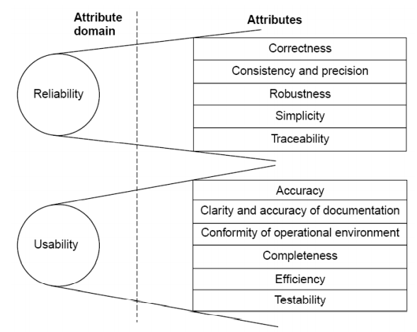

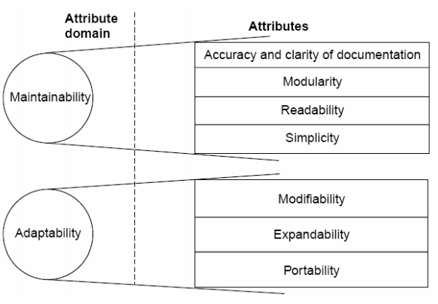

Q35. Explain McCall Software Quality Model.

The McCall Software Quality Model defines software quality based on three key perspectives: Product Revision, Product Transition, and Product Operation. Each perspective is associated with quality factors that influence software performance and usability.
- Product Operation: Focuses on the software's functionality and performance during use.
  - Factors: Correctness, Reliability, Efficiency, Integrity, Usability.
- Product Revision: Deals with the ability to modify, adapt, and maintain the software.
  - Factors: Maintainability, Flexibility, Testability.
- Product Transition: Addresses the software's adaptability to new environments or platforms.
  - Factors: Portability, Reusability, Interoperability.
These factors are further broken into metrics and criteria to assess specific aspects of software quality. The model ensures that both user needs and developer requirements are met effectively.
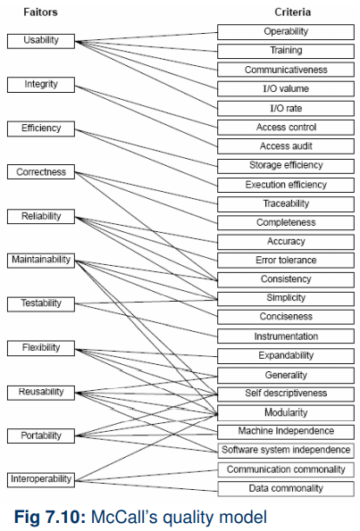
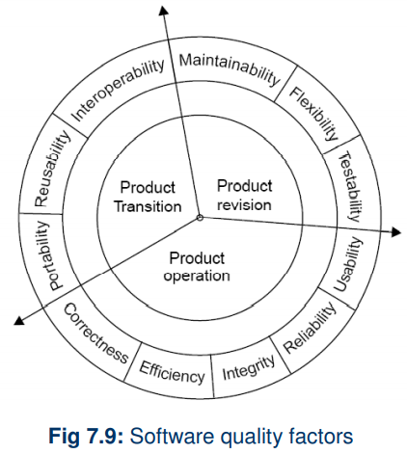

Q36. Explain the Boehm Software Quality Model.

In the Boehm Software Quality Model, the constructs are categorized as primary use, intermediate constructs, and primitive constructs, forming a hierarchical structure for evaluating software quality:
- Primary Use:
These represent the top-level goals or perspectives of software quality, focusing on the software's overall purpose:
  - As-is Utility: How effectively the software serves its intended purpose in operation.
  - Maintainability: The ease of modifying the software to meet future needs.
  - Portability: The ability to adapt the software to different environments.
- Intermediate Constructs:
These link the primary uses to measurable attributes. They break down high-level goals into manageable sub-goals:
  - Examples include Testability, Understandability, Modifiability, Efficiency, Reliability, and Human Engineering.
- Primitive Constructs:
These are the lowest-level attributes that directly influence the intermediate constructs. They are measurable and form the foundation of the model:
  - Examples include Code Clarity, Modularity, Error Frequency, Response Time, and Resource Utilization.
By linking these constructs, the Boehm model enables a structured and measurable approach to evaluating software quality across various dimensions.
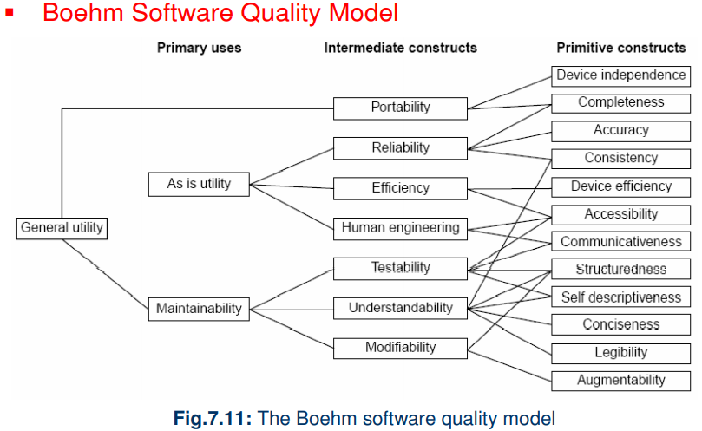
Q37. Explain ISO 9126 Software Quality Model.

ISO 9126 Software Model
ISO 9126 focuses specifically on software product quality, breaking it into six quality characteristics and their sub-characteristics:
- Functionality:
  - Suitability: How well the software meets functional requirements.
  - Accuracy: Producing correct results.
  - Interoperability: Ability to interact with other systems.
  - Security: Protecting data and operations.
- Reliability:
  - Maturity: Resistance to failures.
  - Fault tolerance: Capability to maintain performance during errors.
  - Recoverability: Ability to recover from failures.
- Usability:
  - Understandability: Easy to comprehend.
  - Learnability: Ease of learning.
  - Operability: Simplicity in operation.
- Efficiency:
  - Time behavior: Speed of operations.
  - Resource utilization: Optimal use of resources.
- Maintainability:
  - Analyzability: Easy to identify defects.
  - Changeability: Simple to modify.
  - Stability: Consistency after changes.
  - Testability: Easy to test.
- Portability:
  - Adaptability: Ability to work in different environments.
  - Installability: Simplicity of installation.
  - Replaceability: Substitutability with similar systems.
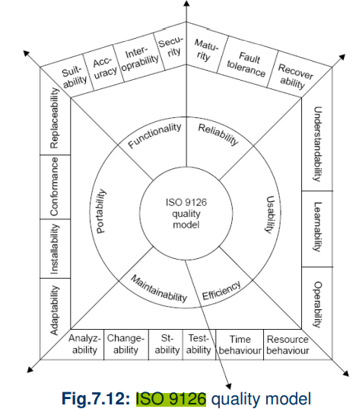

Q36. Explain the Basic and Logarithmic Poisson Model and is there significance in reliability studies?

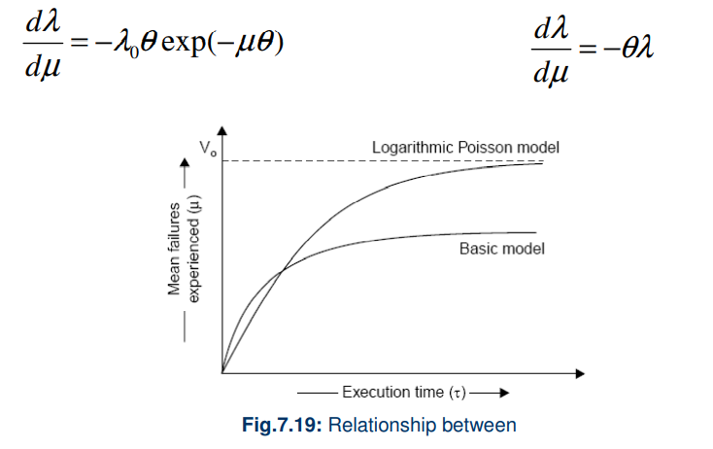

Basic Poisson Model
Description:
- The basic Poisson model assumes that events (e.g., system failures) occur randomly and independently over time. It is characterized by a single parameter, λ (lambda), which represents the average rate of occurrence (mean number of events in a specified interval).
- The probability of observing k events in a time interval t is given by the formula:
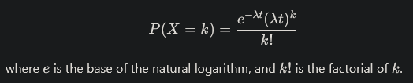

Significance in Reliability Studies:
- Failure Rate Estimation: The basic Poisson model helps estimate the failure rate of systems, enabling organizations to understand how often failures are likely to occur.
- Reliability Prediction: It allows for predicting system reliability over time by modeling how the failure rate may change with time or usage.
- Maintenance Planning: By understanding failure patterns, organizations can optimize maintenance schedules and resource allocation, reducing downtime and costs.
Logarithmic Poisson Model

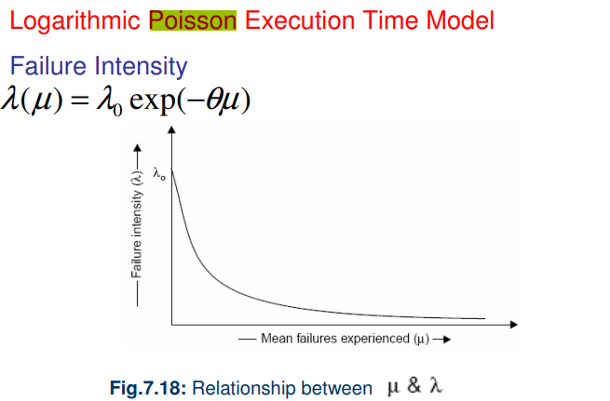
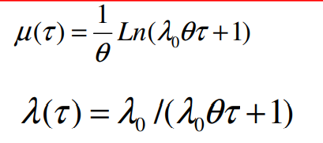

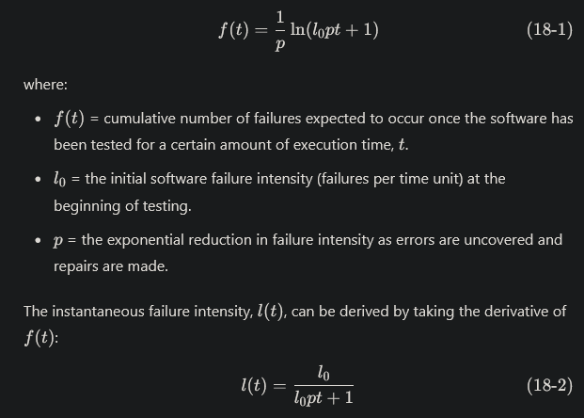
Using statistical modeling and software reliability theory, models of software failures (uncovered during testing) as a function of execution time can be developed [MUS89]. A version of the failure model, called a logarithmic Poisson execution-time model, takes the form:

Using the relationship noted in Equation (18-2), testers can predict the drop-off of errors as testing progresses. The actual error intensity can be plotted against the predicted curve (Figure 18.3). If the actual data gathered during testing and the logarithmic Poisson execution time model are reasonably close to one another over a number of data points, the model can be used to predict the total testing time required to achieve an acceptably low failure intensity.
Q37. Explain Jelinski-Moranda Model and Bug Seeding Model.
The Jelinski-Moranda model is a software reliability growth model that assumes a constant failure rate for each fault in a system. It focuses on predicting the reliability of software systems based on the detection and correction of software faults.

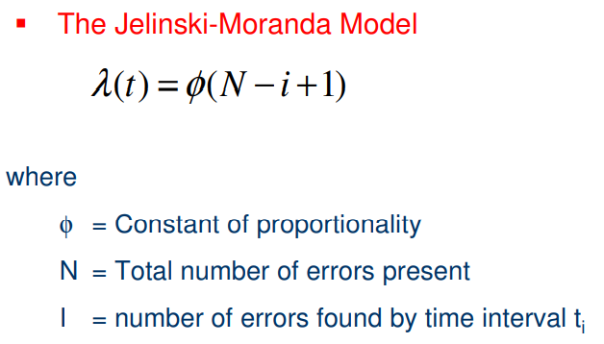

The Bug Seeding Model is a fault injection technique used to assess the effectiveness of a testing process by intentionally introducing known bugs into the software and measuring how many are detected.

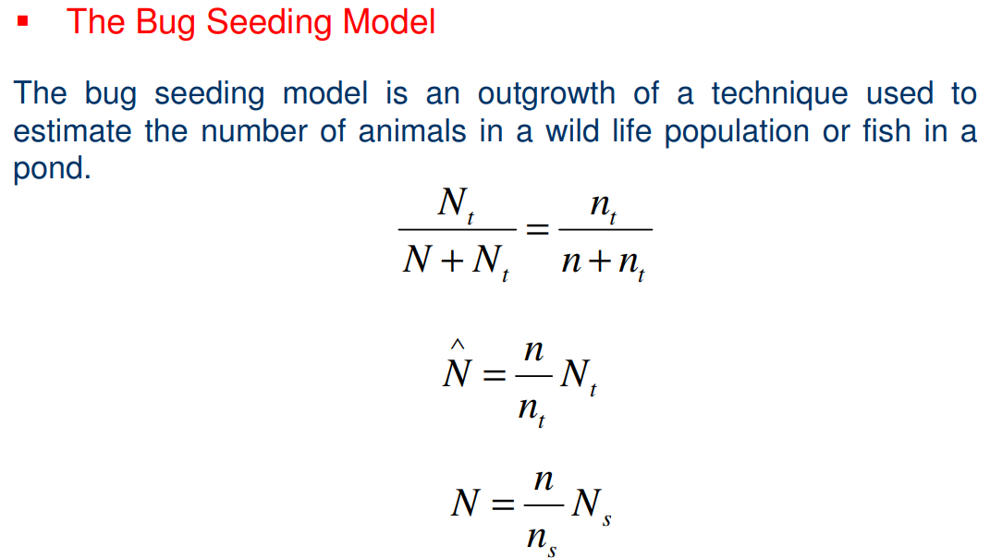

Q38. Explain CMM (Capability Maturity Model) in Detail.
It is a strategy for improving the software process, irrespective of the actual life cycle model use.
The Capability Maturity Model (CMM) is a structured framework for improving software processes within an organization. It provides a strategy for enhancing software quality, reducing risks, and increasing efficiency, irrespective of the specific software life cycle model used. The CMM defines five levels of process maturity, each building on the practices of the previous level.

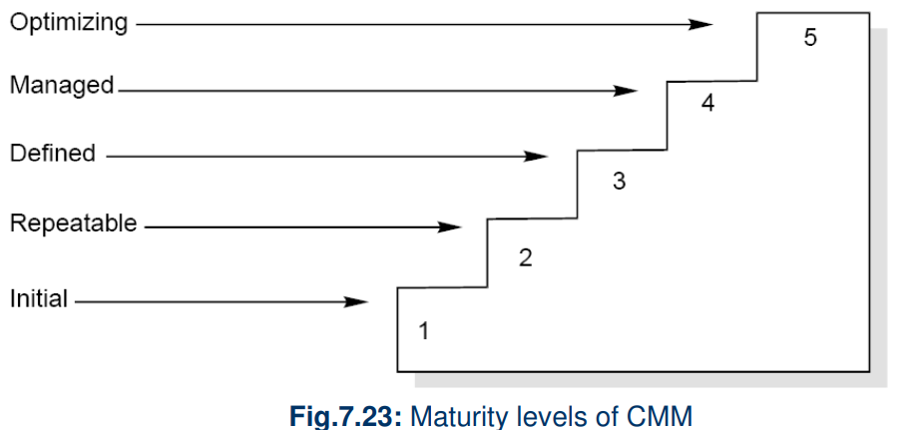
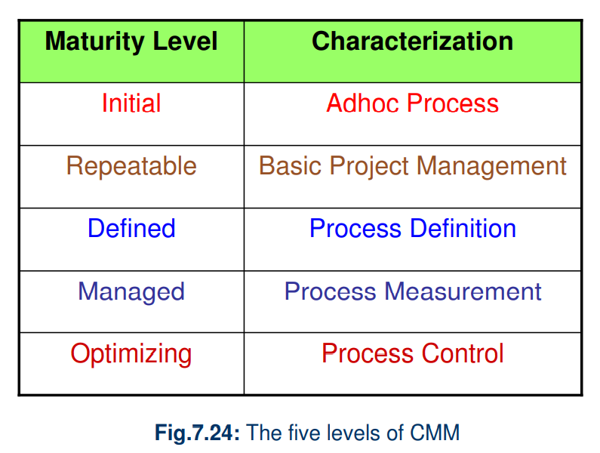

At the Initial Level, the software development process is chaotic and unstructured, with no defined procedures or consistency. Success heavily relies on the skills and efforts of individual team members rather than on established organizational processes.

Key Characteristics:
- Ad Hoc Processes:
Processes are reactive and improvised, with no predefined or repeatable methods.
- Unpredictability:
Project outcomes are highly unpredictable, with frequent schedule slippages and cost overruns.
- Dependency on Individuals:
Success depends on individual efforts and heroics, making it hard to replicate past successes.
- No Process Control:
There are no established metrics or controls to monitor project progress or quality.
- High Risk of Failure:
Lack of structure often leads to inconsistent performance, with a high probability of project failure.

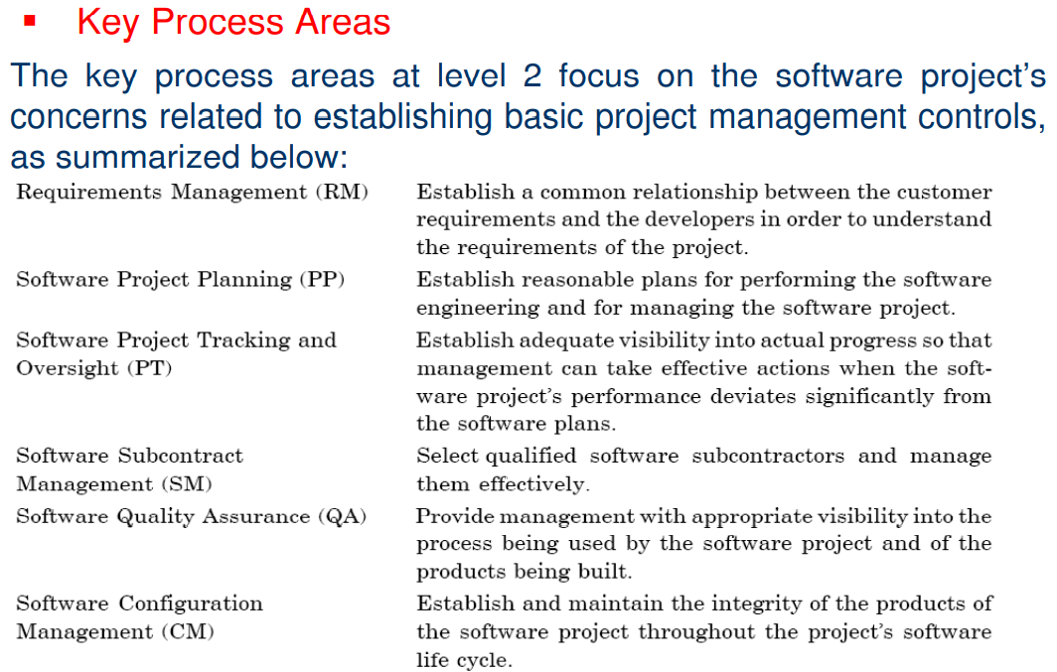
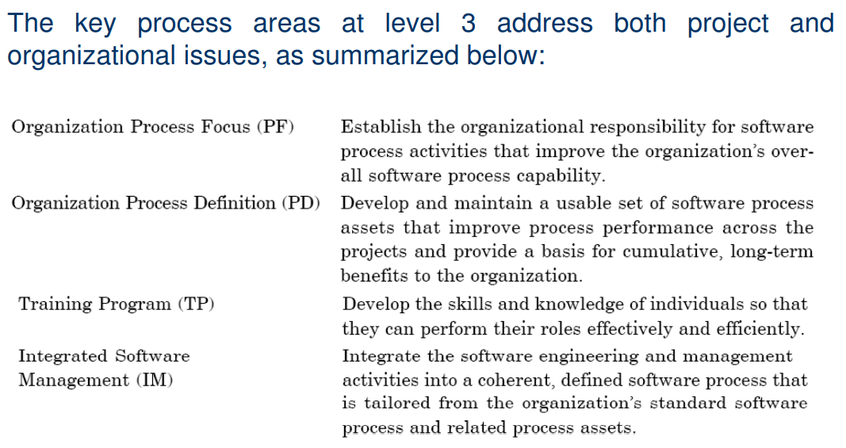
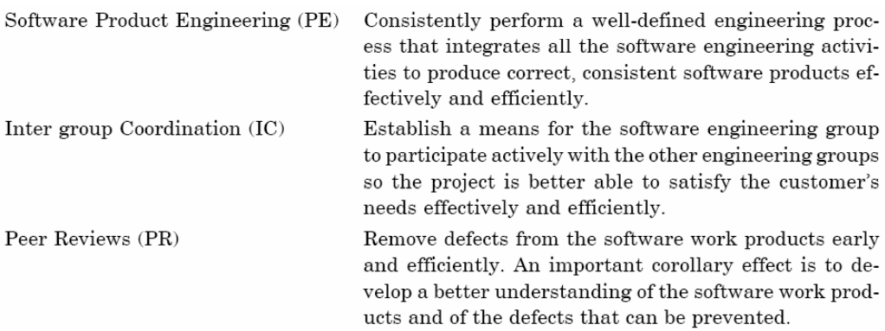
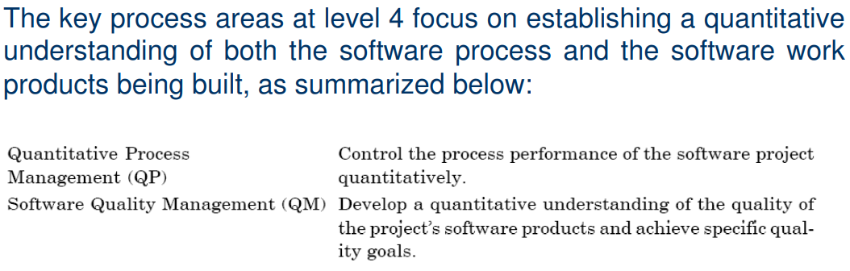
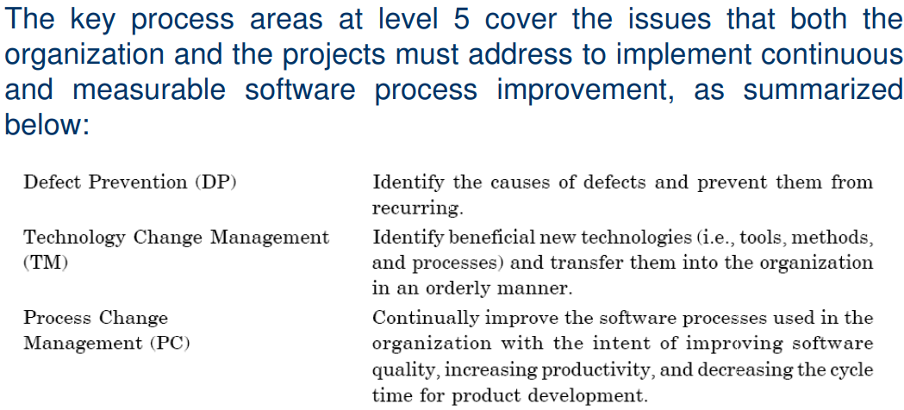
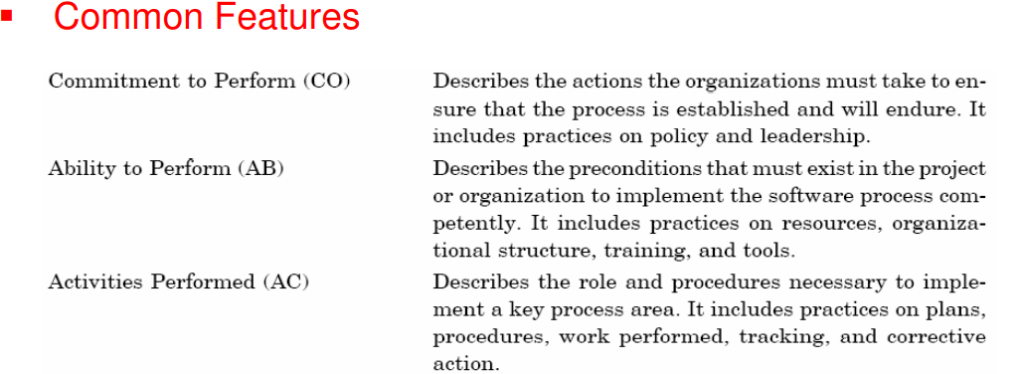
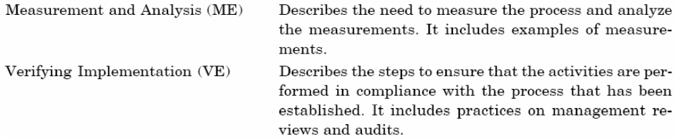
Q39. Explain ISO 9001 Software Quality Model. Differentiate Between ISO 9001 and CMM in tabular form.

ISO 9001 Software Quality Model
ISO 9001 is an internationally recognized standard for quality management systems (QMS), including software quality management. It provides guidelines to ensure that organizations consistently produce products and services meeting customer and regulatory requirements.

Key Features of ISO 9001:
- Management Responsibility: Focus on leadership and commitment.
- Quality System: Documentation and implementation of a quality management system.
- Contract Review: Ensuring customer requirements are met before signing contracts.
- Design Control: Systematic control of the design process to ensure quality.
- Document Control: Proper management of documents to ensure accessibility and updates.
- Purchasing: Ensuring the quality of purchased materials.
- Product Identification and Traceability: Tracking products from development to delivery.
- Process Control: Managing processes to ensure quality standards.
- Inspection and Testing: Verifying product compliance through testing.
- Nonconforming Product Control: Handling defective products systematically.
- Corrective Action: Identifying and resolving root causes of issues.
- Internal Quality Audits: Regular reviews of the QMS.
- Training: Ensuring employees are competent for their roles.
- Statistical Techniques: Using statistical methods to ensure process reliability.

Differences Between ISO 9001 and CMM
Aspect | ISO 9001 | CMM (Capability Maturity Model)
Focus | Quality management system for organizations. | Process maturity and continuous improvement.
Purpose | Ensures compliance with quality standards. | Improves software process capabilities.
Scope | Broad, applies to various industries. | Specific to software development processes.
Key Features | Management responsibility, process control. | Maturity levels, process improvement focus.
Emphasis | Meeting standards and consistency. | Continuous process improvement.
Structure | Requirements-based (document compliance). | Evolutionary (maturity levels).
Outcome | Certification for quality management. | Assessment of process maturity.
Biggest Similarity | "Say what you do; do what you say." | Same principle applies.

Key Similarities
- Both emphasize clear documentation and adherence to processes.
- Both aim for reliable, high-quality output.
- The bottom line for both is ensuring processes are defined, implemented, and continuously improved.

Software Engineering | Unit – 4

Q1. What is Testing?

“Testing is the process of executing a program with the intent of finding errors.”

Q2. Why should we do testing?

Although software testing is itself an expensive activity, yet launching of software without testing may lead to cost potentially much higher than that of testing, specially in systems where human safety is involved. In the software life cycle the earlier the errors are discovered and removed, the lower is the cost of their removal.

Q3. What is fault?

A fault is the representation of an error, where representation is the mode of expression, such as narrative text, data flow diagrams, ER diagrams, source code etc. Defect is a good synonym for fault.

Q4. What is failure?

A failure occurs when a fault executes. A particular fault may cause different failures, depending on how it has been exercised.

Q5. What is a Test Case?

Test case describes an input description and an expected output description.
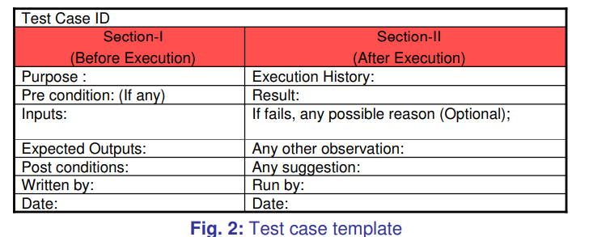

The set of test cases is called a test suite. Hence any combination of test cases may generate a test suite.

Q6. What is Verification?

Verification is the process of evaluating a system or component to determine whether the products of a given development phase satisfy the conditions imposed at the start of that phase.

Q7. What is Validation?

Validation is the process of evaluating a system or component during or at the end of development process to determine whether it satisfies the specified requirements .
Testing= Verification+Validation
Q8. What is Acceptance Testing?

The term Acceptance Testing is used when the software is developed for a specific customer. A series of tests are conducted to enable the customer to validate all requirements. These tests are conducted by the end user / customer and may range from adhoc tests to well planned systematic series of tests.

Q9. What is Functional Testing?

Functional testing is defined as a type of testing that verifies that each function of the software application works in conformance with the requirement and specification. This testing is not concerned with the source code of the application. Each functionality of the software application is tested by providing appropriate test input, expecting the output, and comparing the actual output with the expected output.

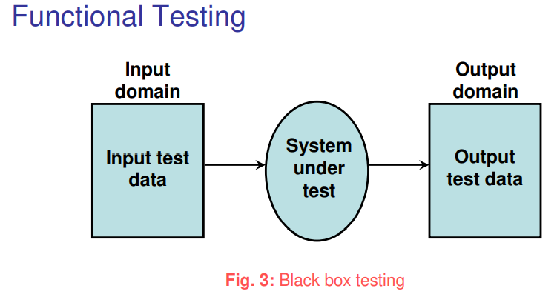

Q10. What is Boundary Value Analysis?

Boundary Value Analysis is based on testing the boundary values of valid and invalid partitions. The behavior at the edge of the equivalence partition is more likely to be incorrect than the behavior within the partition, so boundaries are an area where testing is likely to yield defects.
It checks for the input values near the boundary that have a higher chance of error. Every partition has its maximum and minimum values and these maximum and minimum values are the boundary values of a partition.
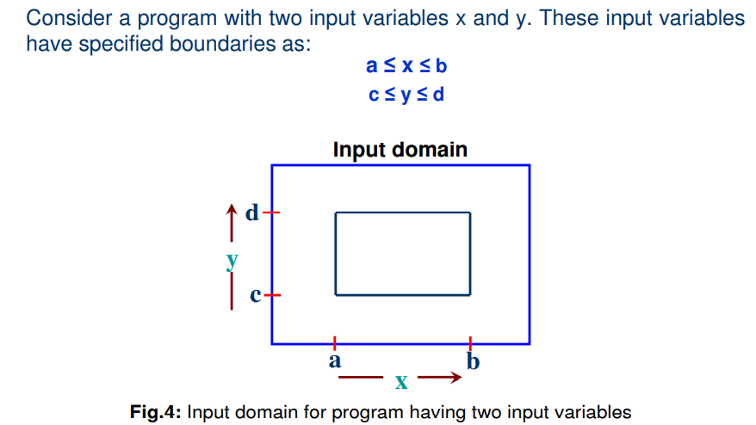

Q11. What is Robustness Testing?

It is nothing but the extension of boundary value analysis. Here, we would like to see, what happens when the extreme values are exceeded with a value slightly greater than the maximum, and a value slightly less than minimum. It means, we want to go outside the legitimate boundary of input domain. This extended form of boundary value analysis is called robustness testing.
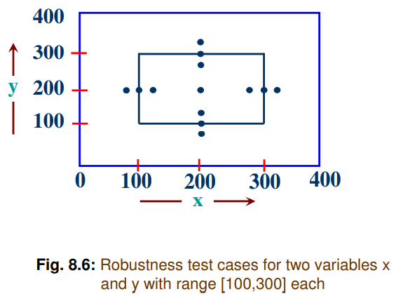

Q12. What is Worst Case testing?

Boundary Value analysis uses the critical fault assumption and therefore only tests for a
single variable at a time assuming its extreme values. By disregarding this assumption we
are able to test the outcome if more than one variable were to assume its extreme value.
In an electronic circuit this is called Worst Case Analysis. In Worst-Case testing we use
this idea to create test cases.

Q13. What is Equivalence Class Testing?

Equivalence Class Testing, which is also known as Equivalence Class Partitioning (ECP) and Equivalence Partitioning, is an important software testing technique used by the team of testers for grouping and partitioning of the test input data, which is then used for the purpose of testing the software product into a number of different classes.
These different classes resemble the specified requirements and common behaviour or attribute(s) of the aggregated inputs. Thereafter, the test cases are designed and created based on each class attribute(s) and one element or input is used from each class for the test execution to validate the software functioning, and simultaneously validates the similar working of the software product for all the other inputs present in their respective classes.
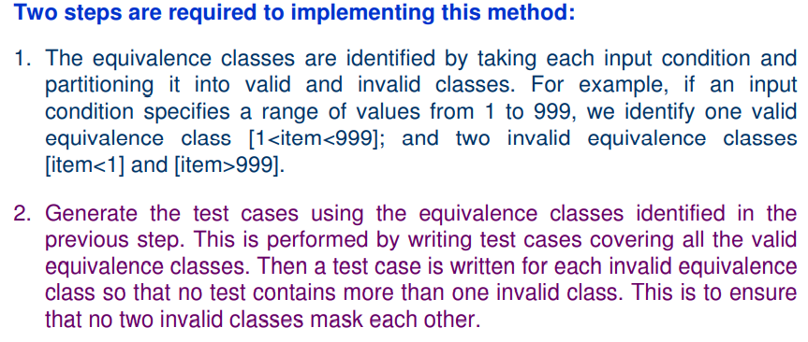

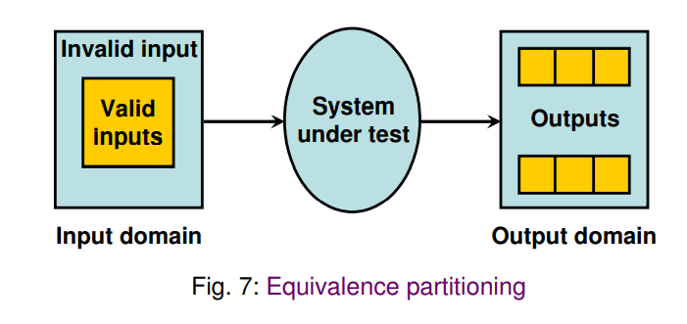
Most of the time, equivalence class testing defines classes of the input domain. However, equivalence classes should also be defined for output domain. Hence, we should design equivalence classes based on input and output domain.

Q14. What is Decision Table Testing?

Decision tables are used in various engineering fields to represent complex logical relationships. This testing is a very effective tool in testing the software and its requirements management. The output may be dependent on many input conditions and decision tables give a tabular view of various combinations of input conditions and these conditions are in the form of True(T) and False(F). Also, it provides a set of conditions and its corresponding actions required in the testing.
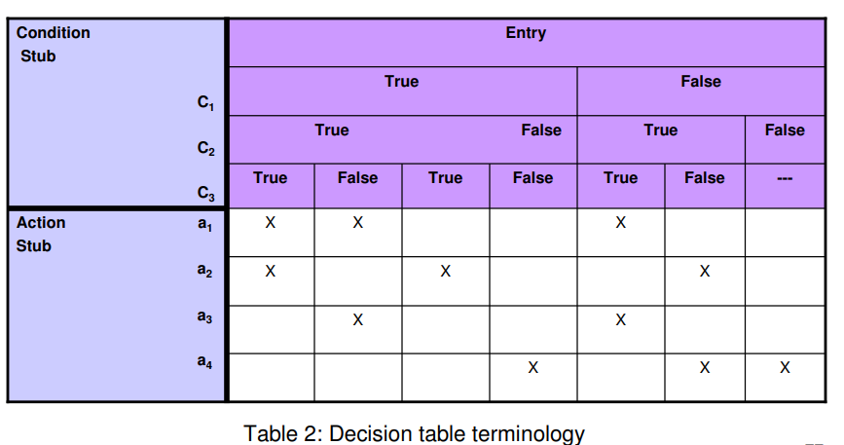

In software testing, the decision table has 4 parts which are divided into portions and are given below :
- Condition Stubs : The conditions are listed in this first upper left part of the decision table that is used to determine a particular action or set of actions.
- Action Stubs : All the possible actions are given in the first lower left portion (i.e, below condition stub) of the decision table.
- Condition Entries : In the condition entry, the values are inputted in the upper right portion of the decision table. In the condition entries part of the table, there are multiple rows and columns which are known as Rule.
- Action Entries : In the action entry, every entry has some associated action or set of actions in the lower right portion of the decision table and these values are called outputs.

Q15. What is Cause Effect Graphing Technique?

Cause Effect Graphing based technique is a technique in which a graph is used to represent the situations of combinations of input conditions. The graph is then converted to a decision table to obtain the test cases. Cause-effect graphing technique is used because boundary value analysis and equivalence class partitioning methods do not consider the combinations of input conditions. But since there may be some critical behaviour to be tested when some combinations of input conditions are considered, that is why cause-effect graphing technique is used.

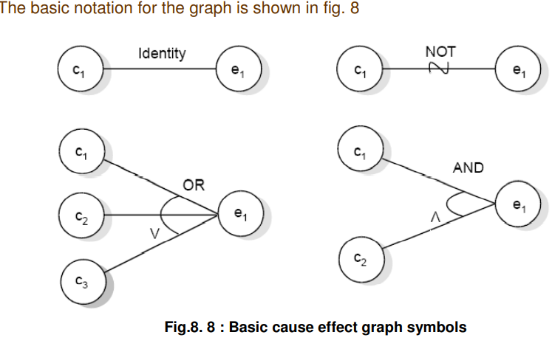

Q16. What is Structural Testing?

Structural testing is a type of software testing that uses the internal design of the software for testing or in other words the software testing which is performed by the team which knows the development phase of the software, is known as structural testing.
Structural testing is related to the internal design and implementation of the software i.e. it involves the development team members in the testing team. It tests different aspects of the software according to its types. Structural testing is just the opposite of behavioral testing.

Q17. What is Path Testing?

Structural testing is related to the internal design and implementation of the software i.e. it involves the development team members in the testing team. It tests different aspects of the software according to its types. Structural testing is just the opposite of behavioral testing.

This type of testing involves:
1. generating a set of paths that will cover every branch in the program.
2. finding a set of test cases that will execute every path in the set of program paths

Q18. What is Control Flow Testing?

Control flow testing is a type of structural testing that uses the programs’s control flow as a model. The entire code, design and structure of the software have to be known for this type of testing. Often this type of testing is used by the developers to test their own code and implementation. This method is used to test the logic of the code so that required result can be obtained.

The control flow of a program can be analysed using a graphical representation known as flow graph. The flow graph is a directed graph in which nodes are either entire statements or fragments of a statement, and edges represents flow of control.

Q19. What is Data Flow Testing?

It uses the control flow graph to explore the unreasonable things that can happen to data. The detection of data flow anomalies are based on the associations between values and variables. Without being initialized usage of variables. Initialized variables are not used once.

i. Statements where variables receive values.
ii. Statements where these values are used or referenced.

As we know, variables are defined and referenced throughout the program. We may have few define/ reference anomalies:

i. A variable is defined but not used/ referenced.
ii. A variable is used but never defined.
iii. A variable is defined twice before it is used.
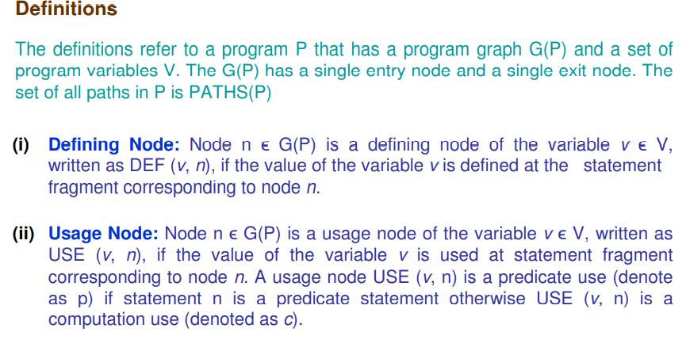

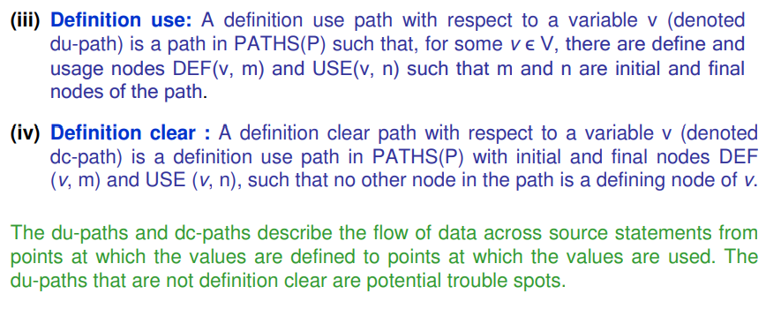

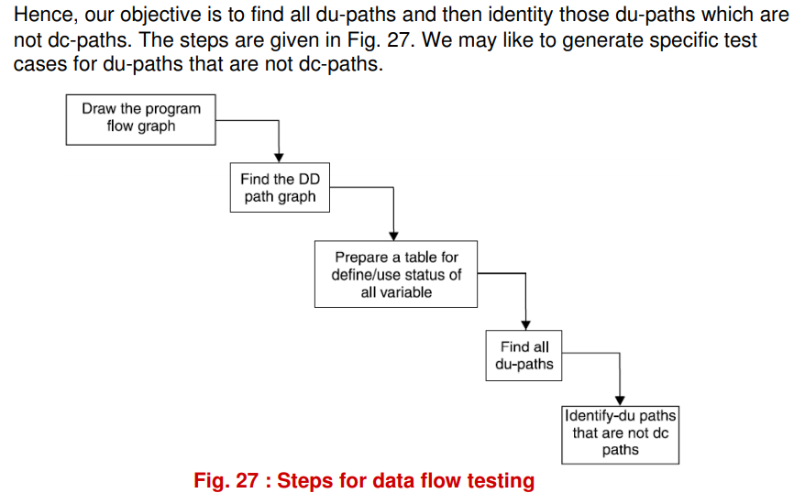

Q20. What is Mutation Testing?

Mutation Testing is a type of Software Testing that is performed to design new software tests and also evaluate the quality of already existing software tests. Mutation testing is related to modification a program in small ways. It focuses to help the tester develop effective tests or locate weaknesses in the test data used for the program.
Mutation testing is a fault based technique that is similar to fault seeding, except that mutations to program statements are made in order to determine properties about test cases. it is basically a fault simulation technique.

Multiple copies of a program are made, and each copy is altered; this altered copy is called a mutant. Mutants are executed with test data to determine whether the test data are capable of detecting the change between the original program and the mutated program.

Q21. Difference between is Unit Testing and Integration Testing.

S. No. | Unit Testing | Integration Testing
1. | In unit testing, each module of the software is tested separately. | In integration testing, all modules of the software are tested combined.
2. | In unit testing tester knows the internal design of the software. | Integration testing doesn’t know the internal design of the software.
3. | Unit testing is performed first of all testing processes. | Integration testing is performed after unit testing and before system testing.
4. | Unit testing is white box testing. | Integration testing is black box testing.
5. | Unit testing is performed by the developer. | Integration testing is performed by the tester.
6. | Detection of defects in unit testing is easy. | Detection of defects in integration testing is difficult.
7. | It tests parts of the project without waiting for others to be completed. | It tests only after the completion of all parts.
8. | Unit testing is less costly. | Integration testing is more costly.
9. | Unit testing is responsible to observe only the functionality of the individual units. | Error detection takes place when modules are integrated to create an overall system.
10. | Module specification is done initially. | Interface specification is done initially.
11. | The proper working of your code with the external dependencies is not ensured by unit testing. | The proper working of your code with the external dependencies is ensured by integration testing.
12. | Maintenance is cost effective. | Maintenance is expensive.
13. | Fast execution as compared to integration testing. | Its speed is slow because of the integration of modules.
14. | Unit testing results in in-depth exposure to the code. | Integration testing results in the integration structure’s detailed visibility.

Q22. Difference Between Unit Testing and System Testing

Aspects | Unit Testing | System Testing
Scope of testing | Tests individual units or components of the software application in isolation | Tests the complete system or software application
Timing of testing | Typically automated and performed by developers during the coding phase | Typically manual and performed by independent testers after the completion of integration testing
Focus of testing | Focuses on verifying the functionality of each unit or component of the software application | Focuses on verifying the functionality of the system as a whole
Testing environment | Tests are executed in a controlled environment, typically using mock objects or test doubles to isolate the unit being tested | Tests are executed in a production-like environment to simulate real-world usage scenarios
Testing frameworks | Uses unit test frameworks such as JUnit, NUnit, or PHPUnit to automate the testing process | Uses system testing frameworks such as Selenium, HP UFT, or IBM Rational Functional Tester to automate the testing process
Purpose of testing | Enables early detection and elimination of defects in the code | Enables validation of the entire software application to ensure it meets the specified requirements
Skills required | Requires a solid understanding of the code and the ability to write effective test cases | Requires a comprehensive understanding of the software application and the ability to write effective test cases
Feedback | Provides fast feedback on the quality of individual units or components | Provides a comprehensive understanding of the quality and readiness of the entire software application
Execution | Typically executed by developers in a continuous integration and delivery (CI/CD) pipeline | Typically executed by independent testers in a separate testing environment
Types of testing | Tests for both functional and non-functional aspects of the software application | Tests for both functional and non-functional aspects of the software application, including performance, security, and usability testing

Q23. What are the levels of testing?

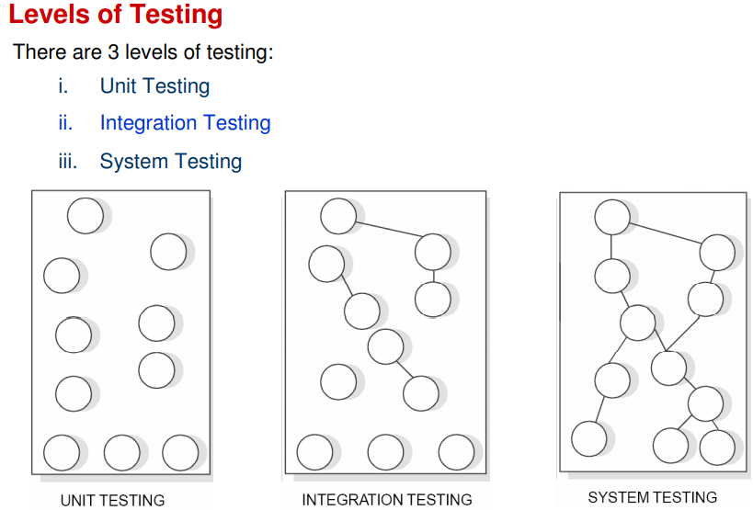

Q24. What is Debugging?

The goal of testing is to identify errors (bugs) in the program. The process of testing generates symptoms, and a program’s failure is a clear symptom of the presence of an error. After getting a symptom, we begin to investigate the cause and place of that error. After identification of place, we examine that portion to identify the cause of the problem. This process is called debugging.

Q25. What is Induction Debugging Approach?

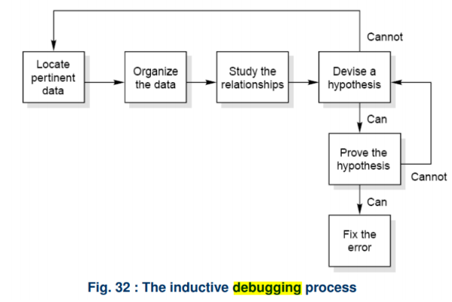

Q26. What is Deduction Debugging Approach?
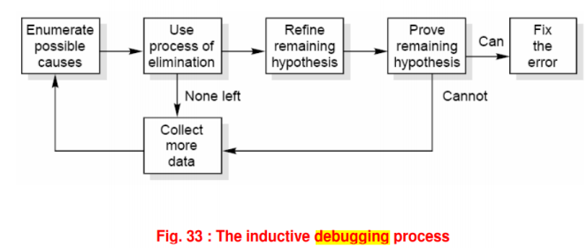

Q27. What are Testing Tools?

One way to improve the quality & quantity of testing is to make the process as pleasant as possible for the tester. This means that tools should be as concise, powerful & natural as possible.
The two broad categories of software testing tools are :
- Static
- Dynamic

Q28. What are the types of testing tools?

Static Test Tools: Static test tools are used to work on the static testing processes. In the testing through these tools, the typical approach is taken. These tools do not test the real execution of the software. Certain input and output are not required in these tools. Static test tools consist of the following:
- Flow analyzers: Flow analyzers provides flexibility in the data flow from input to output.
- Path Tests: It finds the not used code and code with inconsistency in the software.
- Coverage Analyzers: All rationale paths in the software are assured by the coverage analyzers.
- Interface Analyzers: They check out the consequences of passing variables and data in the modules.

Dynamic Test Tools: Dynamic testing process is performed by the dynamic test tools. These tools test the software with existing or current data. Dynamic test tools comprise the following:
- Test driver: The test driver provides the input data to a module-under-test (MUT).
- Test Beds: It displays source code along with the program under execution at the same time.
- Emulators: Emulators provide the response facilities which are used to imitate parts of the system not yet developed.
- Mutation Analyzers: They are used for testing the fault tolerance of the system by knowingly providing the errors in the code of the software.

Q29. What is Regression Testing?

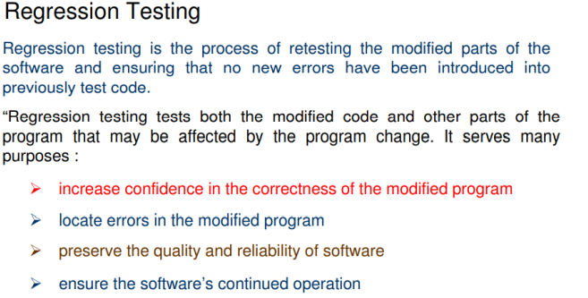

Q30. Difference between Development and Regression Testing?

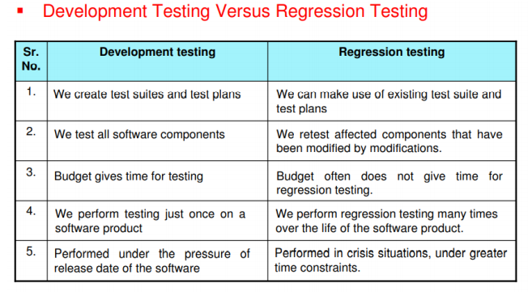

Q31. Difference between Functional Testing and Structural Testing?

Structural Testing | Functional Testing
This test evaluates the code structure or internal implementation of the code. | This test checks whether the software is functioning in accordance with functional requirements and specifications.
It is also known as white-box or clear-box testing as thorough knowledge and access of the code is required. | It is also known as black-box testing as no knowledge of the internal code is required.
Finds errors in the internal code logic and data structure usage. | It ensures that the system is error-free.
It does not ensure that the user requirements are met. | It is a quality assurance testing process ensuring the business requirements are met.
Performed the entire software in accordance with the system requirements. | Functional testing checks that the output is given as per expected.
Testing teams usually require developers to perform structural testing. | A QA professional can simply perform this testing.
Perform on low-level modules/software components. | The functional testing tool works on event analysis methodology.
It provides information on improving the internal structure of the application. | It provides information that prevents business loss.
Structural testing tools follow data analysis methodology. | Functional testing tool works on event analysis methodology.
Writing a structural test case requires understanding the coding aspects of the application. | Before writing a functional test case, a tester is required to understand the application’s requirements.
It examines how well modules communicate with one another. | It examines how well a system satisfies the business needs or the SRS.

Q32. What is Cyclomatic Complexity Number?

Cyclomatic Complexity is a software metric used to measure the complexity of a program's control flow. It is defined as the number of linearly independent paths through a program's source code. This metric is used to quantify the complexity of a program's logic and can help assess the ease of testing, maintenance, and understanding of the code.

Formula:
Cyclomatic complexity (V) can be calculated using the formula:
V = E - N + 2P
Where:
- E is the number of edges in the control flow graph (CFG).
- N is the number of nodes in the control flow graph (CFG).
- P is the number of connected components (usually, P = 1 for a single program).
Alternatively, cyclomatic complexity can be computed using the number of decision points (e.g., if, while, for, case) in the program:
V = D + 1
Where:
- D is the number of decision points (conditional statements).

Interpretation:
- V = 1: The program has no decision points and is simple.
- V = 2-10: The program has low to moderate complexity and can be easily understood and tested.
- V > 10: The program is complex and may be difficult to maintain, test, or understand. It may require refactoring.
Q33. What is Software Maintenance?
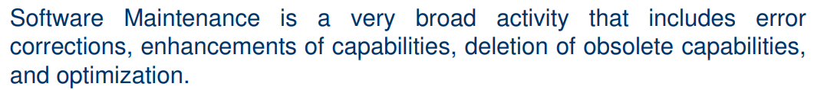
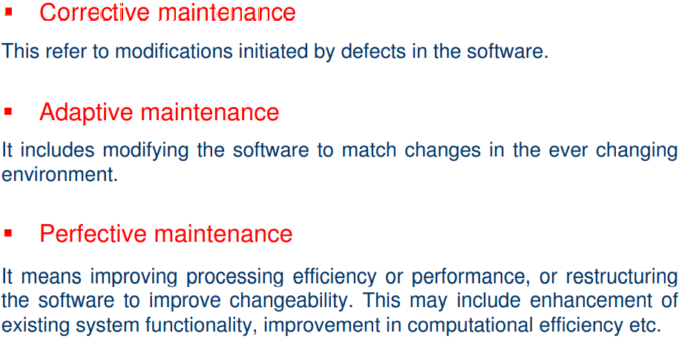
Q34. What are Categories of Maintenance?
There are long term effects of corrective, adaptive and perfective changes. This leads to increase in the complexity of the software, which reflect deteriorating structure. The work is required to be done to maintain it or to reduce it, if possible. This work may be named as preventive maintenance.
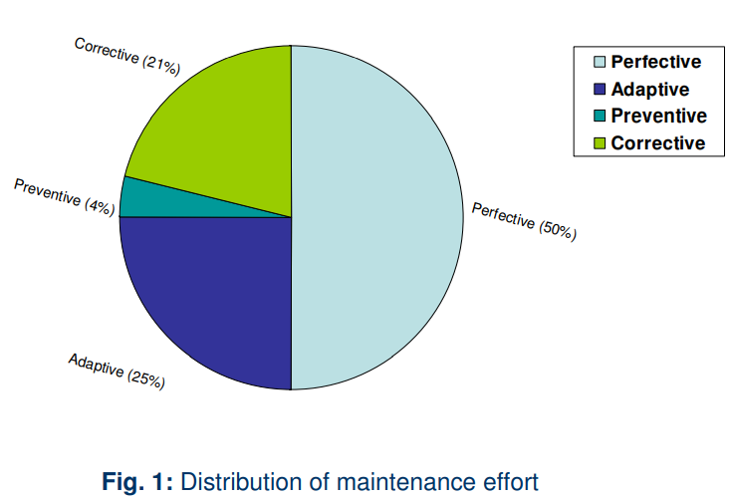

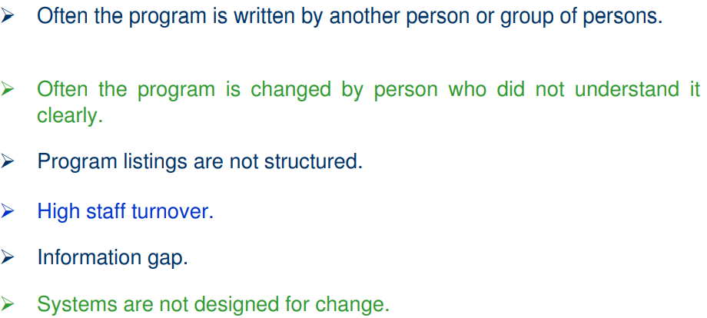
Q35. What are the Problems During Maintenance?
Q36. Explain the maintenance process.
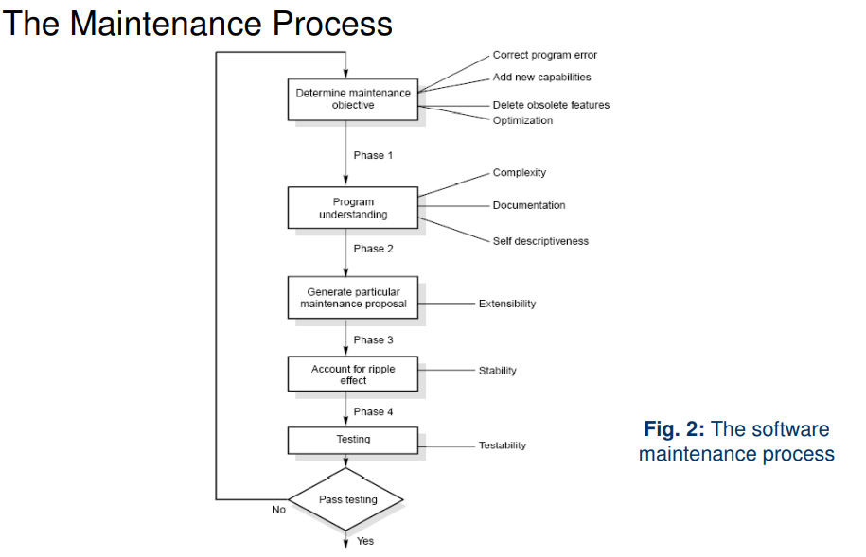
Q37. Explain all the Software Maintenance Model.
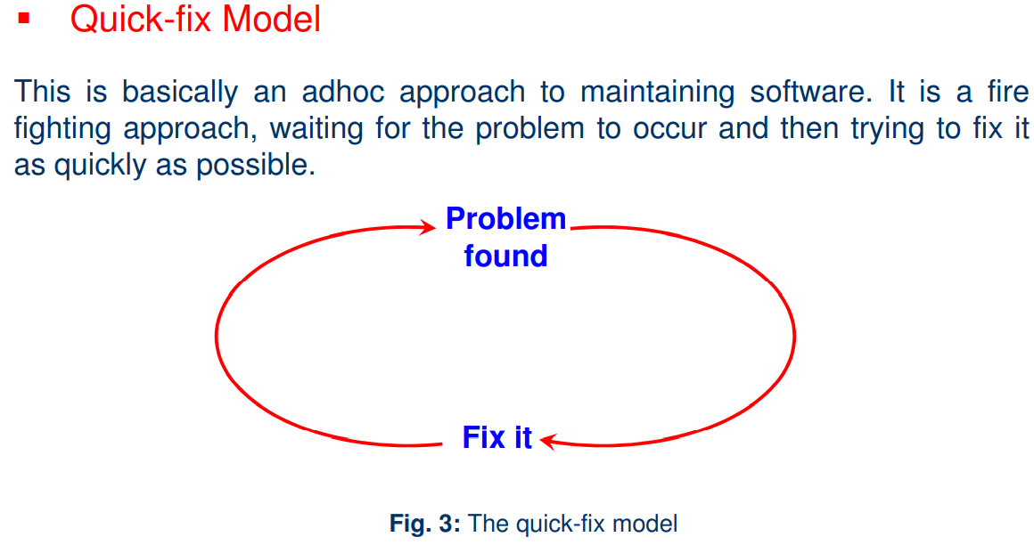



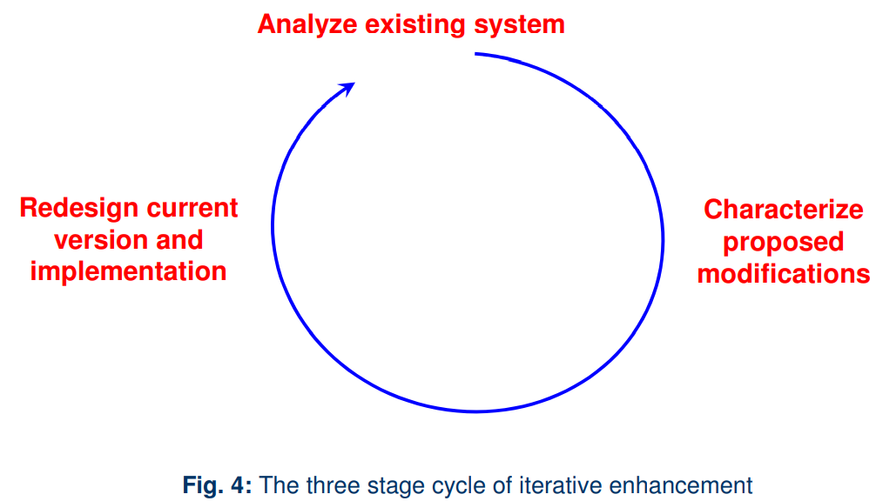
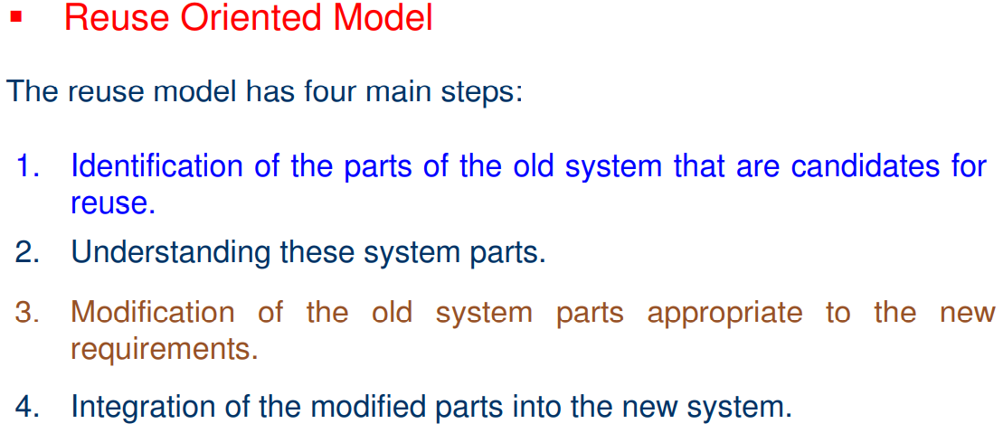
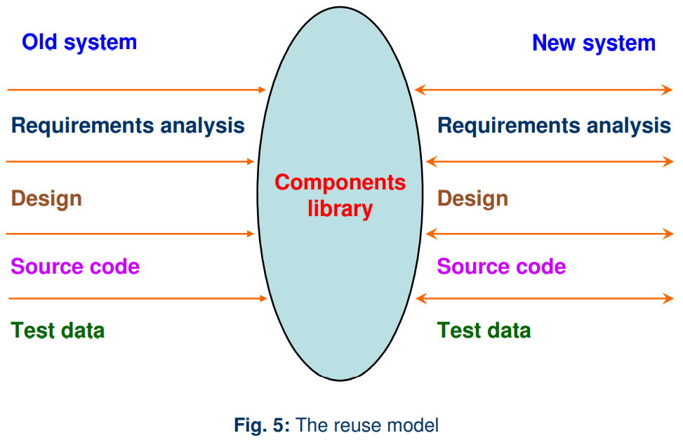

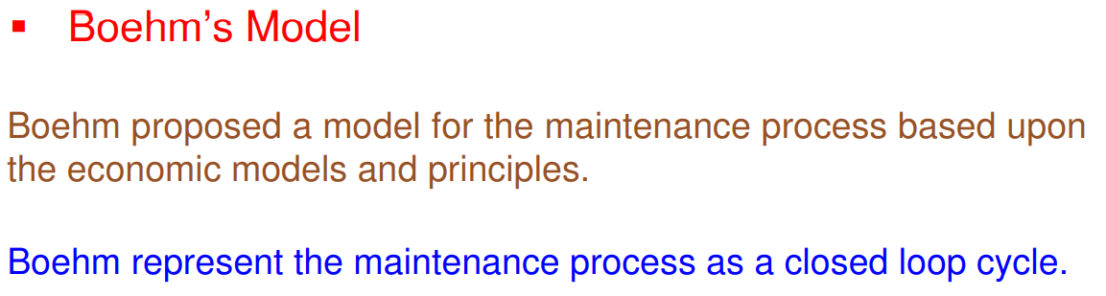
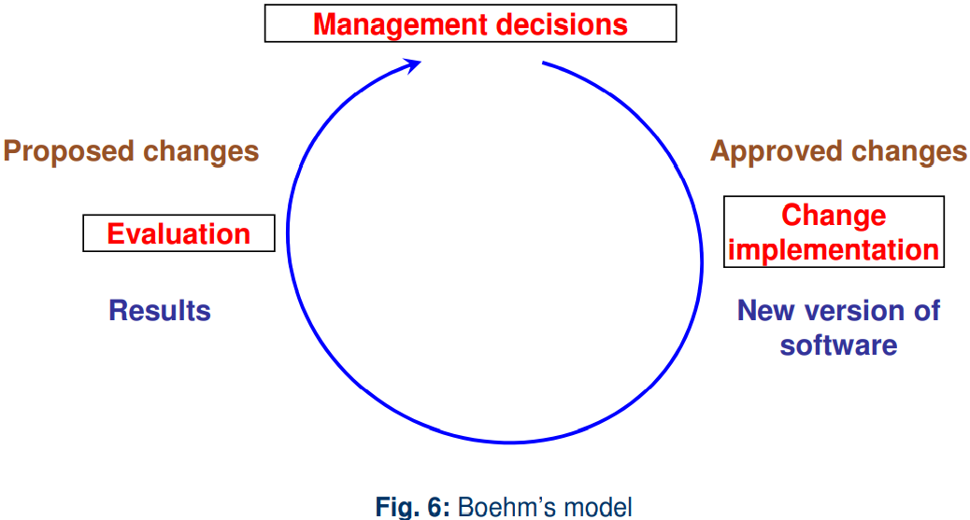

The Boehm Model, developed by Barry Boehm, focuses on software cost estimation, particularly maintenance costs. One of its key components is the Annual Change Traffic (ACT) metric, which helps estimate the effort required for maintenance based on the frequency and nature of changes. Important elements include:

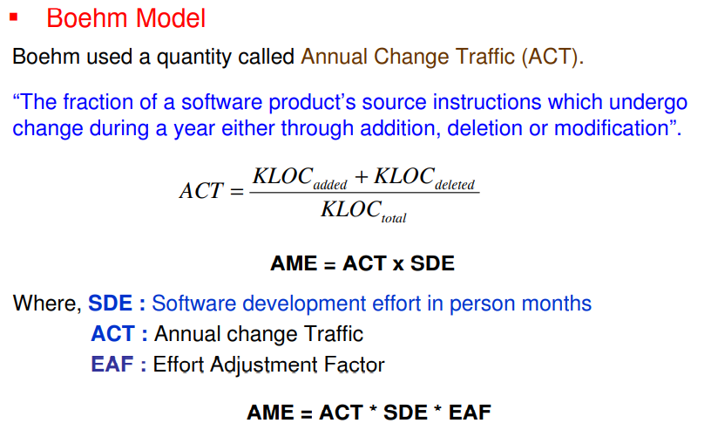
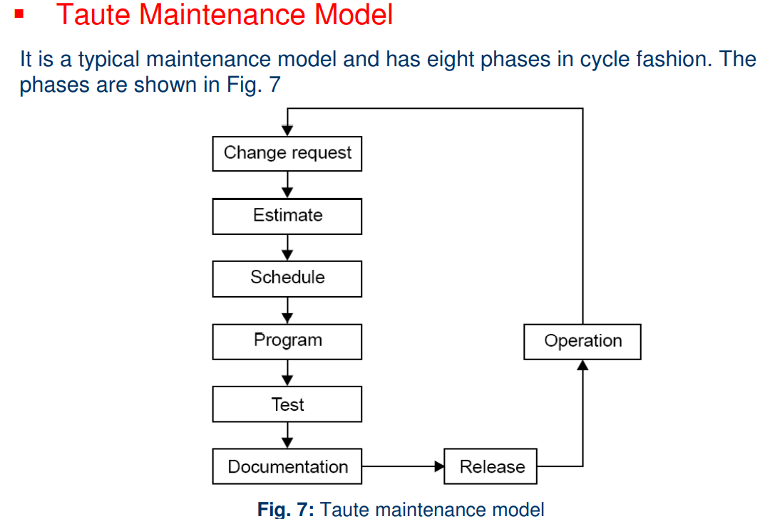

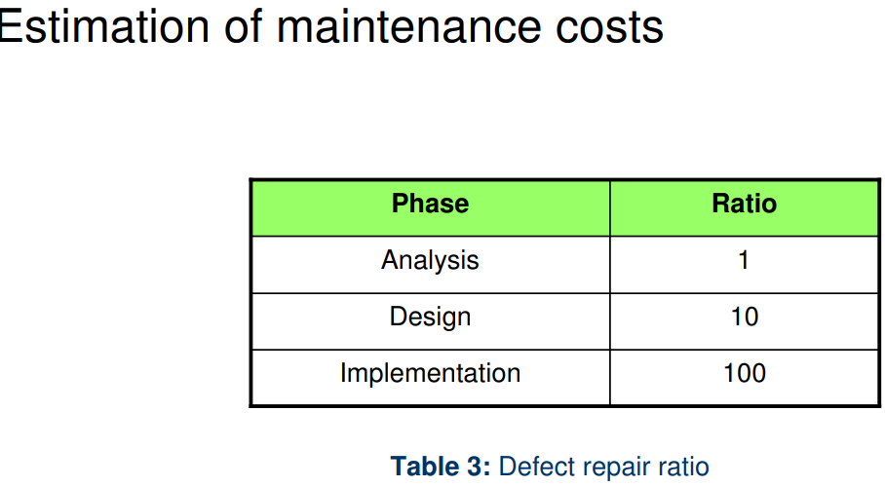

The Belady and Lehman Model, proposed by Mehdi Belady and Mario M. Lehman, focuses on understanding software evolution and its impact on maintenance costs. This model emphasizes the relationship between software changes and various factors influencing these changes.

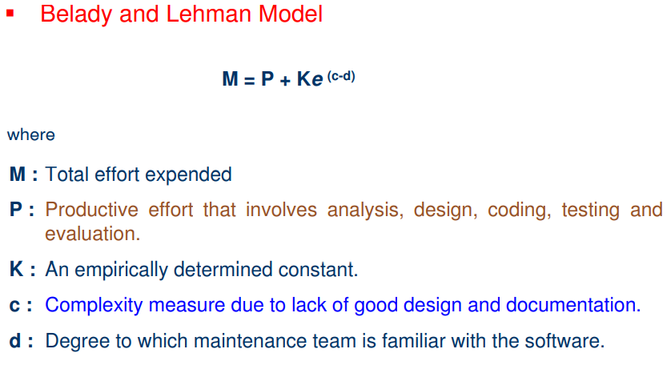

Q37. What is selective retest technique?
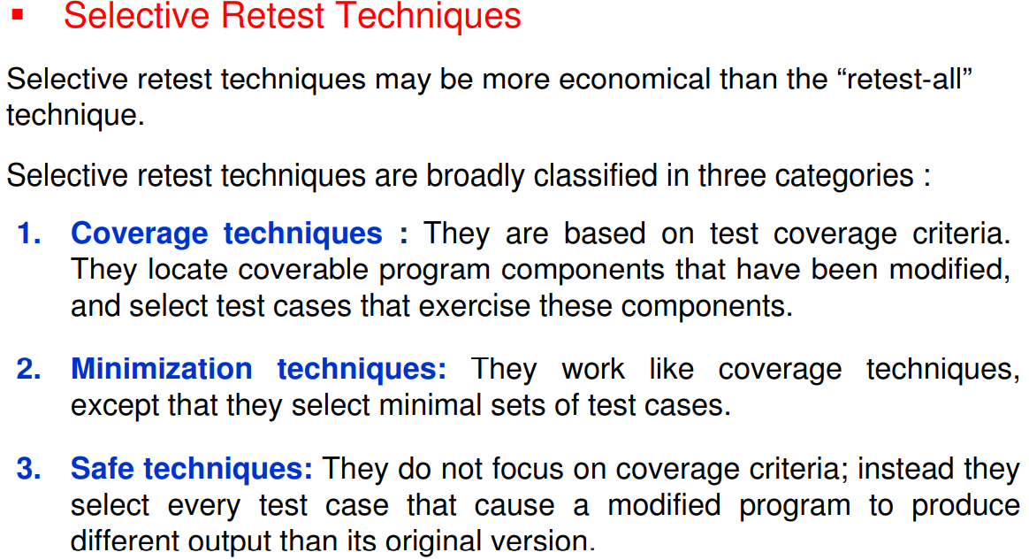
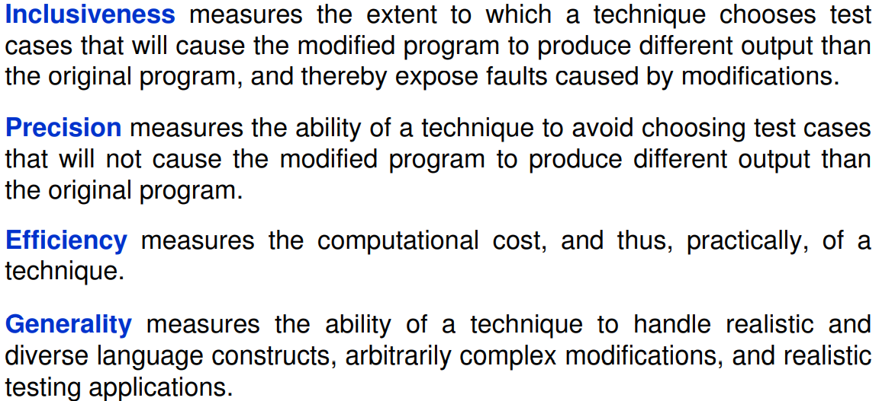
Q38. Discuss Reverse Engineering and Re-engineering in detail.

Reverse Engineering:

Reverse engineering is the process followed in order to find difficult, unknown and hidden information about a software system

Reverse Engineering encompasses a wide array of tasks related to understanding and modifying software system. This array of tasks can be broken into a number of classes

Reverse engineering can extract design information from source code, but the abstraction level, the completeness of the documentation, the degree to which tools and a human analyst work together, and the directionality of the process are highly variable [CAS88]. The abstraction level of a reverse engineering process and the tools used to effect it refers to the sophistication of the design information that can be extracted from source code. Ideally, the abstraction level should be as high as possible. That is, the reverse engineering

The reverse engineering process is represented in Figure 30.3. Before reverse engineering activities can commence, unstructured (“dirty”) source code is restructured (Section 30.4.1) so that it contains only the structured programming constructs.2 This makes the source code easier to read and provides the basis for all the subsequent reverse engineering activities. The core of reverse engineering is an activity called extract abstractions. The engineer must evaluate the old program and from the (often undocumented) source code, extract a meaningful specification of the processing that is performed, the user interface that is applied, and the program data structures or database that is used.

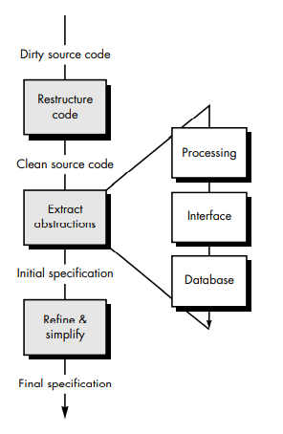
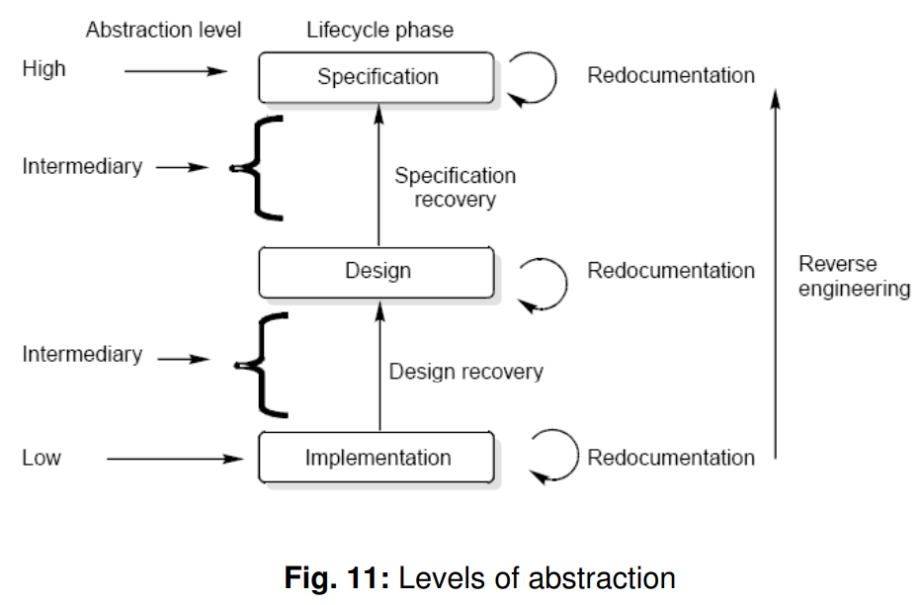

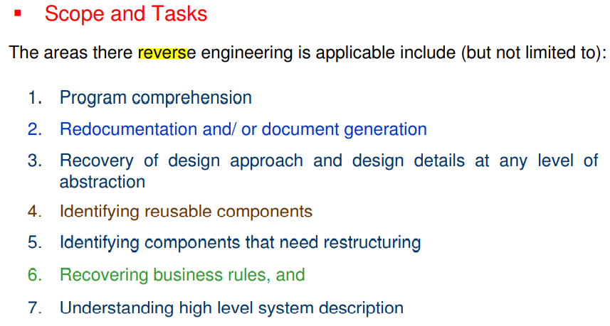
Levels of Reverse Engineering

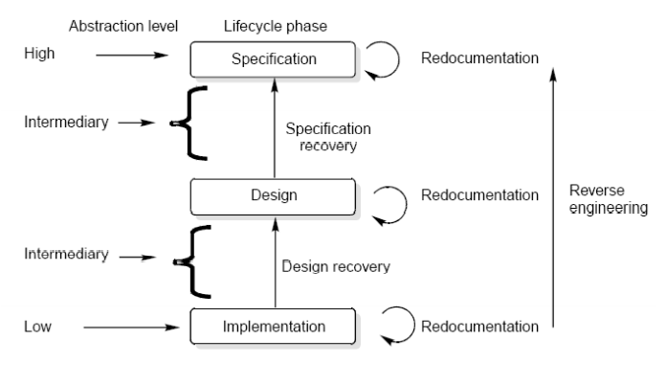
Reverse Engineers detect low level implementation constructs and replace them with their high level counterparts. The process eventually results in an incremental formation of an overall architecture of the program.

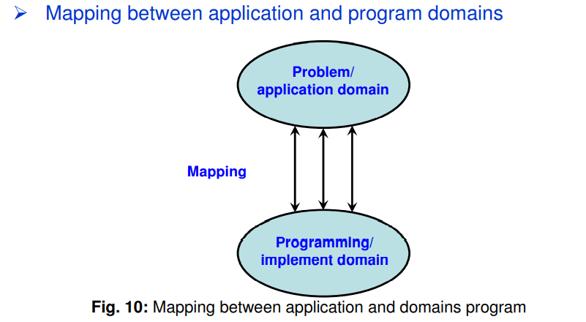
Redocumentation

Redocumentation is the recreation of a semantically equivalent representation within the same relative abstraction level.

Design recovery

Design recovery entails identifying and extracting meaningful higher level abstractions beyond those obtained directly from examination of the source code. This may be achieved from a combination of code, existing design documentation, personal experience, and knowledge of the problem and application domains.

Software RE-Engineering

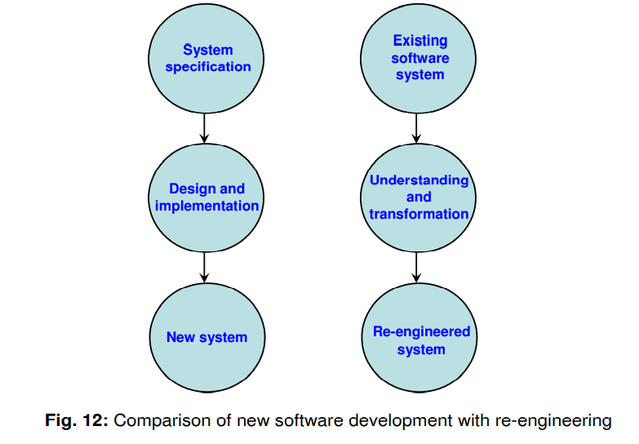

Software Re-engineering
Software re-engineering is concerned with taking existing legacy systems and re-implementing them to make them more maintainable. The critical distinction between re-engineering and new software development is the starting point for the development, as shown in Figure 12.
Best Practices for Software Maintenance
To effectively maintain and re-engineer legacy systems, the following suggestions may be useful:
- Study Code Well Before Attempting Changes:
  - Thoroughly understanding the existing codebase helps avoid introducing new bugs during modifications.
- Concentrate on Overall Control Flow and Not Coding:
  - Focus on the overall structure and logic of the software to ensure that changes align with the intended functionality.
- Heavily Comment Internal Code:
  - Detailed comments enhance code readability and provide context, facilitating easier understanding for future maintainers.
- Create Cross References:
  - Cross-referencing related code segments helps developers understand dependencies and interactions within the system.
- Build Symbol Tables:
  - Symbol tables assist in tracking variable definitions and scopes, making it easier to manage complex variable usage.
- Use Own Variables, Constants, and Declarations to Localize the Effect:
  - Defining well-scoped variables reduces the risk of unintended side effects from changes.
- Keep Detailed Maintenance Documents:
  - Comprehensive documentation of maintenance activities provides historical context and aids future maintenance efforts.

Software Re-engineering Steps:-

Source Code Translation
  - Hardware platform update: Organizations may need to change their standard hardware platform, and compilers for the original programming language might not be available on the new platform.
  - Staff skill shortages: A lack of trained maintenance staff for the original language, especially for non-standard or outdated languages, can pose a significant challenge.
  - Organizational policy changes: Organizations may standardize on a particular language to minimize support costs. Maintaining multiple versions of old compilers is often expensive.

Program Restructuring
  - Control flow-driven restructuring: This focuses on imposing a clear control structure within the source code, which can be inter-modular or intra-modular in nature.
  - Efficiency-driven restructuring: This involves modifying a function or algorithm to improve efficiency, such as replacing an IF-THEN-ELSE-IF-ELSE construct with a CASE construct.

- Adaptation-driven restructuring:
  - This involves altering the coding style to fit a new programming language or operating environment. For example, converting an imperative program in PASCAL into a functional program in LISP.

Q39. What is Configuration Management?

The process of software development and maintenance is controlled is called configuration management. The configuration management is different in development and maintenance phases of life cycle due to different environments.

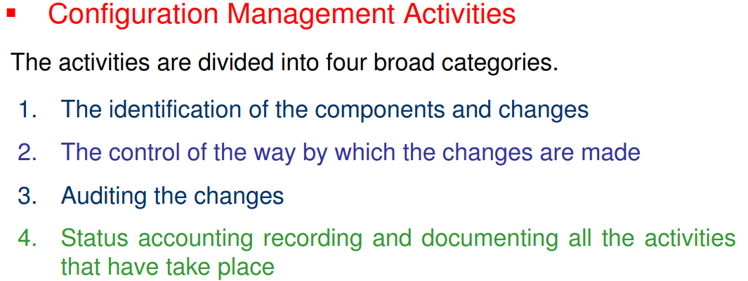

Q40. What are Software Versions and Version Control?

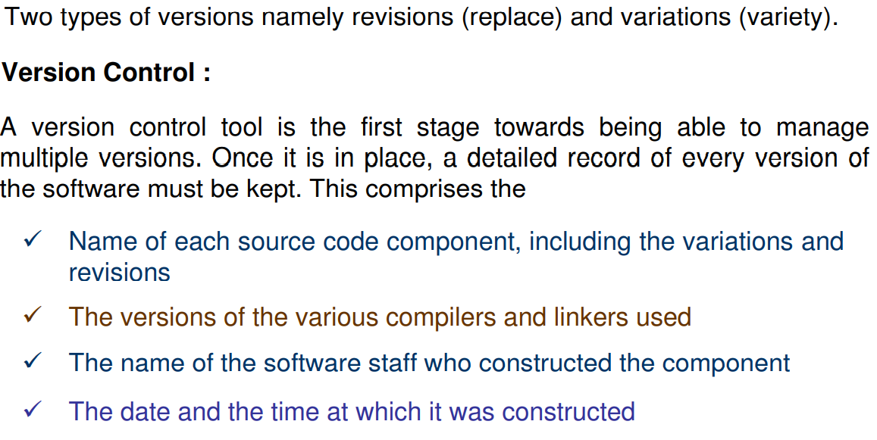

Q41. What is Change Control Process?

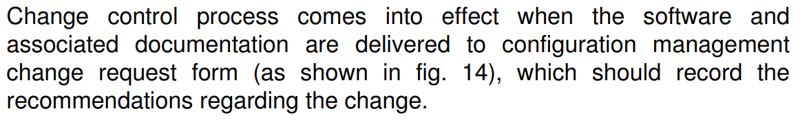
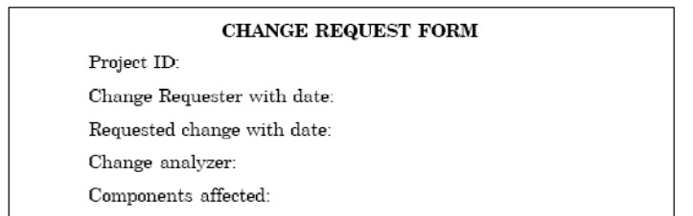
Q42. What is Software Documentation? Explain User and System Documentation.

Software Documentation is the written record that provides information about a software system, aiming to communicate its purpose, content, and details with clarity.

User Documentation
This type of documentation is intended for end-users. It provides instructions on how to use the software effectively, including user guides, tutorials, and troubleshooting steps. The goal is to make the software accessible and understandable for its intended audience.
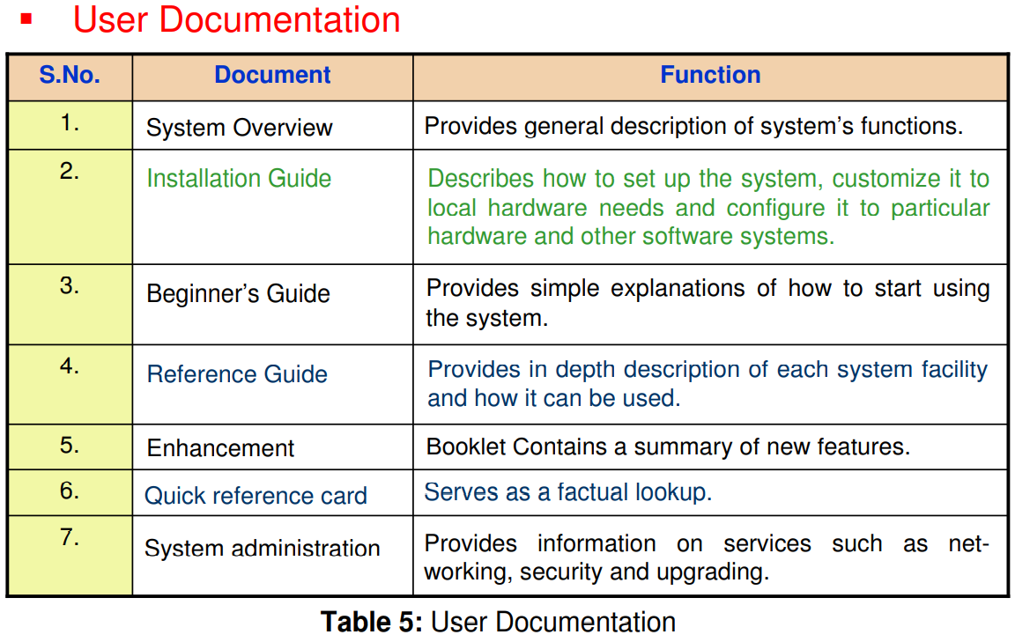

System Documentation
This encompasses detailed records about the system's analysis, specifications, design, implementation, testing, security, error diagnosis, and recovery processes. It is primarily for developers and technical personnel involved in maintaining or enhancing the system.

